Mapping Variables

# Instructions for tidycensus:  
# https://walker-data.com/tidycensus/articles/basic-usage.html  
# Census code lists, definitions, accuracy:  
# https://www.census.gov/programs-surveys/acs/technical-documentation/code-lists.html  
# Census API variables:  
# https://api.census.gov/data/2019/acs/acs1/variables.html  
# https://api.census.gov/data/2010/dec/sf1/variables.html  
  
# Load libraries  
library(tidyverse)

## -- Attaching packages --------------------------------------- tidyverse 1.3.1 --

## v ggplot2 3.3.5 v purrr 0.3.4  
## v tibble 3.1.3 v dplyr 1.0.7  
## v tidyr 1.1.3 v stringr 1.4.0  
## v readr 2.0.1 v forcats 0.5.1

## -- Conflicts ------------------------------------------ tidyverse_conflicts() --  
## x dplyr::filter() masks stats::filter()  
## x dplyr::lag() masks stats::lag()

library(tidycensus)  
library(readr)  
library(gridExtra)

##   
## Attaching package: 'gridExtra'

## The following object is masked from 'package:dplyr':  
##   
## combine

# API Key:  
api_key <- read_file("api.key")  
census_api_key(api_key)

## To install your API key for use in future sessions, run this function with `install = TRUE`.

# Variables of interest:  
total_population <- c("B01003_001E")  
# Vacancy status variables:  
vacancy_vars <- c("B25004_001E", "B25004_002E", "B25004_003E", "B25004_004E",   
 "B25004_005E", "B25004_006E", "B25004_007E", "B25004_008E",  
 "B25005_001E", "B25005_002E", "B25005_003E")  
# Internet/Broadband variable:  
# (there are more variables, check out the 2019 acs variables list)  
internet_variables <- c("B28002_001E", "B28002_002E", "B28002_003E",  
 "B28002_004E", "B28002_005E", "B28002_006E",   
 "B28002_007E", "B28002_008E", "B28002_009E",   
 "B28002_010E", "B28002_011E", "B28002_012E",   
 "B28002_013E")  
internet_variables_noE <- substr(internet_variables, 1, nchar(internet_variables)-1)  
  
# Variables:  
# all_vars <- c(total_population, vacancy_vars, internet_variables)  
all_vars <- c(total_population, internet_variables)

# Get variable descriptions:  
variable_descriptions <- load_variables(2019, "acs5")

# Get a dataset:  
the_data <- get_acs(geography="block group", year=2019, state="MA",  
 variables=all_vars, geometry=TRUE)

## Getting data from the 2015-2019 5-year ACS

## Downloading feature geometry from the Census website. To cache shapefiles for use in future sessions, set `options(tigris_use_cache = TRUE)`.

## | | | 0% | |= | 1% | |== | 3% | |=== | 4% | |==== | 5% | |===== | 7% | |====== | 8% | |====== | 9% | |======= | 11% | |========== | 14% | |=========== | 16% | |============== | 19% | |============== | 21% | |=============== | 21% | |================ | 23% | |================= | 25% | |=================== | 27% | |==================== | 28% | |===================== | 30% | |====================== | 32% | |======================= | 33% | |======================== | 35% | |========================= | 35% | |========================== | 37% | |============================ | 40% | |============================= | 41% | |============================= | 42% | |============================== | 43% | |================================ | 45% | |================================ | 46% | |================================== | 48% | |==================================== | 51% | |===================================== | 53% | |======================================== | 57% | |========================================= | 59% | |============================================ | 62% | |============================================= | 64% | |=============================================== | 68% | |================================================= | 70% | |=================================================== | 73% | |==================================================== | 75% | |====================================================== | 78% | |======================================================= | 78% | |======================================================== | 80% | |=========================================================== | 84% | |============================================================ | 86% | |============================================================= | 87% | |============================================================== | 89% | |================================================================ | 91% | |================================================================== | 94% | |=================================================================== | 96% | |======================================================================| 100%

data_against_summary <- get_acs(geography="block group", year=2019, state="MA",  
 variables=all_vars, geometry=TRUE, summary_var="B01003_001")

## Getting data from the 2015-2019 5-year ACS  
## Downloading feature geometry from the Census website. To cache shapefiles for use in future sessions, set `options(tigris_use_cache = TRUE)`.

# Only for Suffolk county:  
data_against_summary_suffolk <- get_acs(geography="block group", year=2019, state="MA", county="Suffolk",  
 variables=all_vars, geometry=TRUE, summary_var="B01003_001")

## Getting data from the 2015-2019 5-year ACS  
## Downloading feature geometry from the Census website. To cache shapefiles for use in future sessions, set `options(tigris_use_cache = TRUE)`.

# Divide estimates by summary:  
data_against_summary$percent <- (data_against_summary$estimate / data_against_summary$summary_est) * 100  
data_against_summary_suffolk$percent <- (data_against_summary_suffolk$estimate / data_against_summary_suffolk$summary_est) * 100  
  
# Save to csv:  
write.csv(the_data, "2019acs_internet_vacancy.csv")  
write.csv(data_against_summary, "2019acs_internet_vacancy_against_summary.csv")

# Merge data with dataset descriptions:  
data_against_summary2 <- merge(data_against_summary, variable_descriptions, by.x="variable", by.y="name", all.x=TRUE)

# Get population by county:  
county_population <- get_acs(geography="county", year=2019, state="MA", variables=total_population)

## Getting data from the 2015-2019 5-year ACS

# Get counties:  
county_vector <- county_population$NAME  
county_vector <- substr(county_vector, 1, nchar(county_vector)-15)  
county_vector

## [1] "Barnstable County" "Berkshire County" "Bristol County"   
## [4] "Dukes County" "Essex County" "Franklin County"   
## [7] "Hampden County" "Hampshire County" "Middlesex County"   
## [10] "Nantucket County" "Norfolk County" "Plymouth County"   
## [13] "Suffolk County" "Worcester County"

# ##############################################################################  
# Figure of total population:  
the_data %>%   
 filter(variable=="B01003_001") %>%   
 ggplot(aes(fill=estimate)) +  
 geom_sf(color=NA) +  
 coord_sf(crs=4326, expand=FALSE) +  
 # coord_sf(crs=26911, expand=FALSE) +  
 # coord_sf(crs=26911, expand=FALSE, xlim=c(-74, -70), ylim=c(42, 44)) +  
 scale_fill_viridis_c(option = "magma", na.value="white") +  
 ggtitle("Total Population")

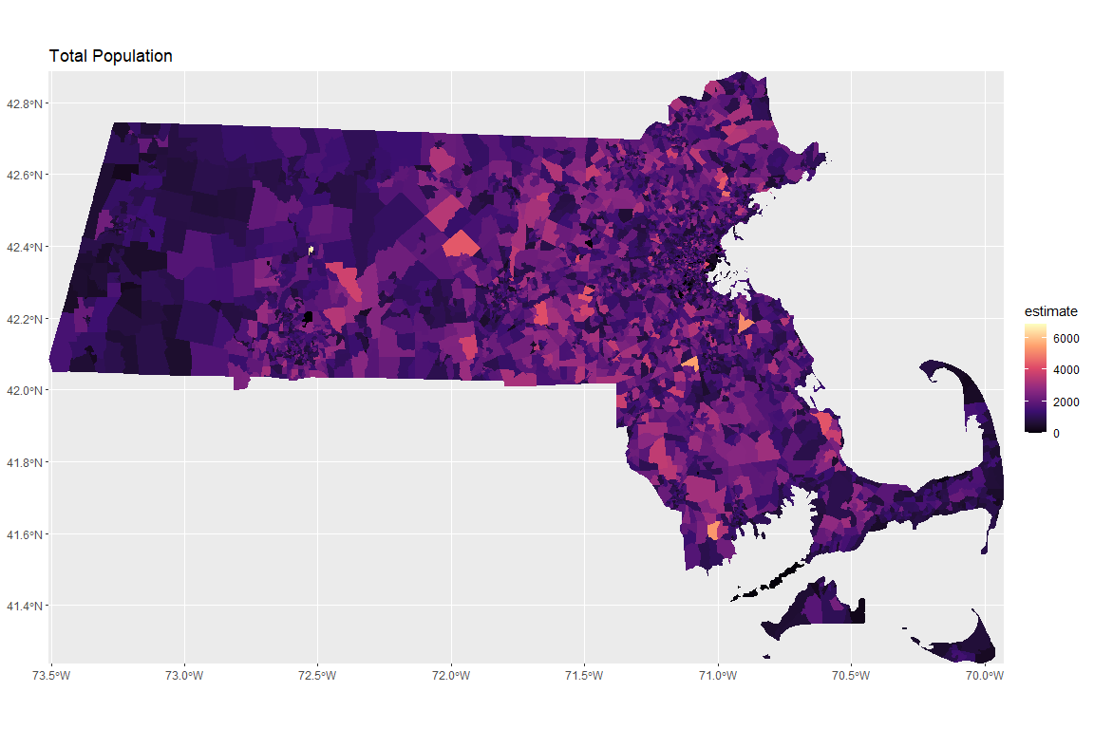

# # ##############################################################################  
# # For cable: B28002_007E  
# data_against_summary %>%   
# filter(variable=="B28002_007") %>%   
# ggplot(aes(fill=percent)) +  
# geom_sf(color=NA) +  
# coord_sf(crs=26911) +  
# scale_fill_viridis_c(option = "magma", na.value="white") +  
# ggtitle("With Cable/Fiber optic/DSL Broadband subscription")

# # For only the county:  
# data_against_summary_suffolk %>%   
# filter(variable=="B28002_007") %>%   
# ggplot(aes(fill=percent)) +  
# geom_sf(color=NA) +  
# coord_sf(crs=26911) +  
# scale_fill_viridis_c(option = "magma", na.value="white") +  
# ggtitle("With Cable/Fiber optic/DSL Broadband subscription, Suffolk County")

# # ###############################################################################  
# # No access to internet: B28002_013  
# data_against_summary_suffolk %>%   
# filter(variable=="B28002_013") %>%   
# ggplot(aes(fill=percent)) +  
# geom_sf(color=NA) +  
# coord_sf(crs=26911) +  
# scale_fill_viridis_c(option = "magma", na.value="white") +  
# ggtitle("Without Access to Internet, Suffolk County")

# # No access to internet: B28002_013  
# data_against_summary %>%   
# filter(variable=="B28002_013") %>%   
# ggplot(aes(fill=percent)) +  
# geom_sf(color=NA) +  
# coord_sf(crs=26911) +  
# scale_fill_viridis_c(option = "magma", na.value="white") +  
# ggtitle("Without Access to Internet")

# # All internet variables:  
# data_against_summary2 %>%   
# filter(variable!="B01003_001") %>%   
# ggplot(aes(fill=percent)) +  
# geom_sf(color=NA) +  
# coord_sf(crs=26911) +  
# scale_fill_viridis_c(option = "magma", na.value="white") +  
# facet_wrap(~variable, ncol=3)

# Plot internet variables for MA:  
# Image list:  
ma_images <- list()  
  
# Loop to generate images:  
for (the_var in internet_variables_noE){  
 # Get variable description:  
 var_des <- variable_descriptions$label[variable_descriptions$name==the_var]  
 cat("For variable: ", the_var, ": ", var_des, "\n")  
 # Make plot:  
 ma_images[[the_var]] <- data_against_summary %>%   
 filter(variable==the_var) %>%   
 ggplot(aes(fill=percent)) +  
 geom_sf(color=NA) +  
 coord_sf(crs=4326) +  
 scale_fill_viridis_c(option = "magma", na.value="white") +  
 ggtitle(paste("Massachusetts\n", var_des, " \n(", the_var, ")")) +  
 theme(plot.title=element_text(size=12),  
 plot.margin=unit(c(0.25, 0.25, 0.25, 0.25), "in"))  
 # Plot image:  
 print(ma_images[[the_var]])  
}

## For variable: B28002_001 : Estimate!!Total:

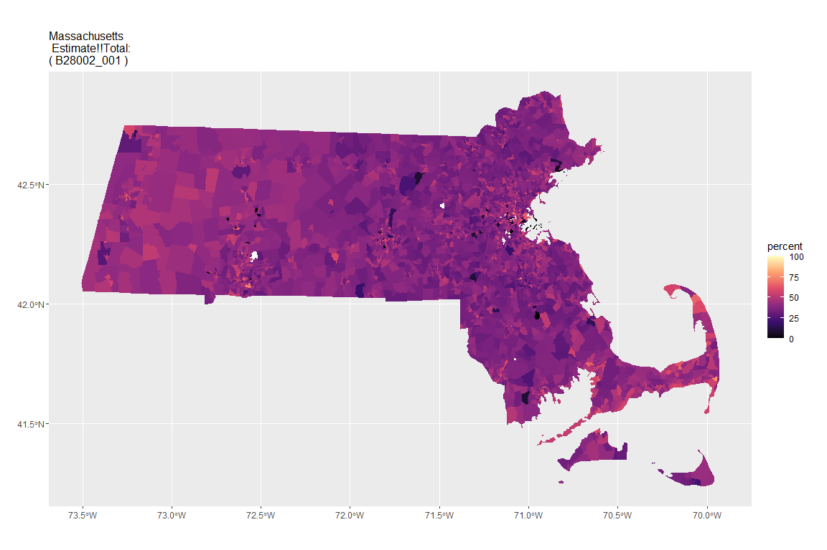

## For variable: B28002_002 : Estimate!!Total:!!With an Internet subscription

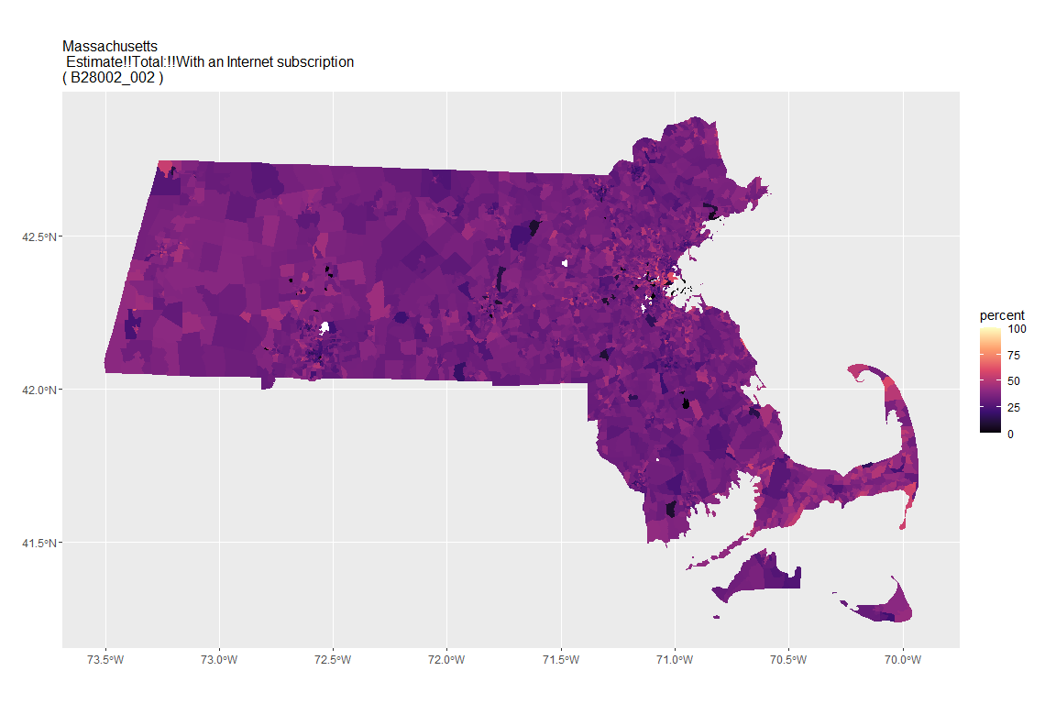

## For variable: B28002_003 : Estimate!!Total:!!With an Internet subscription!!Dial-up with no other type of Internet subscription

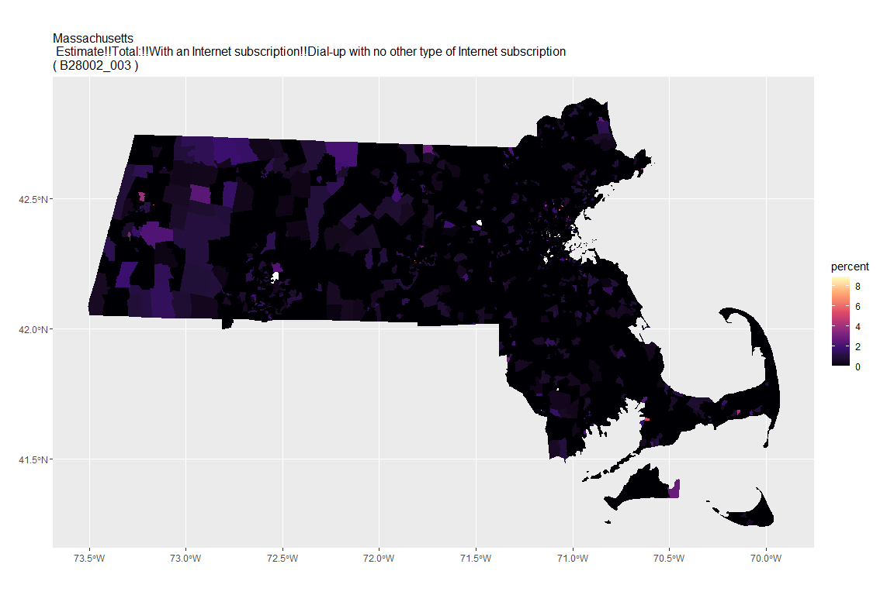

## For variable: B28002_004 : Estimate!!Total:!!With an Internet subscription!!Broadband of any type

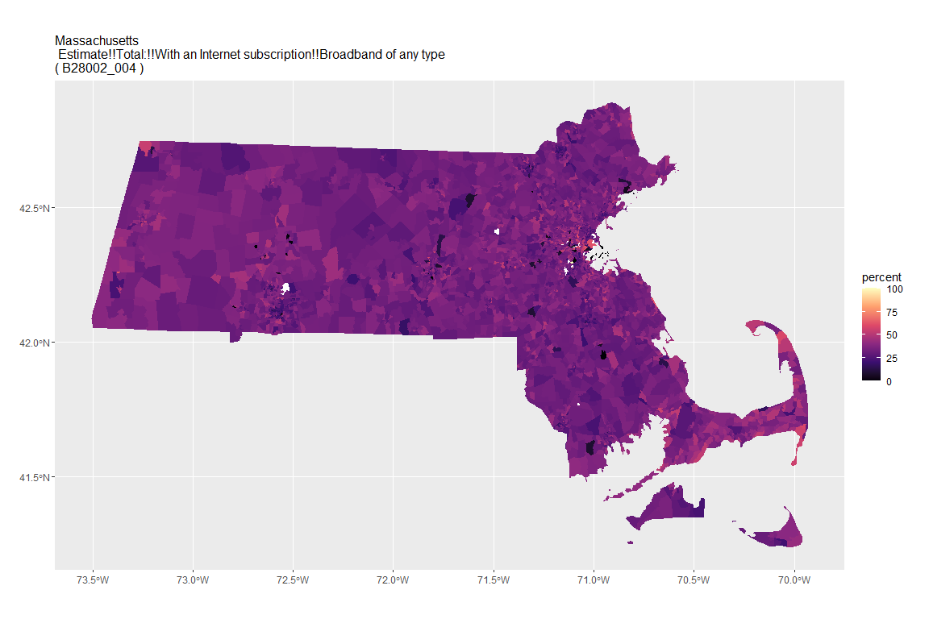

## For variable: B28002_005 : Estimate!!Total:!!With an Internet subscription!!Cellular data plan

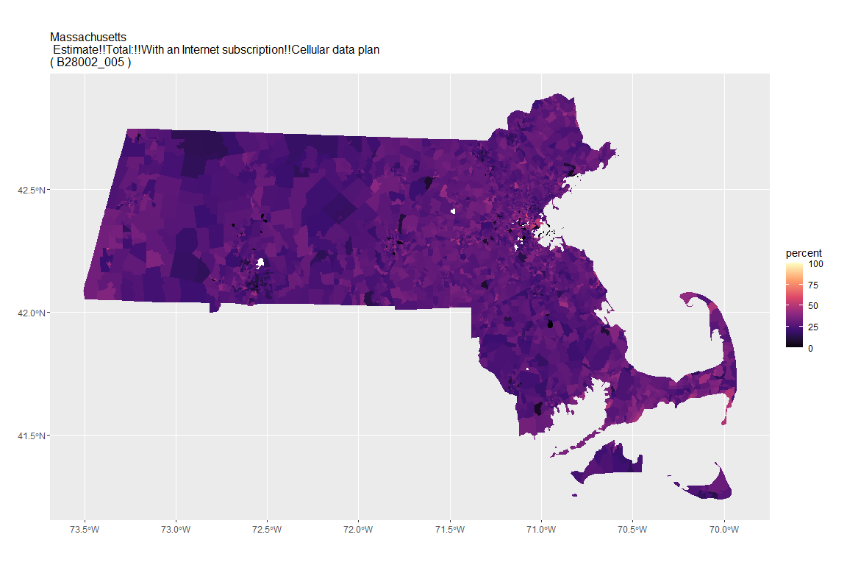

## For variable: B28002_006 : Estimate!!Total:!!With an Internet subscription!!Cellular data plan!!Cellular data plan with no other type of Internet subscription

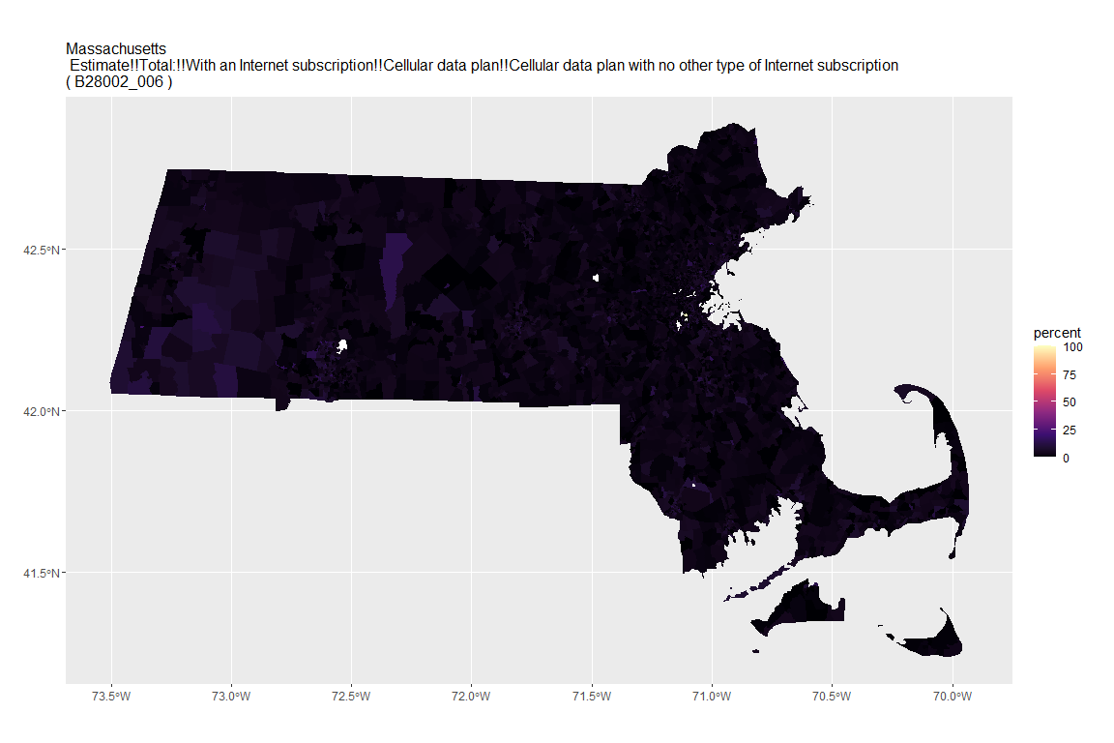

## For variable: B28002_007 : Estimate!!Total:!!With an Internet subscription!!Broadband such as cable, fiber optic or DSL

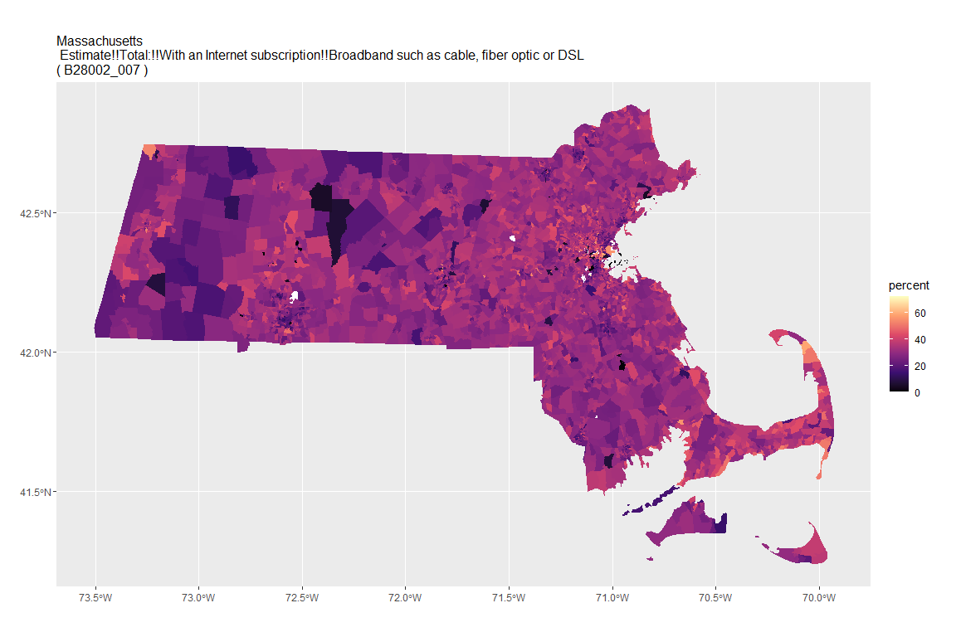

## For variable: B28002_008 : Estimate!!Total:!!With an Internet subscription!!Broadband such as cable, fiber optic or DSL!!Broadband such as cable, fiber optic or DSL with no other type of Internet subscription

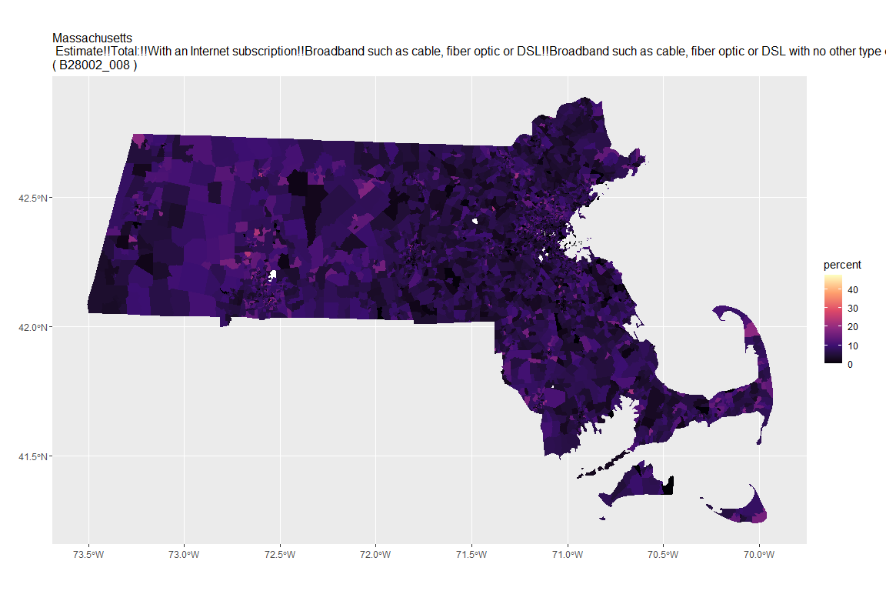

## For variable: B28002_009 : Estimate!!Total:!!With an Internet subscription!!Satellite Internet service

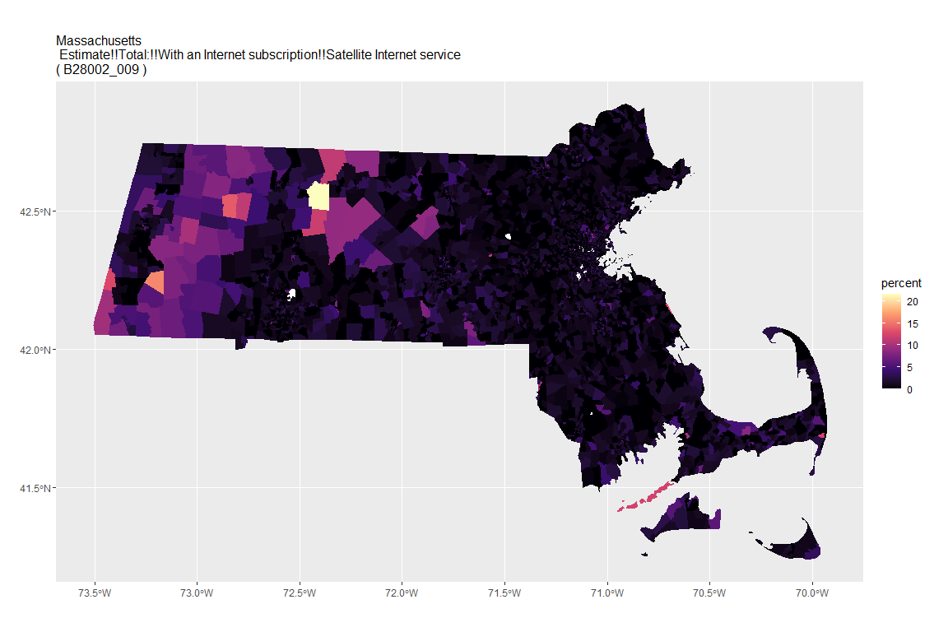

## For variable: B28002_010 : Estimate!!Total:!!With an Internet subscription!!Satellite Internet service!!Satellite Internet service with no other type of Internet subscription

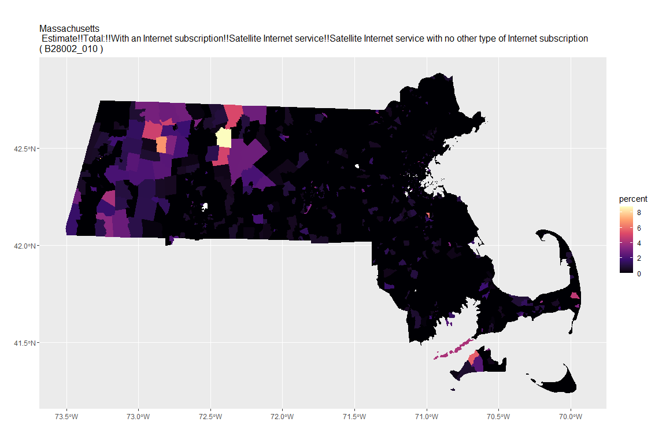

## For variable: B28002_011 : Estimate!!Total:!!With an Internet subscription!!Other service with no other type of Internet subscription

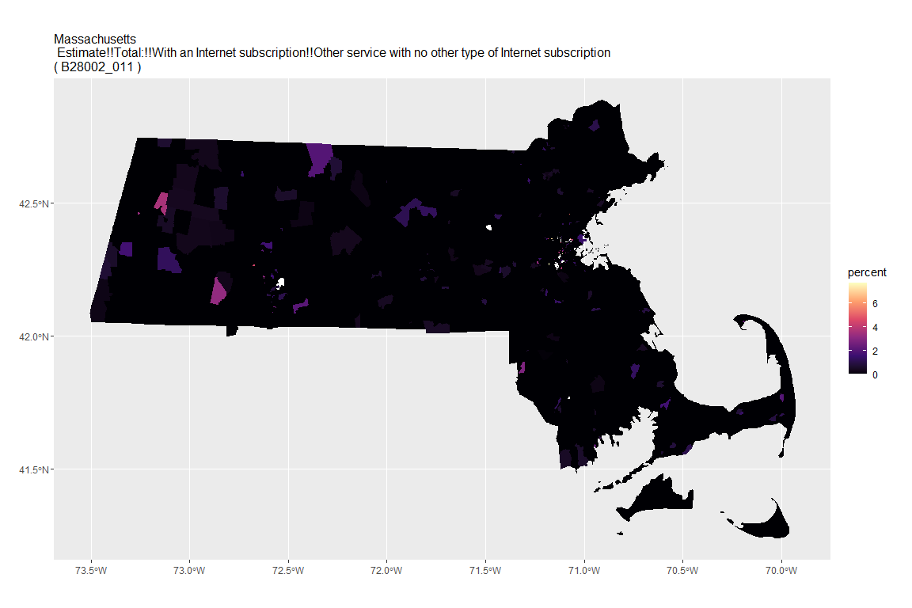

## For variable: B28002_012 : Estimate!!Total:!!Internet access without a subscription

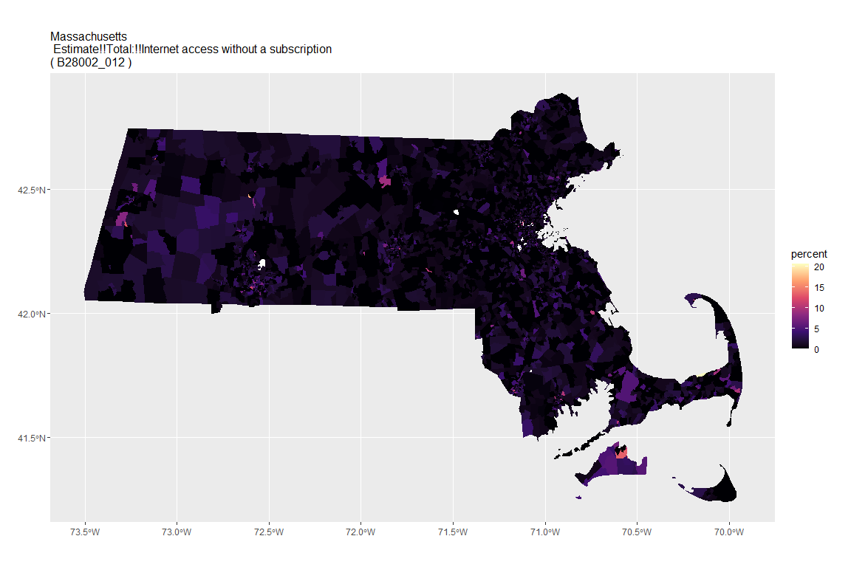

## For variable: B28002_013 : Estimate!!Total:!!No Internet access

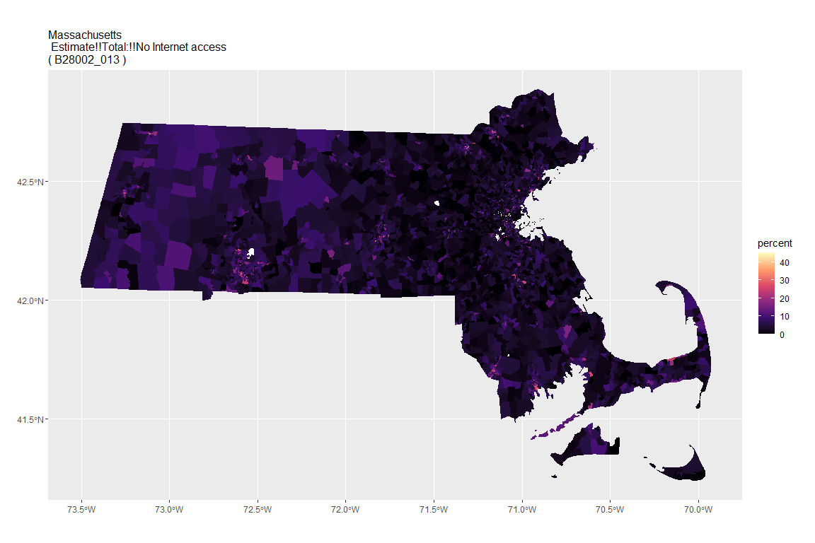

# # Image list:  
# suffolk_images <- list()  
#   
# # Loop to generate images:  
# for (the_var in internet_variables_noE){  
# # Get variable description:  
# var_des <- variable_descriptions$label[variable_descriptions$name==the_var]  
# # Make plot:  
# suffolk_images[[the_var]] <- data_against_summary_suffolk %>%   
# filter(variable==the_var) %>%   
# ggplot(aes(fill=percent)) +  
# geom_sf(color=NA) +  
# coord_sf(crs=26911) +  
# scale_fill_viridis_c(option = "magma", na.value="white") +  
# ggtitle(paste("Suffolk County\n", var_des, " \n(", the_var, ")")) +  
# theme(plot.title=element_text(size=12),  
# plot.margin=unit(c(0.25, 0.25, 0.25, 0.25), "in"))  
# # Plot image:  
# print(suffolk_images[[the_var]])  
# }

# Do for all counties:  
# Initialize list to store images:  
county_images = list()  
for (county in county_vector){  
 cat("For county: ", county, "\n")  
 # Get county data:  
 county_data <- get_acs(geography="block group", year=2019, state="MA", county=county,  
 variables=all_vars, geometry=TRUE, summary_var="B01003_001")  
 # Divide estimates by summary:  
 county_data$percent <- (county_data$estimate / county_data$summary_est) * 100  
 # Initalize list to store images:  
 county_images[[county]] = list()  
 # Loop to generate images:  
 for (the_var in internet_variables_noE){  
 var_des <- variable_descriptions$label[variable_descriptions$name==the_var]  
 cat("For variable: ", the_var, ": ", var_des, "\n")  
 # Make plot:  
 county_images[[county]][[the_var]] <- county_data %>%   
 filter(variable==the_var) %>%   
 ggplot(aes(fill=percent)) +  
 geom_sf(color=NA) +  
 coord_sf(crs=4326) +  
 scale_fill_viridis_c(option = "magma", na.value="white") +  
 ggtitle(paste(county, "\n", var_des, " \n(", the_var, ")")) +  
 theme(plot.title=element_text(size=12),  
 plot.margin=unit(c(0.25, 0.25, 0.25, 0.25), "in"))  
 # Plot image:  
 print(county_images[[county]][[the_var]])  
 }  
   
}

## For county: Barnstable County

## Getting data from the 2015-2019 5-year ACS

## Downloading feature geometry from the Census website. To cache shapefiles for use in future sessions, set `options(tigris_use_cache = TRUE)`.

## For variable: B28002_001 : Estimate!!Total:

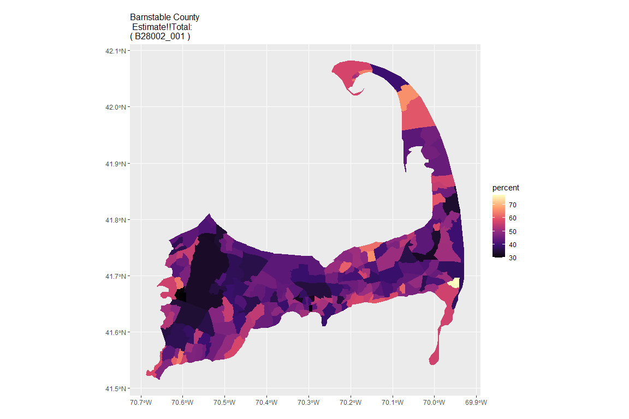

## For variable: B28002_002 : Estimate!!Total:!!With an Internet subscription

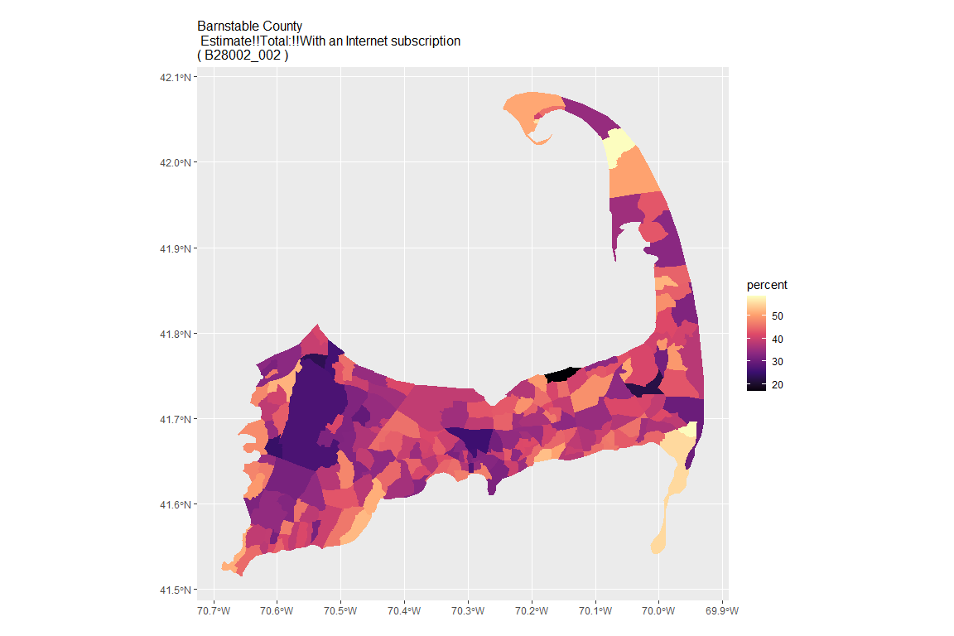

## For variable: B28002_003 : Estimate!!Total:!!With an Internet subscription!!Dial-up with no other type of Internet subscription

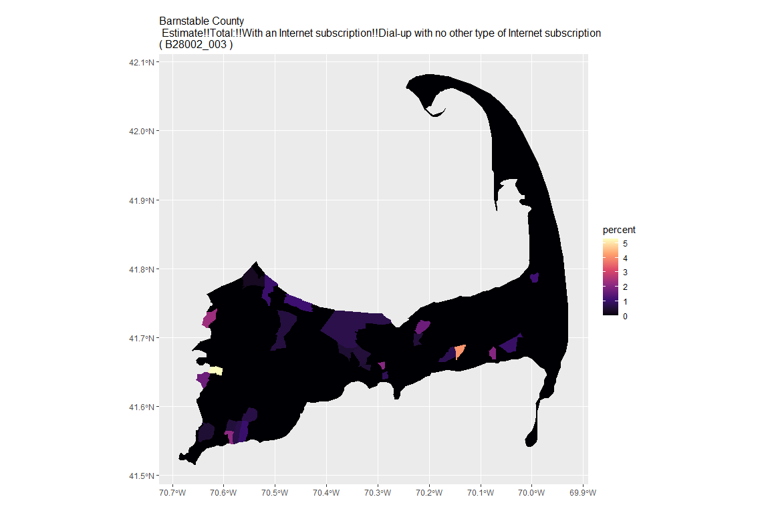

## For variable: B28002_004 : Estimate!!Total:!!With an Internet subscription!!Broadband of any type

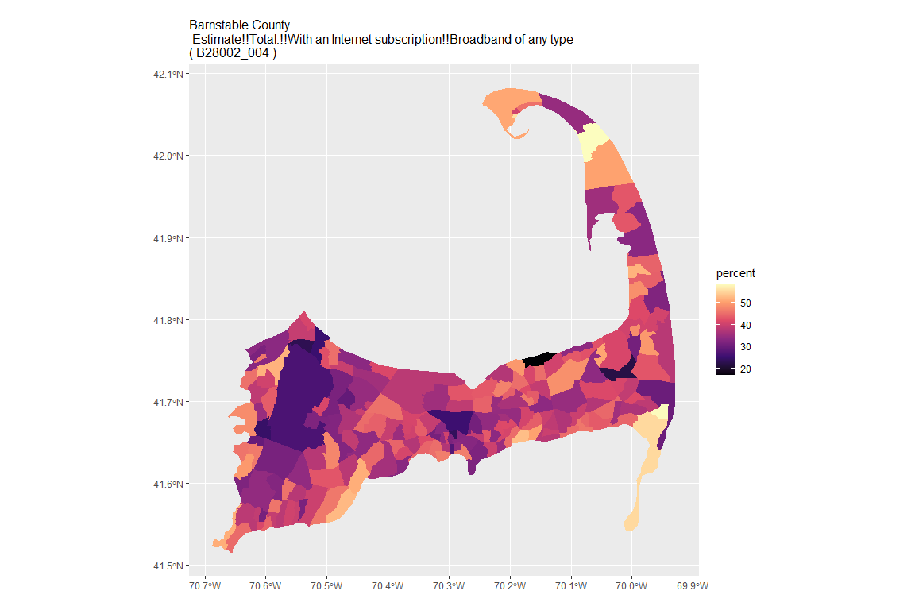

## For variable: B28002_005 : Estimate!!Total:!!With an Internet subscription!!Cellular data plan

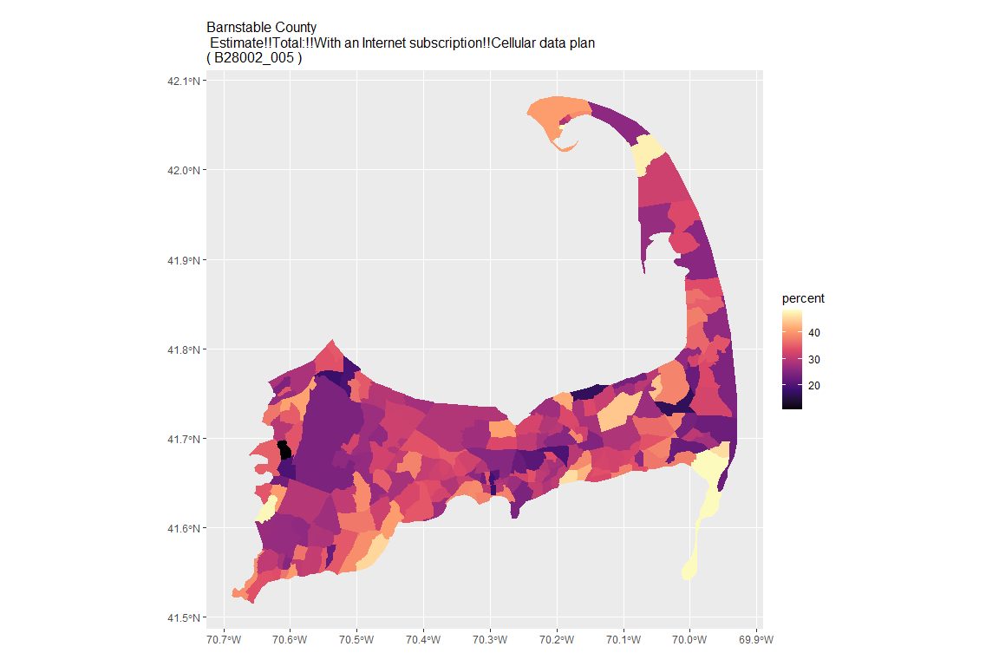

## For variable: B28002_006 : Estimate!!Total:!!With an Internet subscription!!Cellular data plan!!Cellular data plan with no other type of Internet subscription

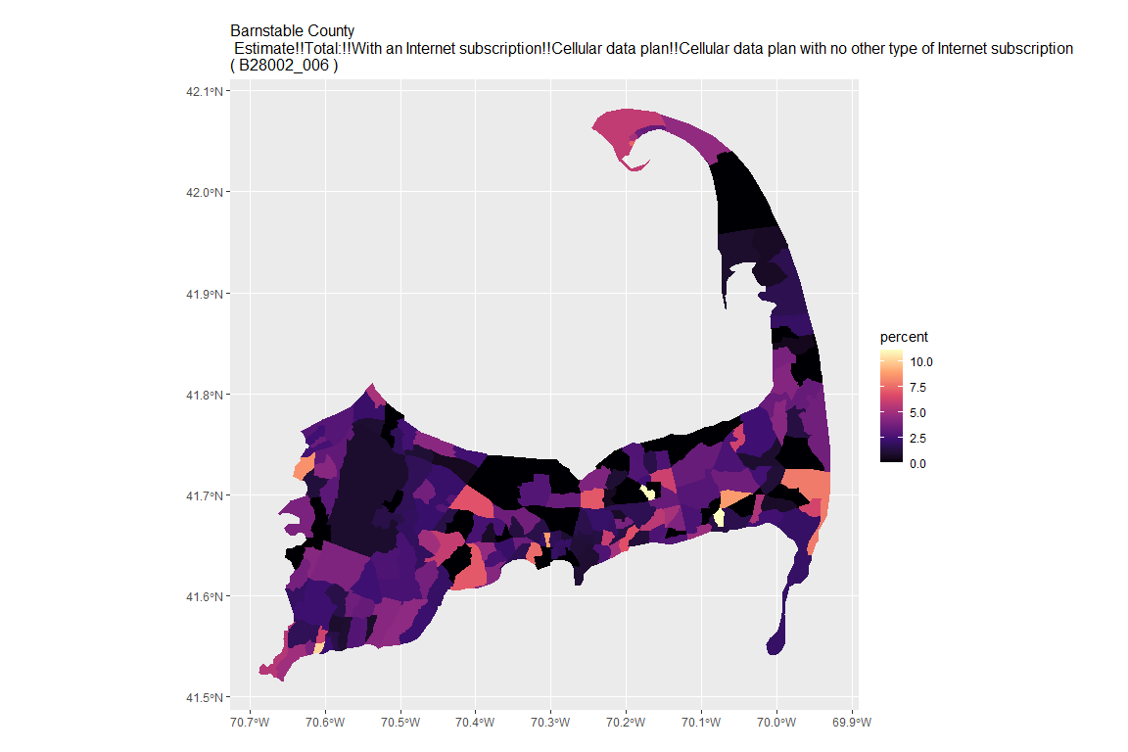

## For variable: B28002_007 : Estimate!!Total:!!With an Internet subscription!!Broadband such as cable, fiber optic or DSL

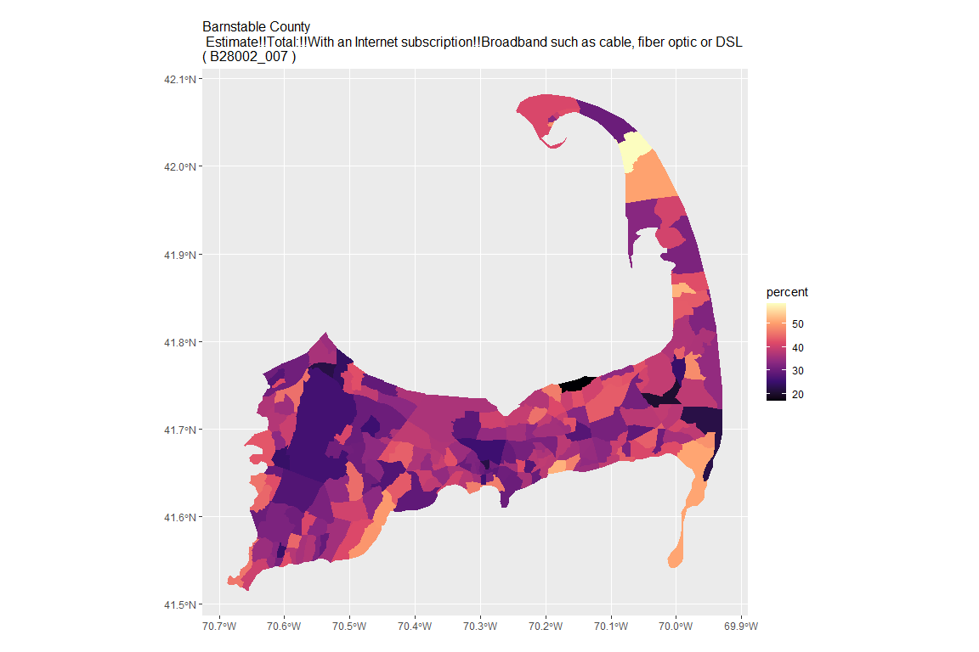

## For variable: B28002_008 : Estimate!!Total:!!With an Internet subscription!!Broadband such as cable, fiber optic or DSL!!Broadband such as cable, fiber optic or DSL with no other type of Internet subscription

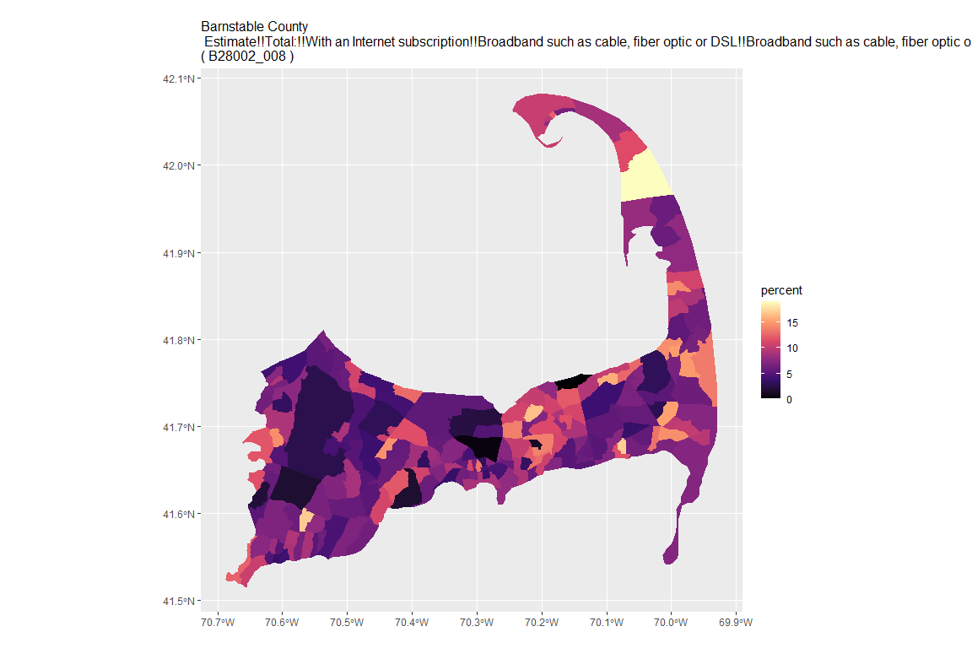

## For variable: B28002_009 : Estimate!!Total:!!With an Internet subscription!!Satellite Internet service

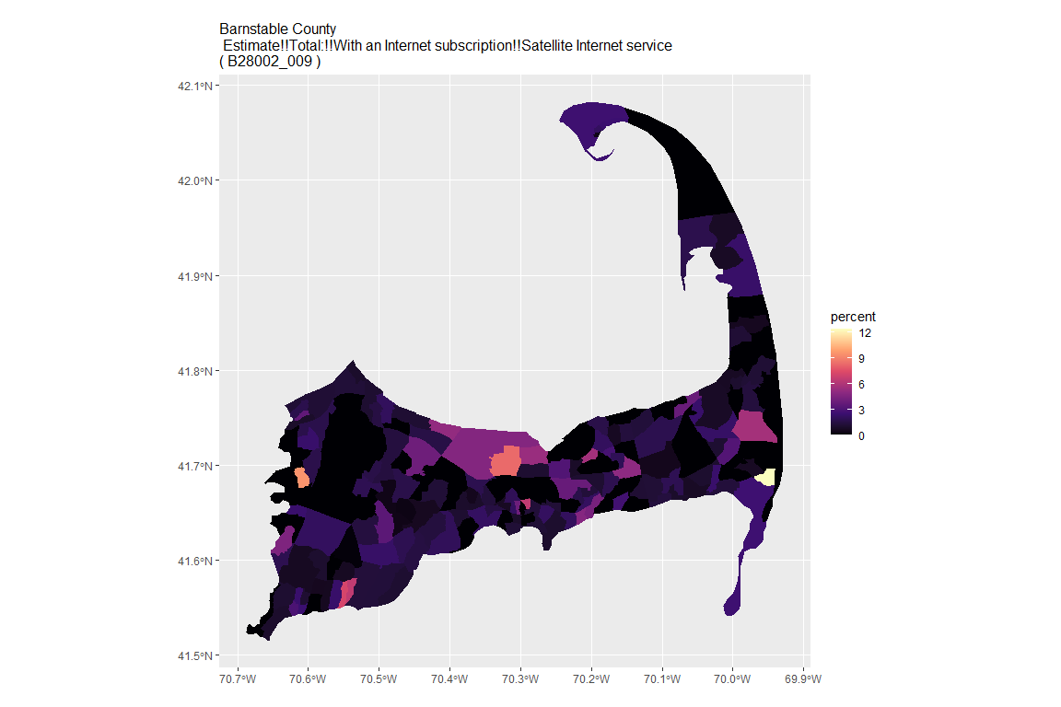

## For variable: B28002_010 : Estimate!!Total:!!With an Internet subscription!!Satellite Internet service!!Satellite Internet service with no other type of Internet subscription

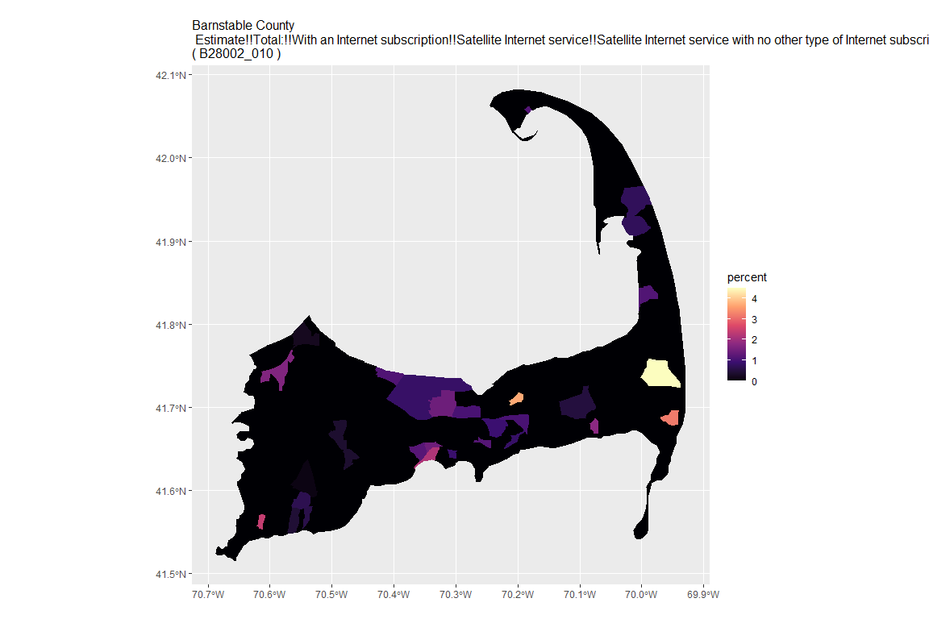

## For variable: B28002_011 : Estimate!!Total:!!With an Internet subscription!!Other service with no other type of Internet subscription

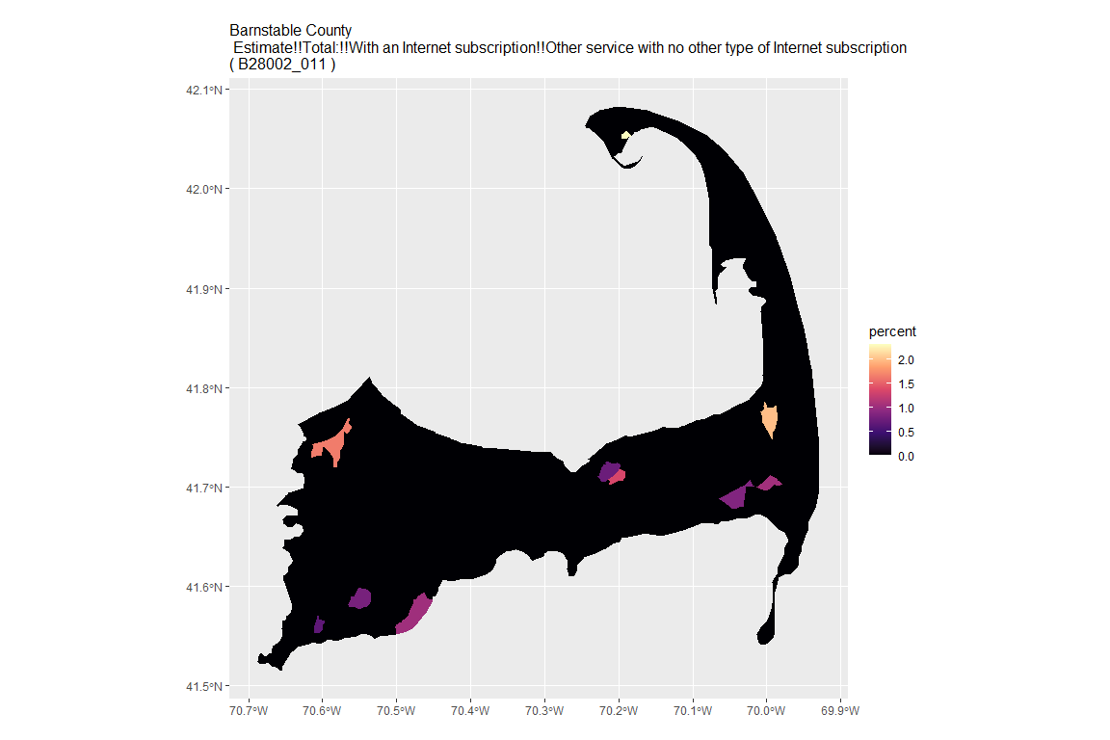

## For variable: B28002_012 : Estimate!!Total:!!Internet access without a subscription

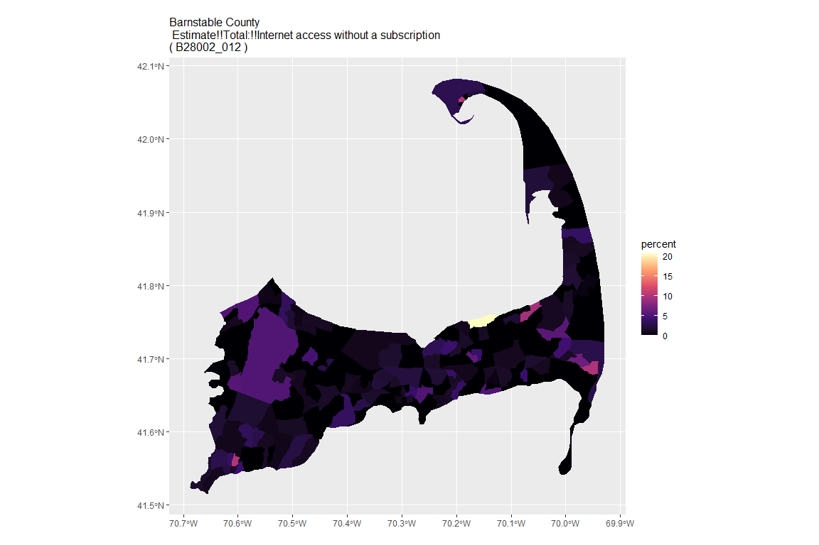

## For variable: B28002_013 : Estimate!!Total:!!No Internet access

## For county: Berkshire County

## Getting data from the 2015-2019 5-year ACS  
## Downloading feature geometry from the Census website. To cache shapefiles for use in future sessions, set `options(tigris_use_cache = TRUE)`.

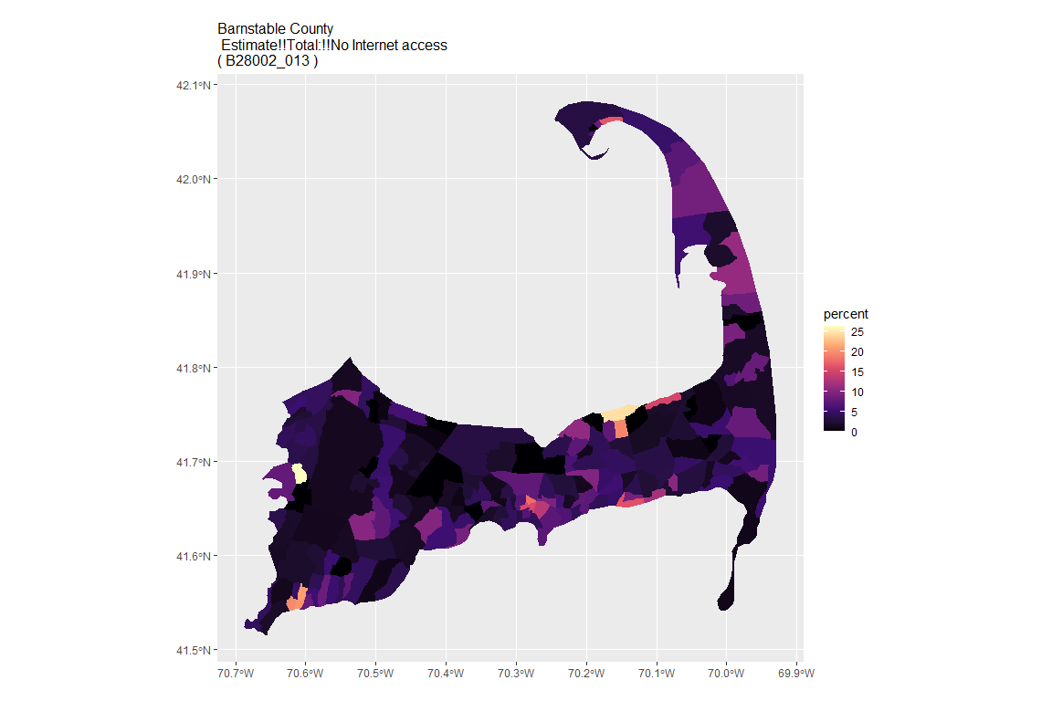

## For variable: B28002_001 : Estimate!!Total:

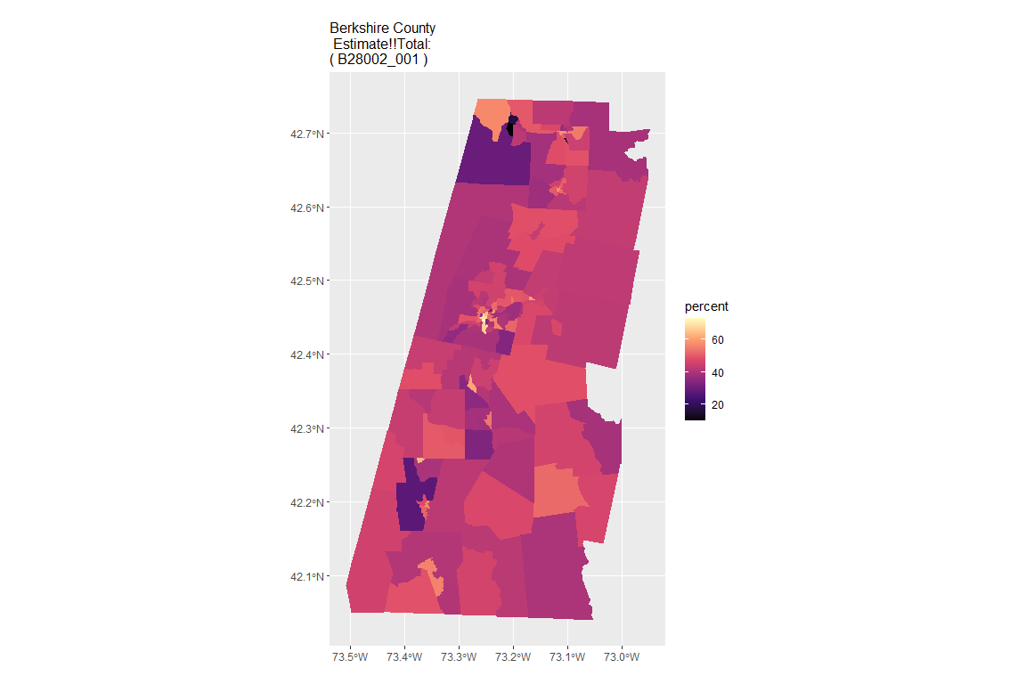

## For variable: B28002_002 : Estimate!!Total:!!With an Internet subscription

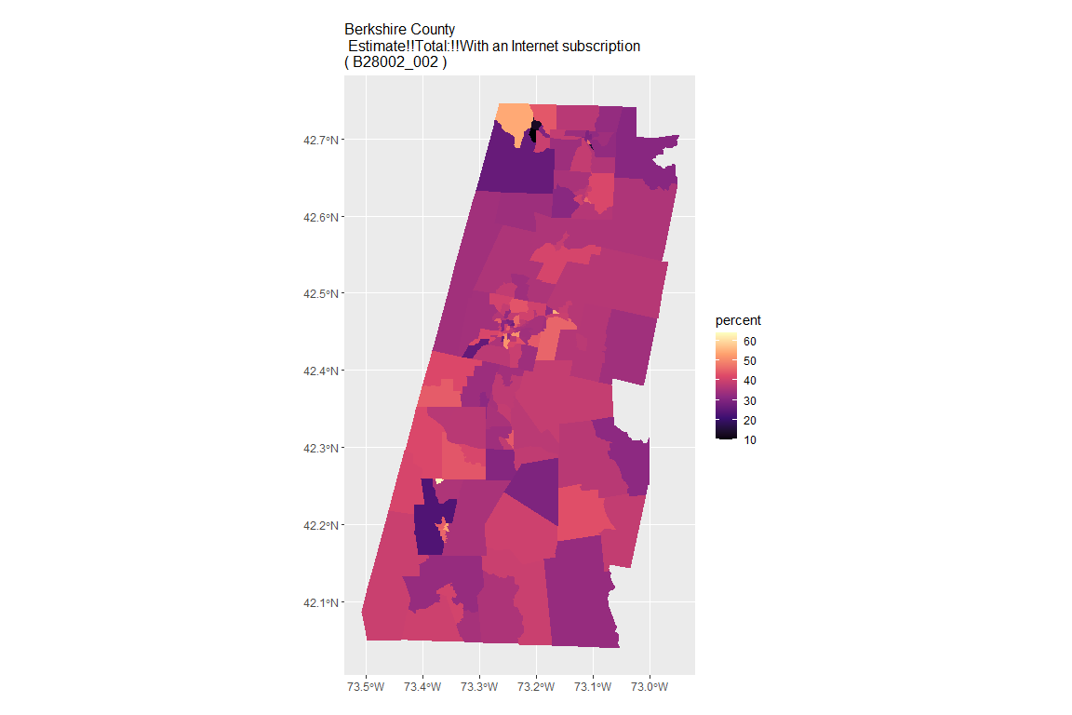

## For variable: B28002_003 : Estimate!!Total:!!With an Internet subscription!!Dial-up with no other type of Internet subscription

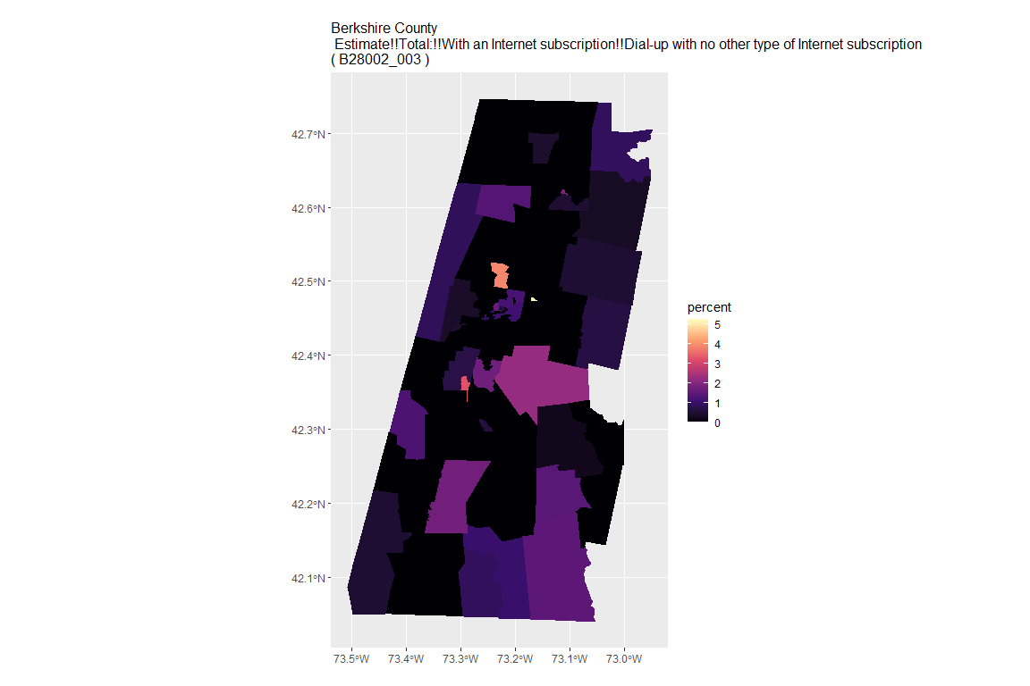

## For variable: B28002_004 : Estimate!!Total:!!With an Internet subscription!!Broadband of any type

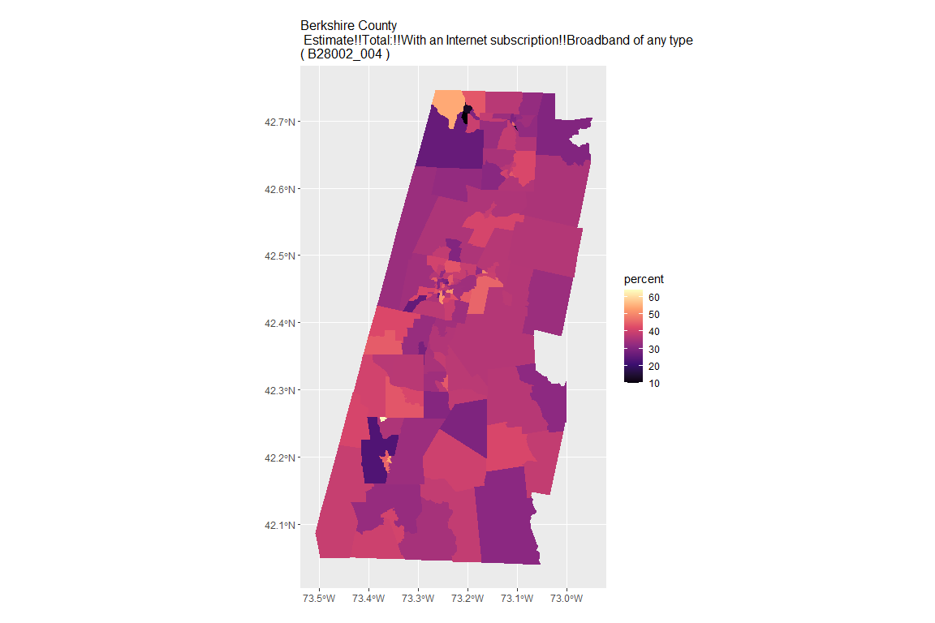

## For variable: B28002_005 : Estimate!!Total:!!With an Internet subscription!!Cellular data plan

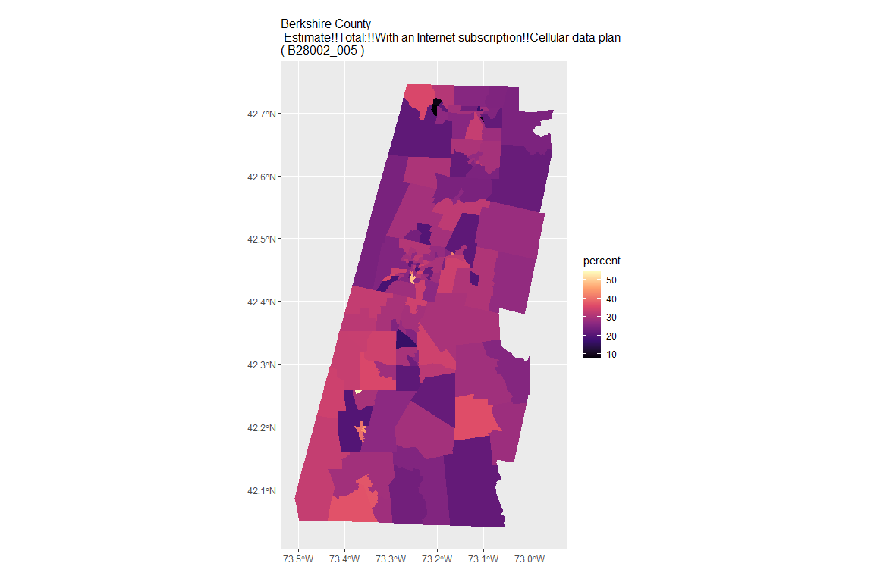

## For variable: B28002_006 : Estimate!!Total:!!With an Internet subscription!!Cellular data plan!!Cellular data plan with no other type of Internet subscription

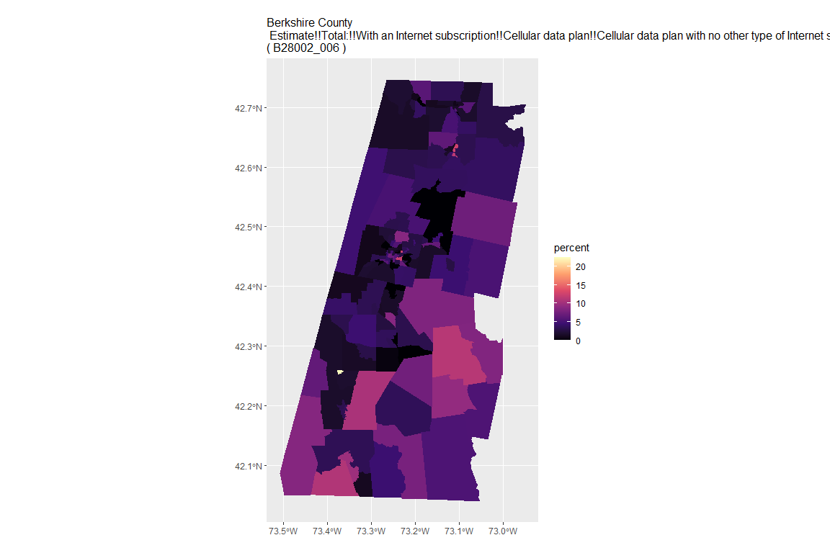

## For variable: B28002_007 : Estimate!!Total:!!With an Internet subscription!!Broadband such as cable, fiber optic or DSL

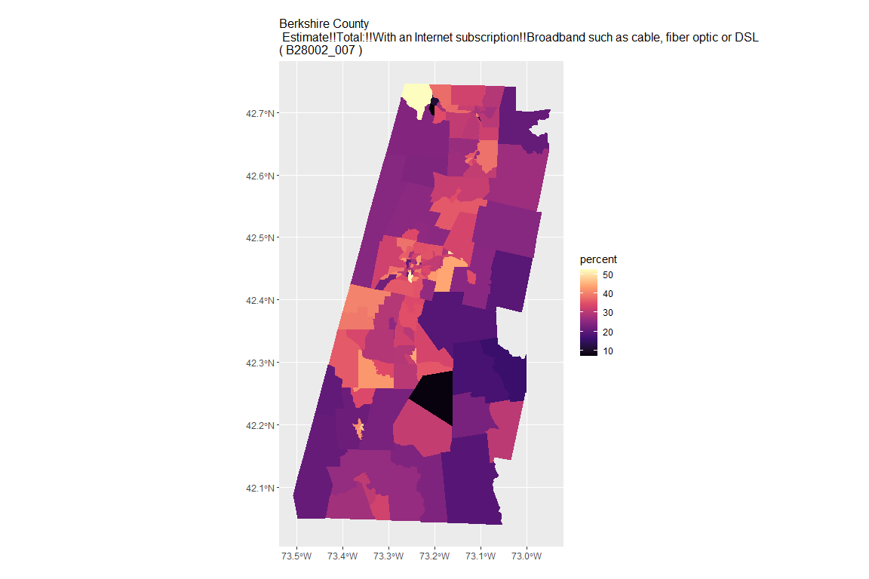

## For variable: B28002_008 : Estimate!!Total:!!With an Internet subscription!!Broadband such as cable, fiber optic or DSL!!Broadband such as cable, fiber optic or DSL with no other type of Internet subscription

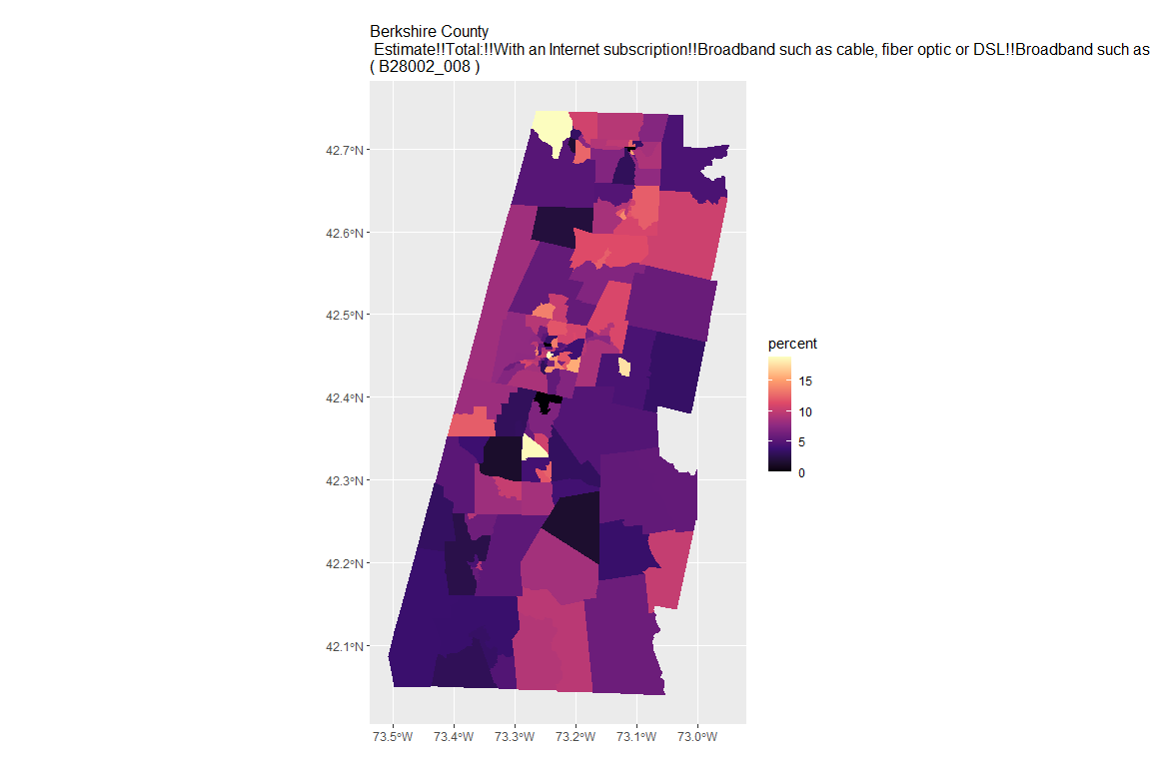

## For variable: B28002_009 : Estimate!!Total:!!With an Internet subscription!!Satellite Internet service

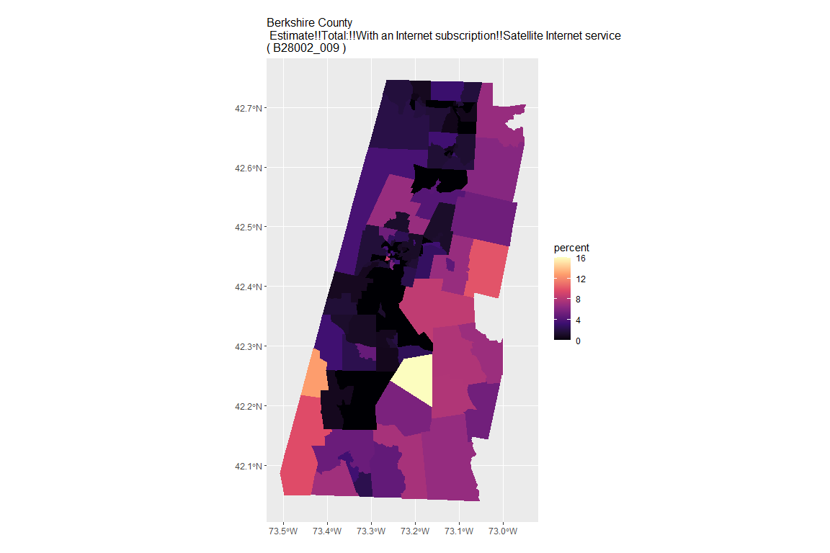

## For variable: B28002_010 : Estimate!!Total:!!With an Internet subscription!!Satellite Internet service!!Satellite Internet service with no other type of Internet subscription

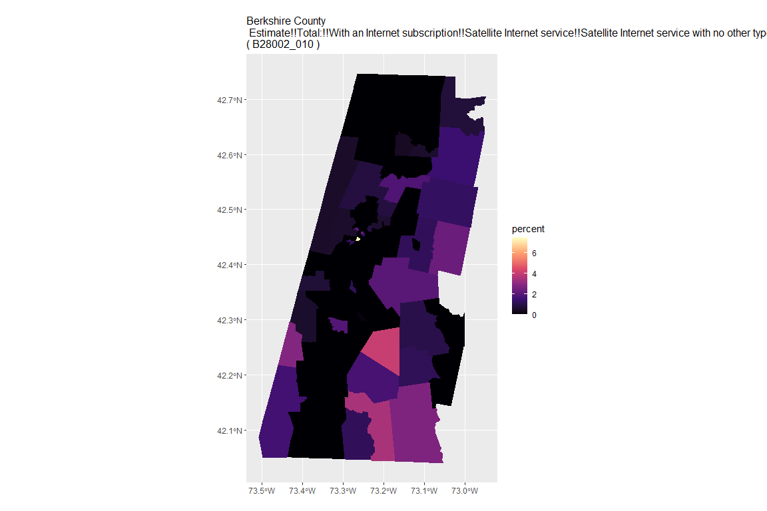

## For variable: B28002_011 : Estimate!!Total:!!With an Internet subscription!!Other service with no other type of Internet subscription

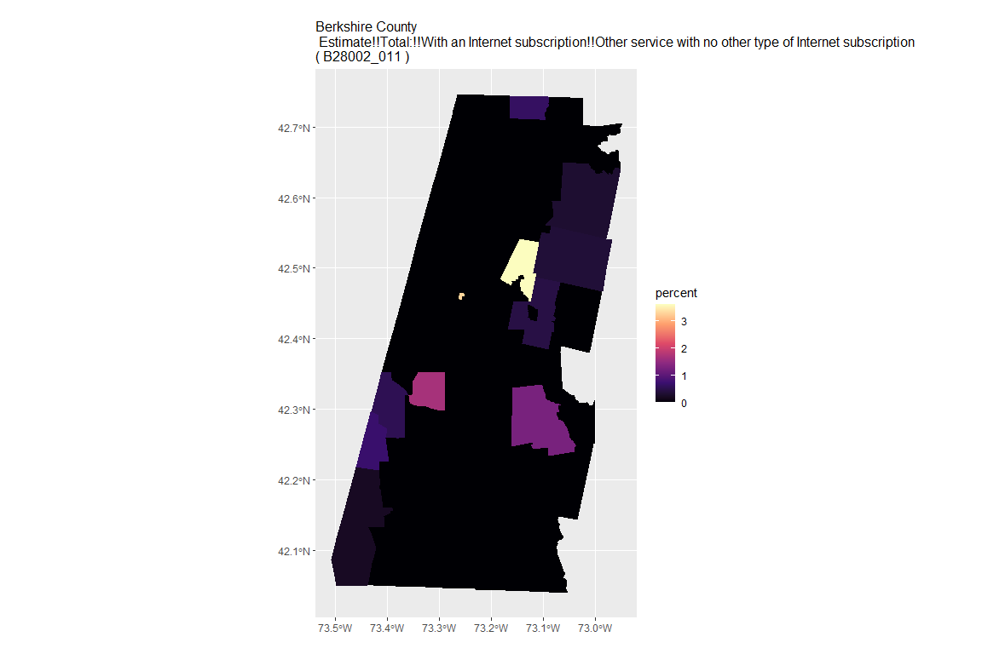

## For variable: B28002_012 : Estimate!!Total:!!Internet access without a subscription

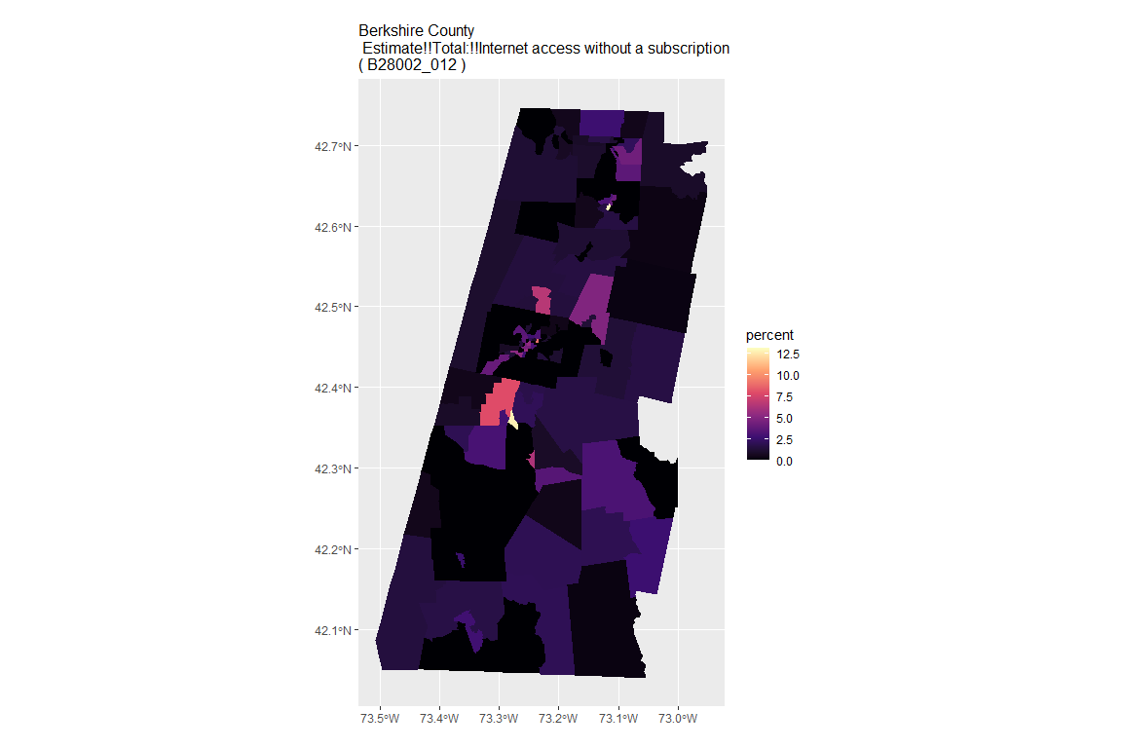

## For variable: B28002_013 : Estimate!!Total:!!No Internet access

## For county: Bristol County

## Getting data from the 2015-2019 5-year ACS  
## Downloading feature geometry from the Census website. To cache shapefiles for use in future sessions, set `options(tigris_use_cache = TRUE)`.

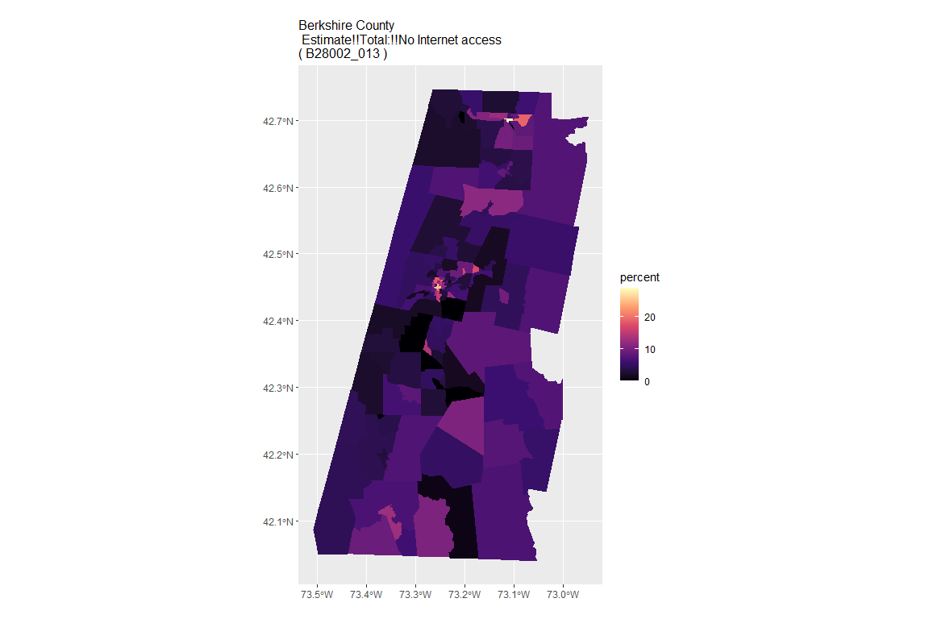

## For variable: B28002_001 : Estimate!!Total:

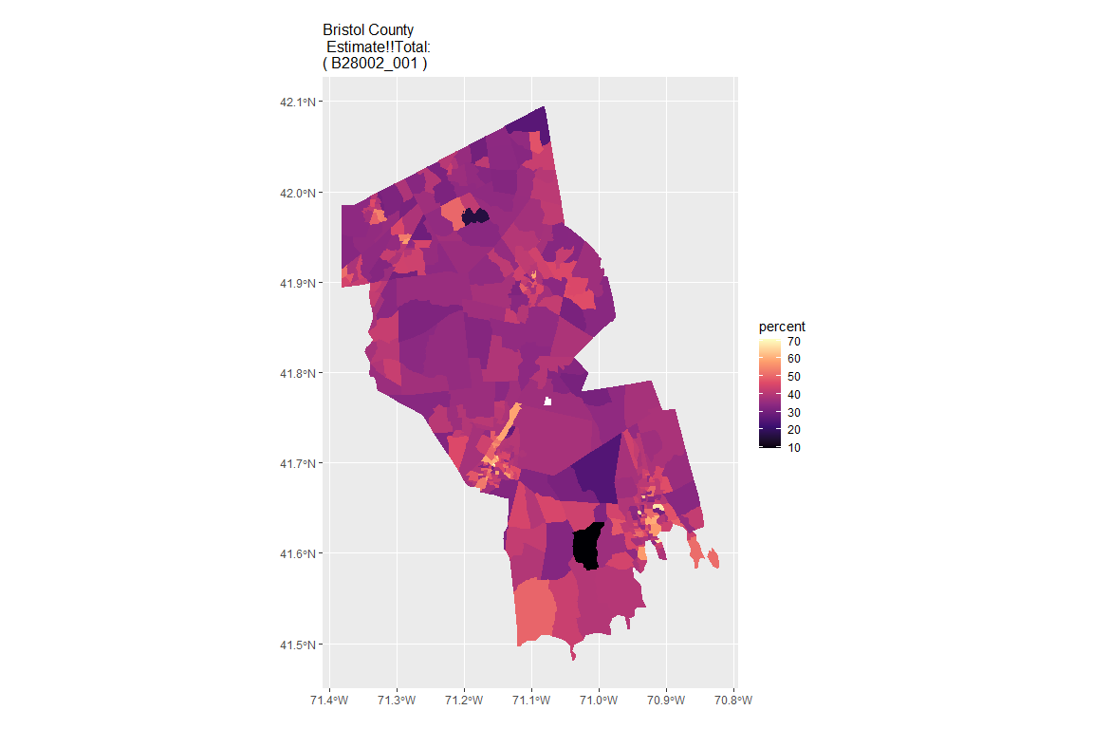

## For variable: B28002_002 : Estimate!!Total:!!With an Internet subscription

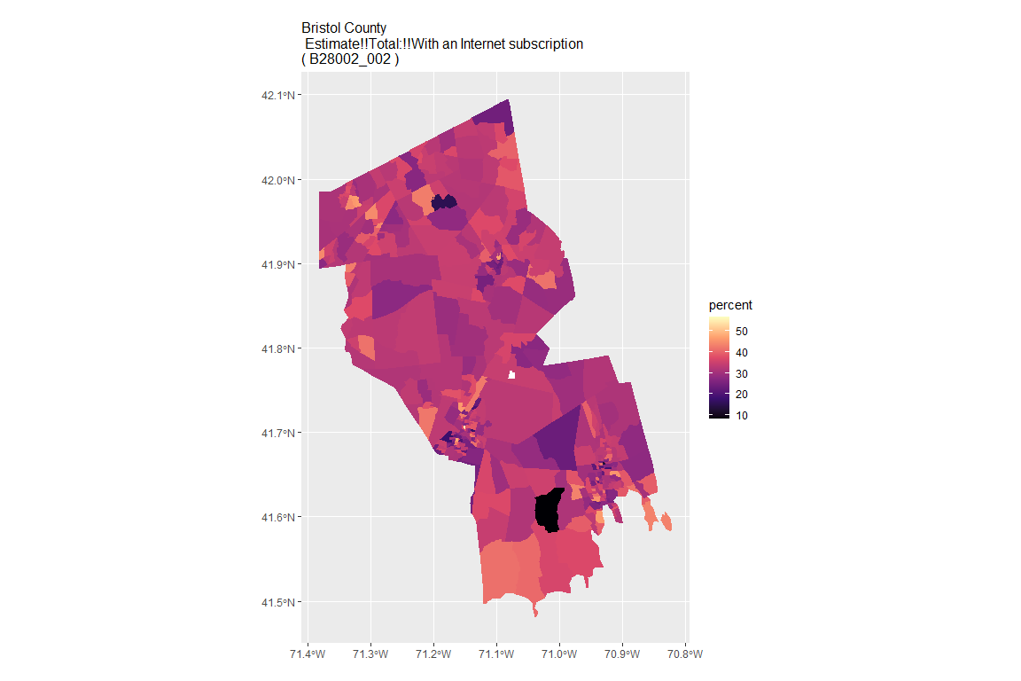

## For variable: B28002_003 : Estimate!!Total:!!With an Internet subscription!!Dial-up with no other type of Internet subscription

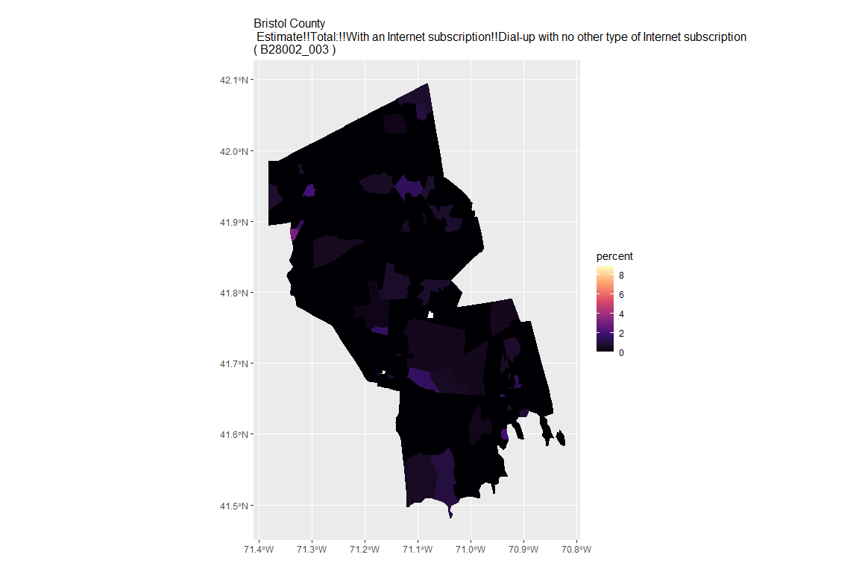

## For variable: B28002_004 : Estimate!!Total:!!With an Internet subscription!!Broadband of any type

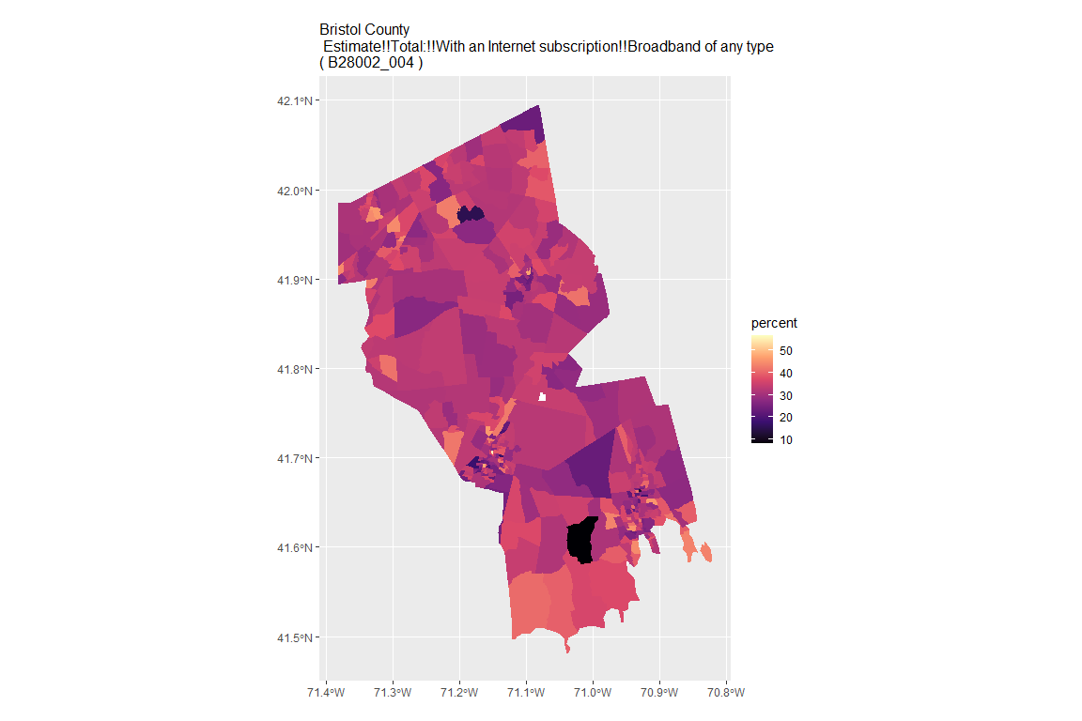

## For variable: B28002_005 : Estimate!!Total:!!With an Internet subscription!!Cellular data plan

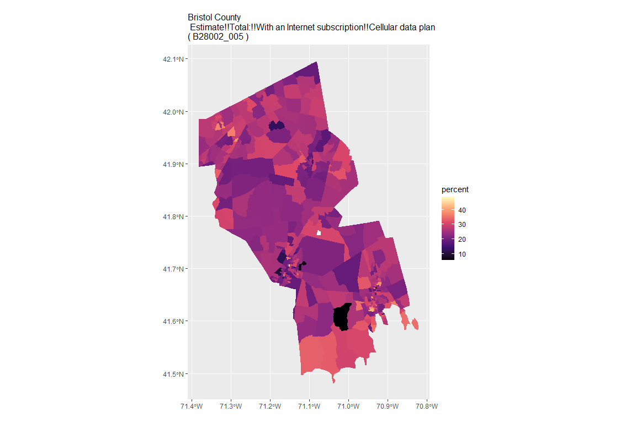

## For variable: B28002_006 : Estimate!!Total:!!With an Internet subscription!!Cellular data plan!!Cellular data plan with no other type of Internet subscription

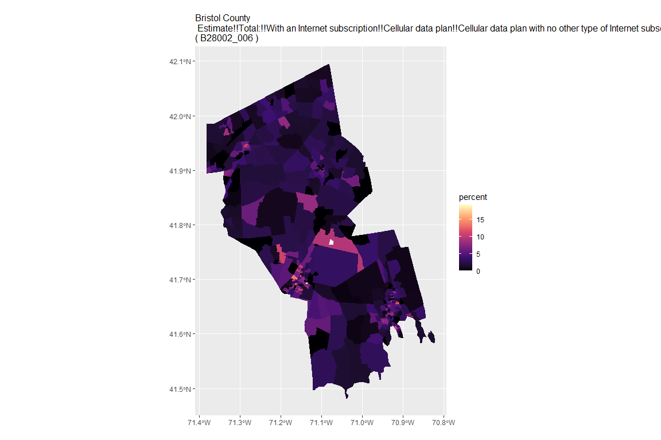

## For variable: B28002_007 : Estimate!!Total:!!With an Internet subscription!!Broadband such as cable, fiber optic or DSL

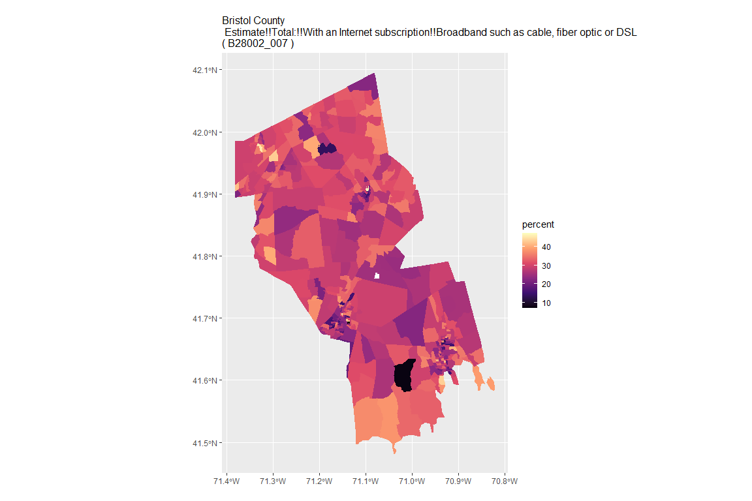

## For variable: B28002_008 : Estimate!!Total:!!With an Internet subscription!!Broadband such as cable, fiber optic or DSL!!Broadband such as cable, fiber optic or DSL with no other type of Internet subscription

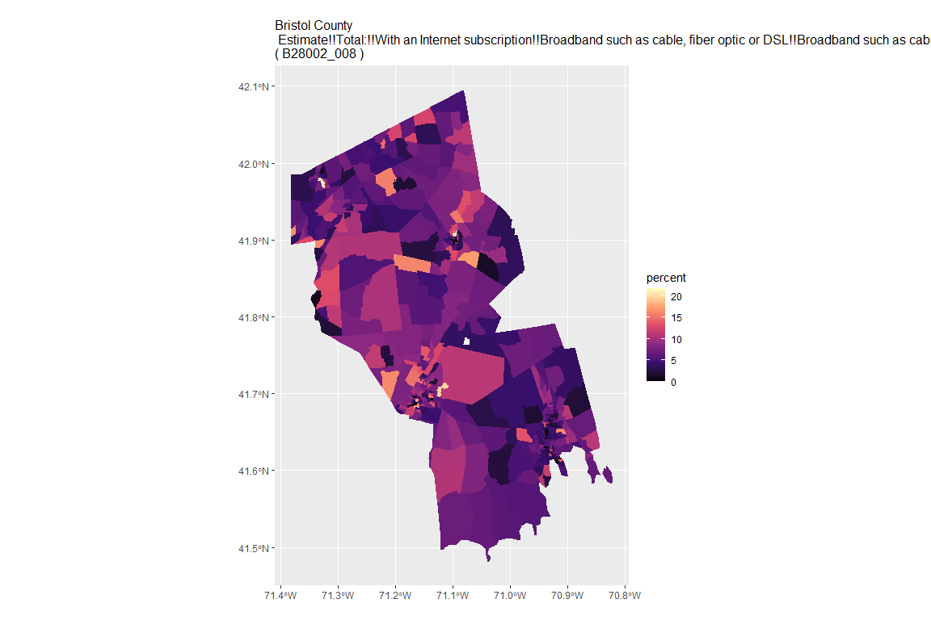

## For variable: B28002_009 : Estimate!!Total:!!With an Internet subscription!!Satellite Internet service

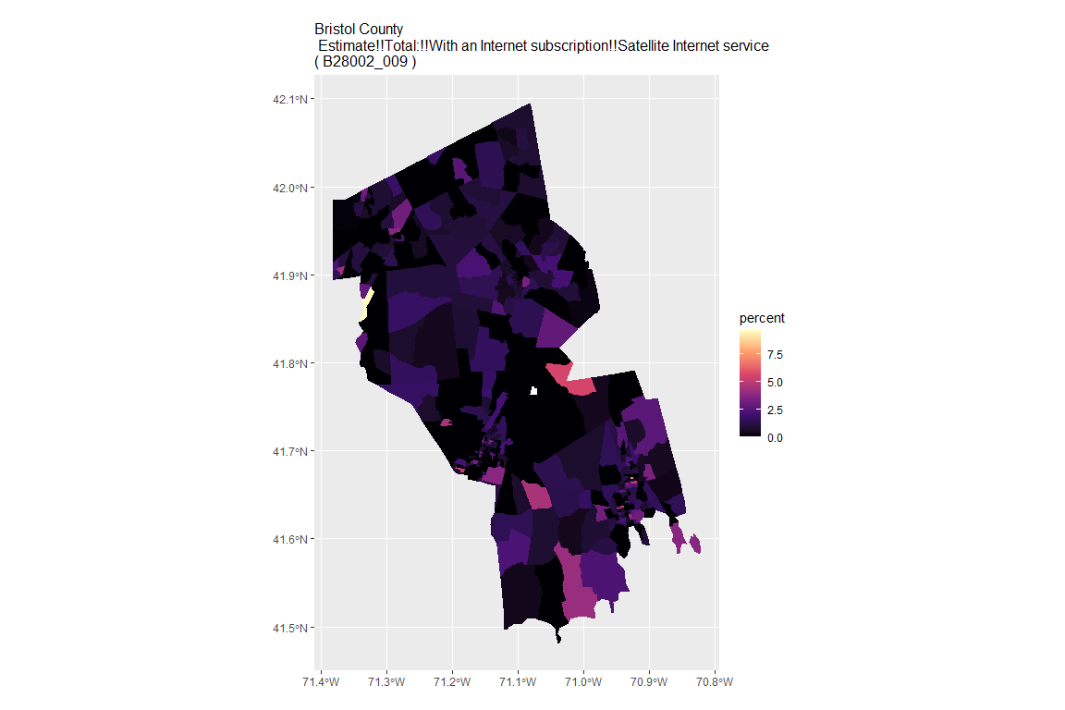

## For variable: B28002_010 : Estimate!!Total:!!With an Internet subscription!!Satellite Internet service!!Satellite Internet service with no other type of Internet subscription

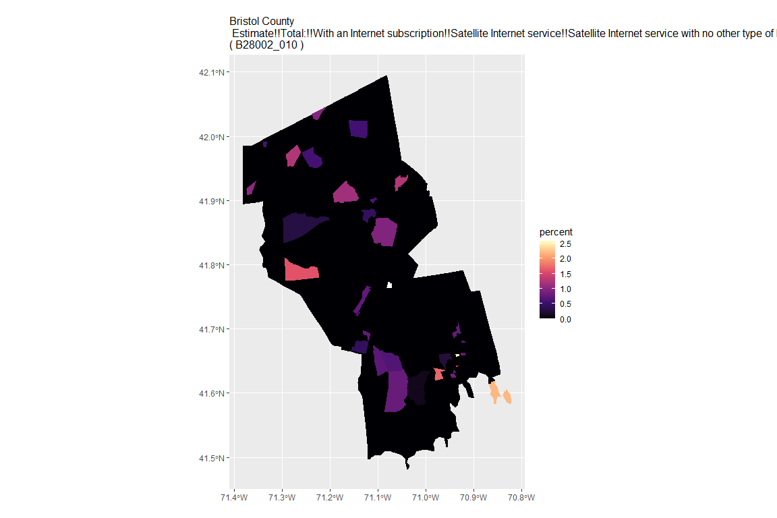

## For variable: B28002_011 : Estimate!!Total:!!With an Internet subscription!!Other service with no other type of Internet subscription

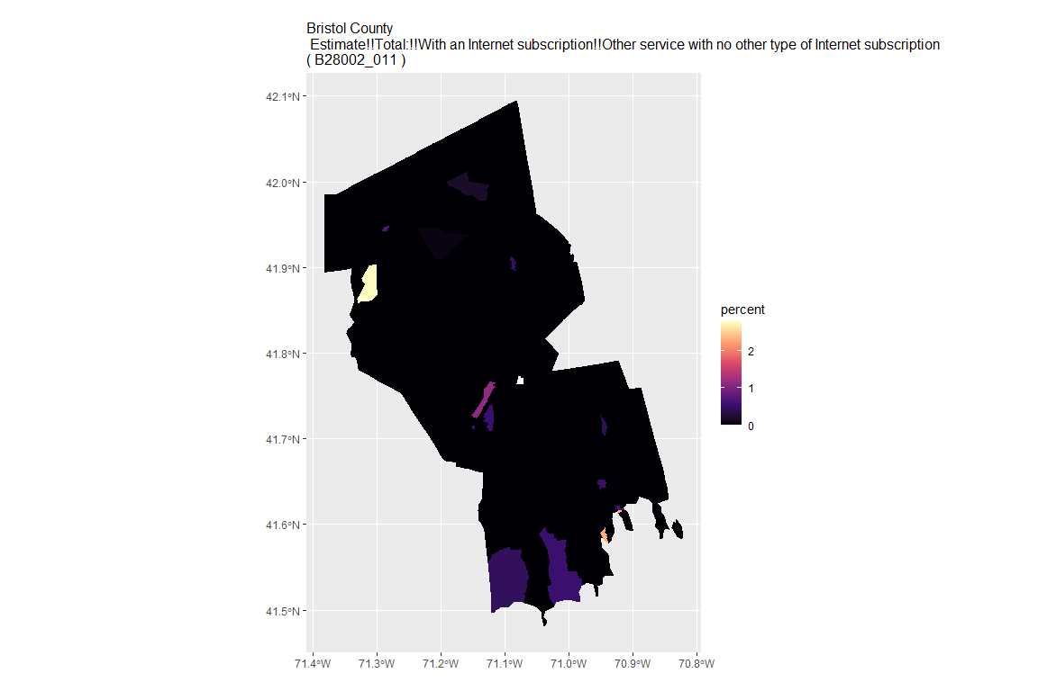

## For variable: B28002_012 : Estimate!!Total:!!Internet access without a subscription

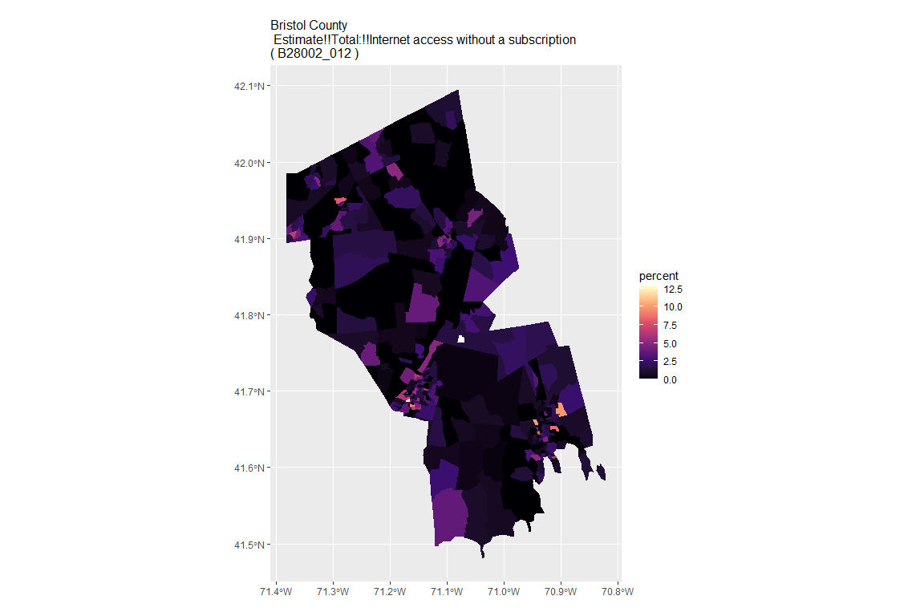

## For variable: B28002_013 : Estimate!!Total:!!No Internet access

## For county: Dukes County

## Getting data from the 2015-2019 5-year ACS  
## Downloading feature geometry from the Census website. To cache shapefiles for use in future sessions, set `options(tigris_use_cache = TRUE)`.

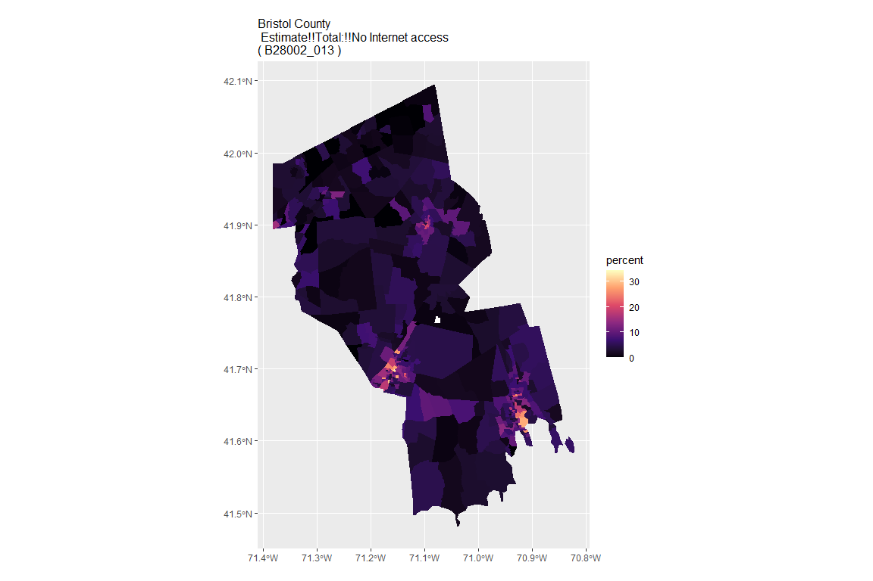

## For variable: B28002_001 : Estimate!!Total:

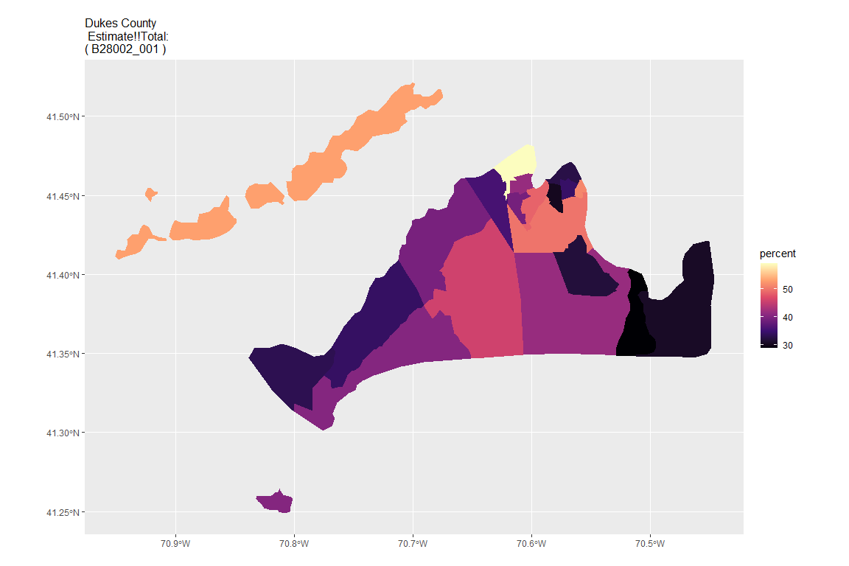

## For variable: B28002_002 : Estimate!!Total:!!With an Internet subscription

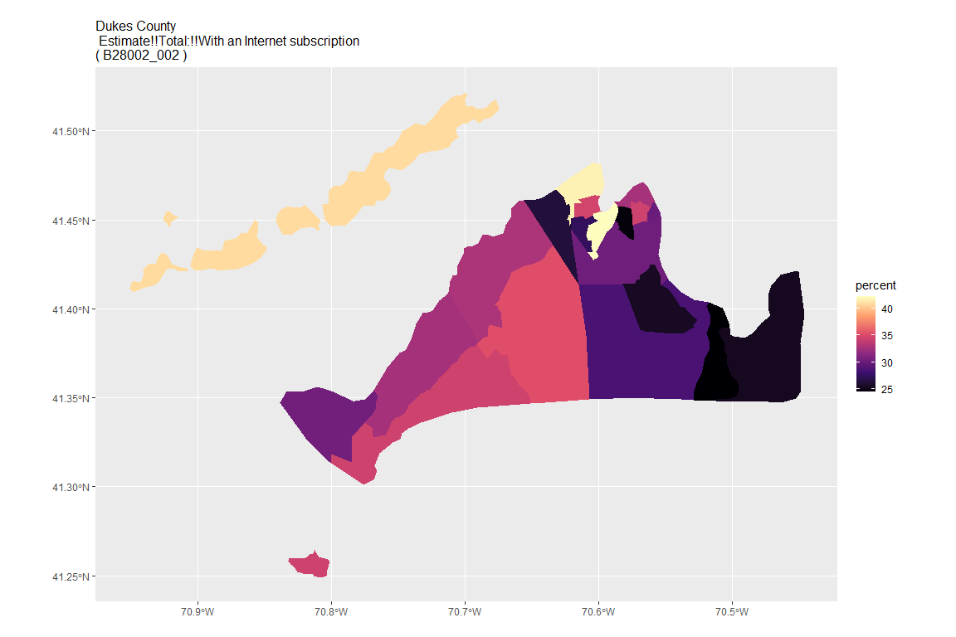

## For variable: B28002_003 : Estimate!!Total:!!With an Internet subscription!!Dial-up with no other type of Internet subscription

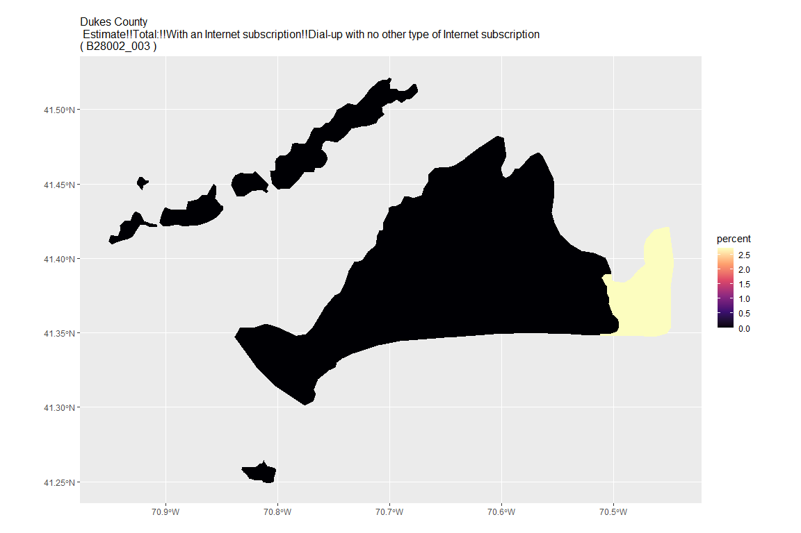

## For variable: B28002_004 : Estimate!!Total:!!With an Internet subscription!!Broadband of any type

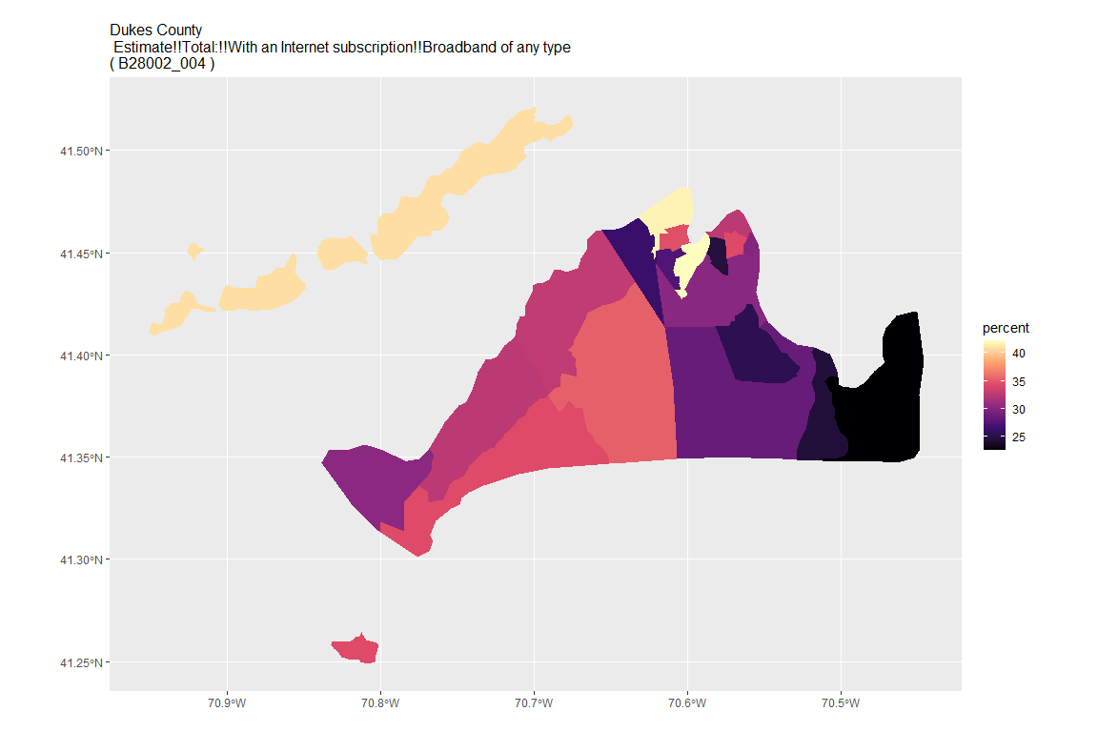

## For variable: B28002_005 : Estimate!!Total:!!With an Internet subscription!!Cellular data plan

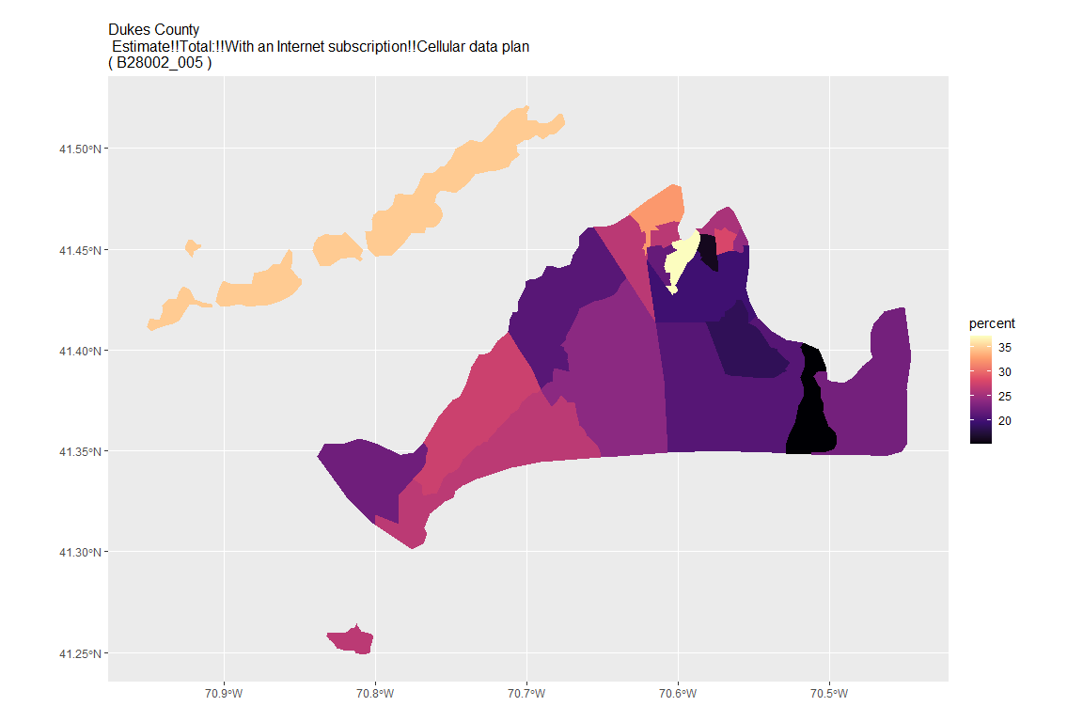

## For variable: B28002_006 : Estimate!!Total:!!With an Internet subscription!!Cellular data plan!!Cellular data plan with no other type of Internet subscription

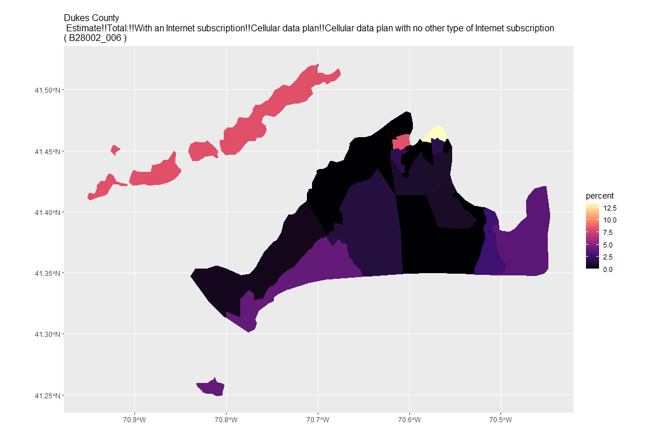

## For variable: B28002_007 : Estimate!!Total:!!With an Internet subscription!!Broadband such as cable, fiber optic or DSL

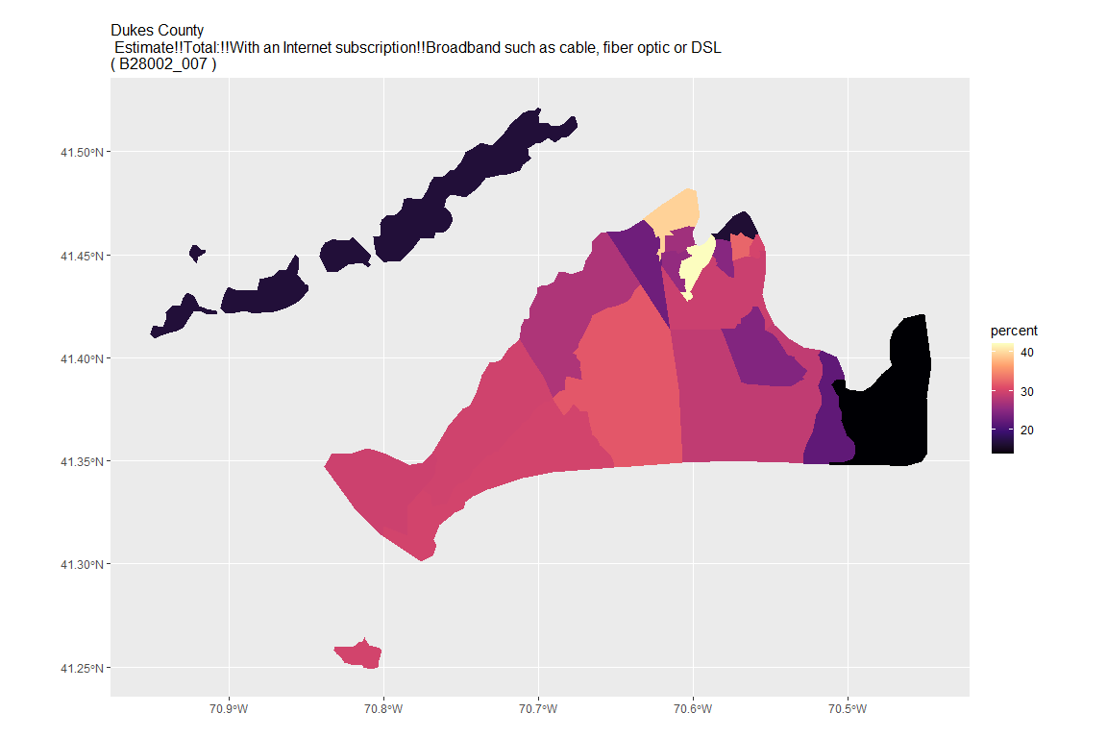

## For variable: B28002_008 : Estimate!!Total:!!With an Internet subscription!!Broadband such as cable, fiber optic or DSL!!Broadband such as cable, fiber optic or DSL with no other type of Internet subscription

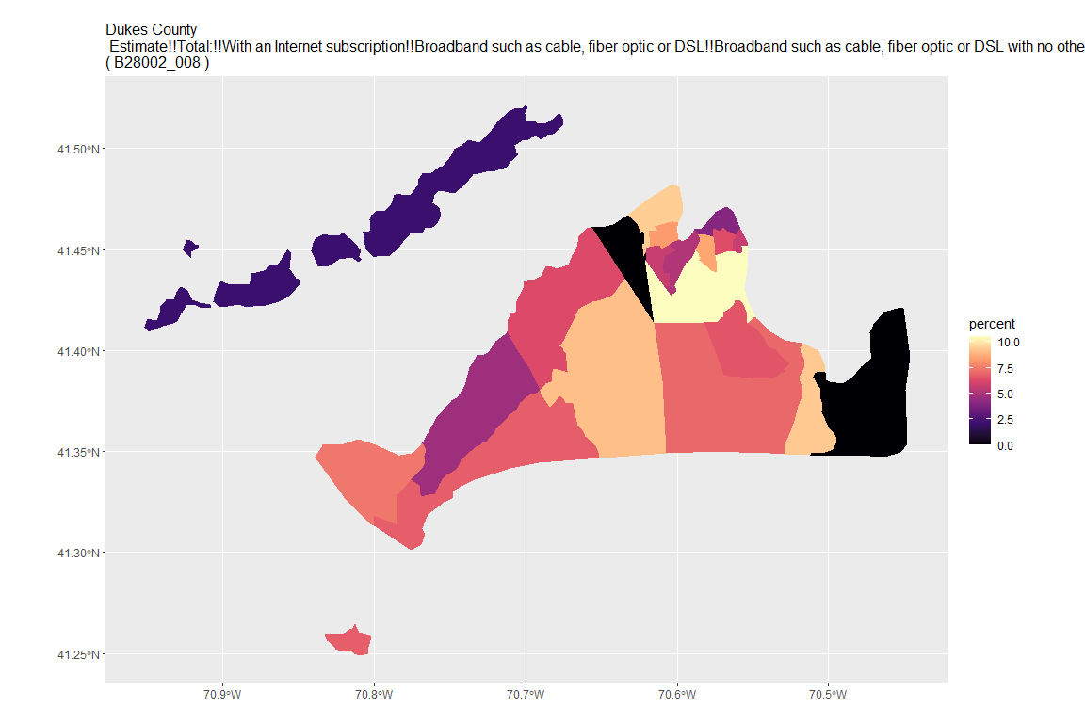

## For variable: B28002_009 : Estimate!!Total:!!With an Internet subscription!!Satellite Internet service

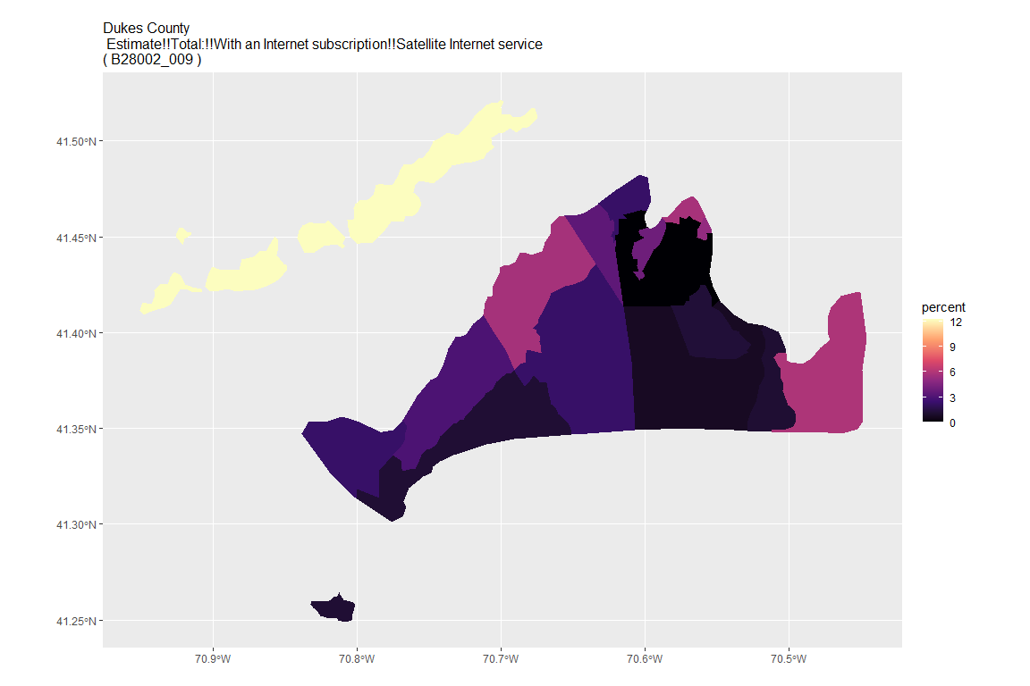

## For variable: B28002_010 : Estimate!!Total:!!With an Internet subscription!!Satellite Internet service!!Satellite Internet service with no other type of Internet subscription

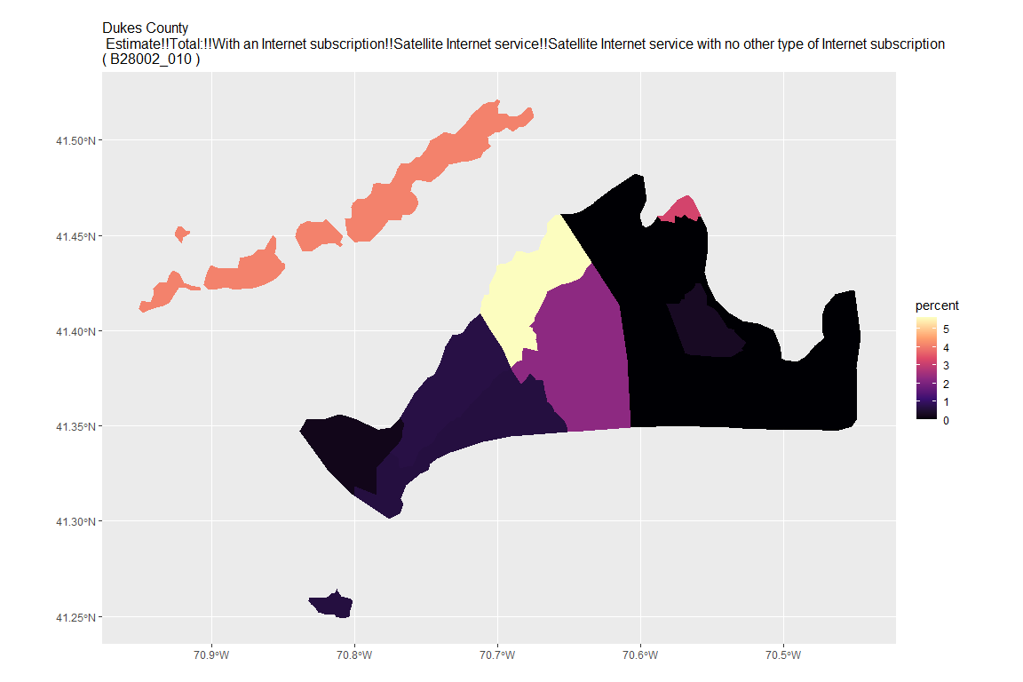

## For variable: B28002_011 : Estimate!!Total:!!With an Internet subscription!!Other service with no other type of Internet subscription

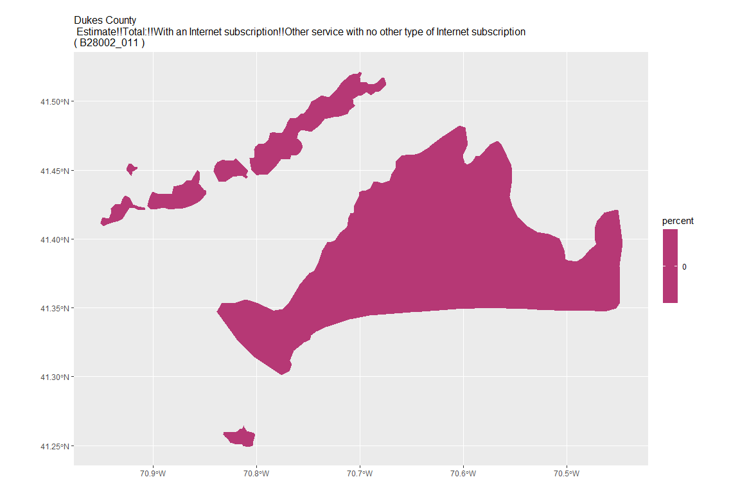

## For variable: B28002_012 : Estimate!!Total:!!Internet access without a subscription

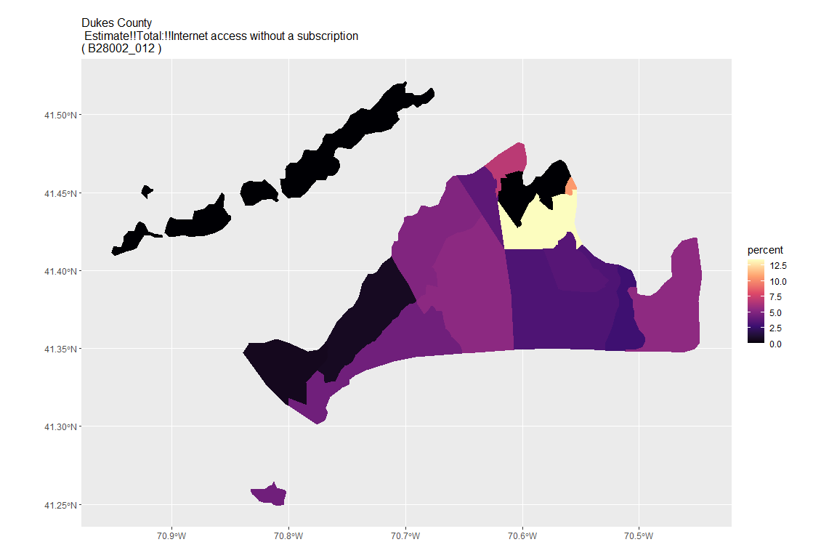

## For variable: B28002_013 : Estimate!!Total:!!No Internet access

## For county: Essex County

## Getting data from the 2015-2019 5-year ACS  
## Downloading feature geometry from the Census website. To cache shapefiles for use in future sessions, set `options(tigris_use_cache = TRUE)`.

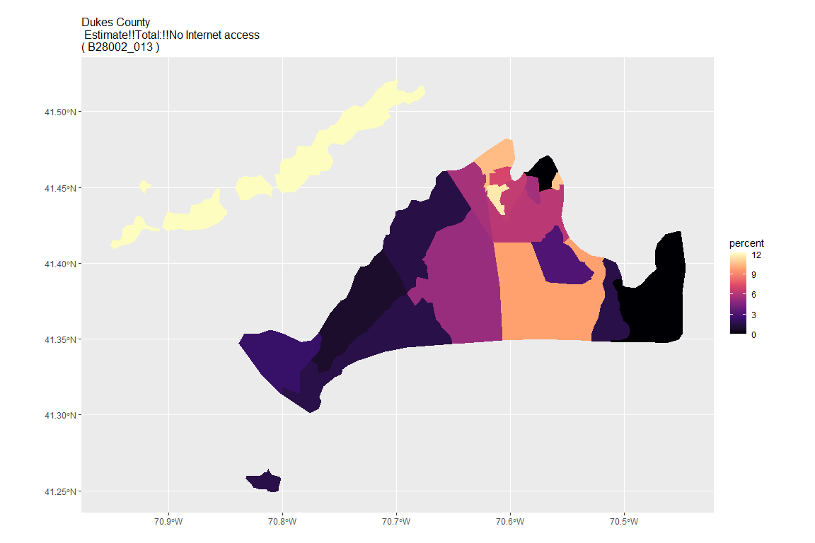

## For variable: B28002_001 : Estimate!!Total:

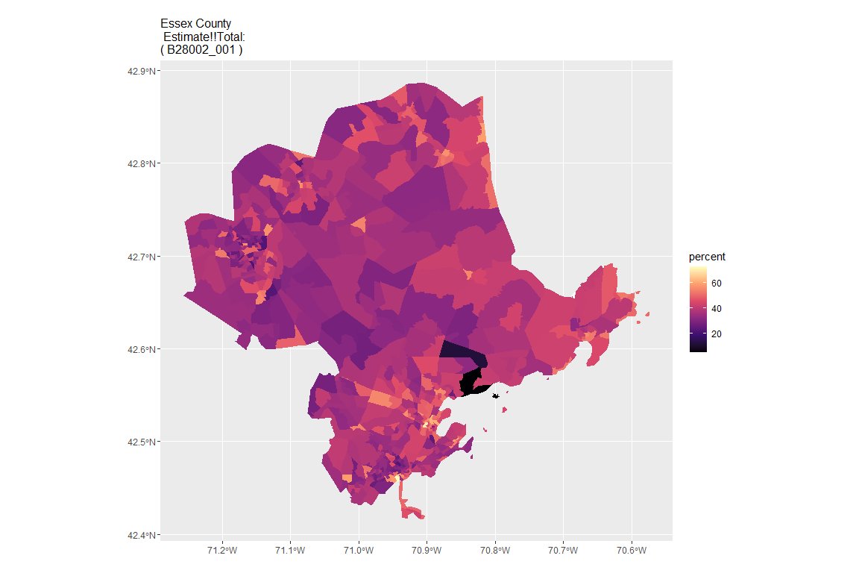

## For variable: B28002_002 : Estimate!!Total:!!With an Internet subscription

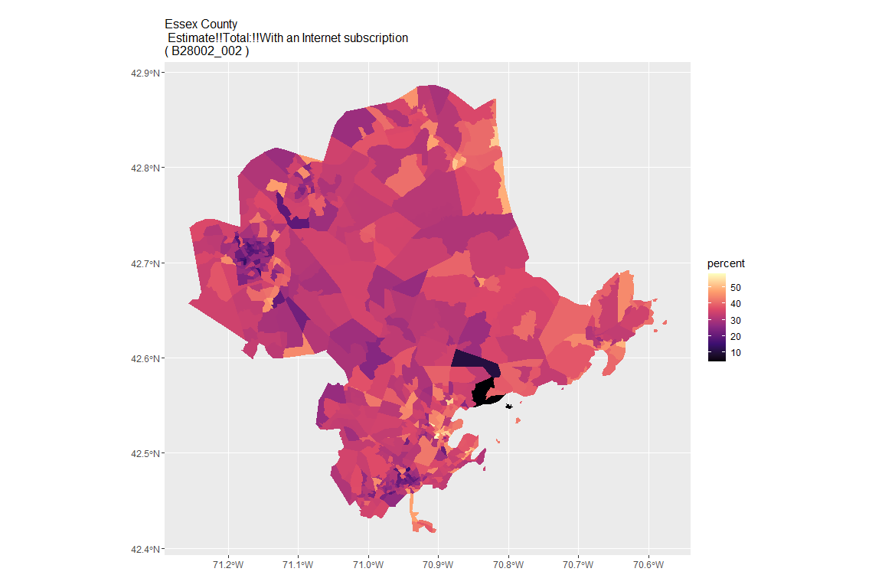

## For variable: B28002_003 : Estimate!!Total:!!With an Internet subscription!!Dial-up with no other type of Internet subscription

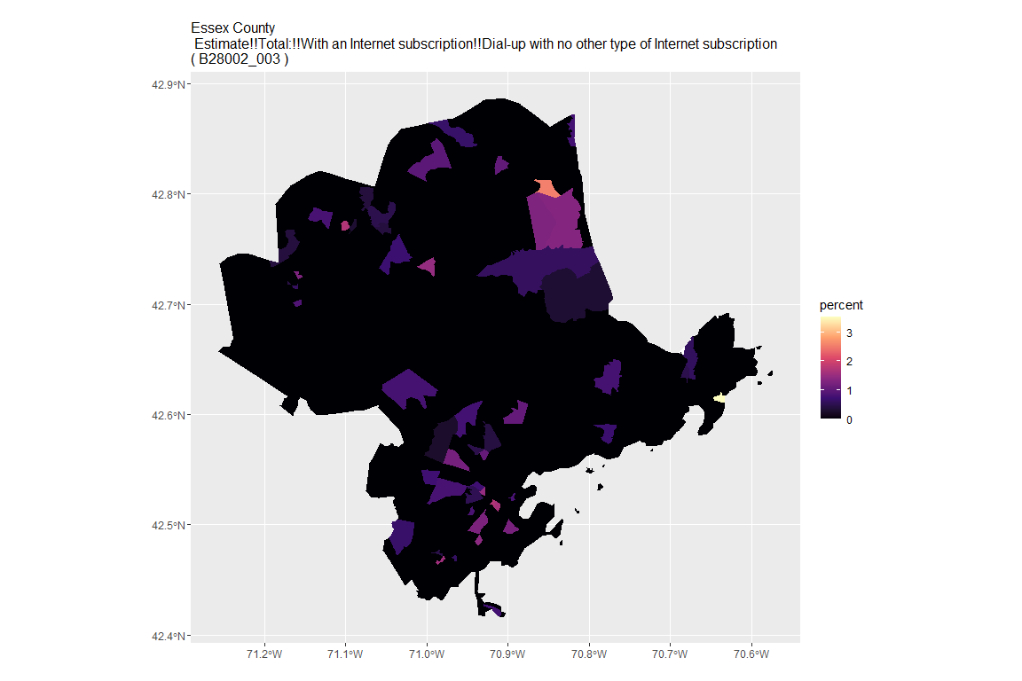

## For variable: B28002_004 : Estimate!!Total:!!With an Internet subscription!!Broadband of any type

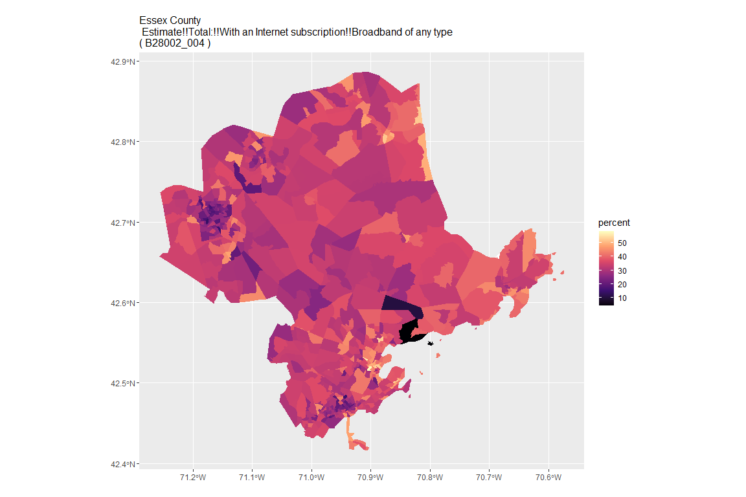

## For variable: B28002_005 : Estimate!!Total:!!With an Internet subscription!!Cellular data plan

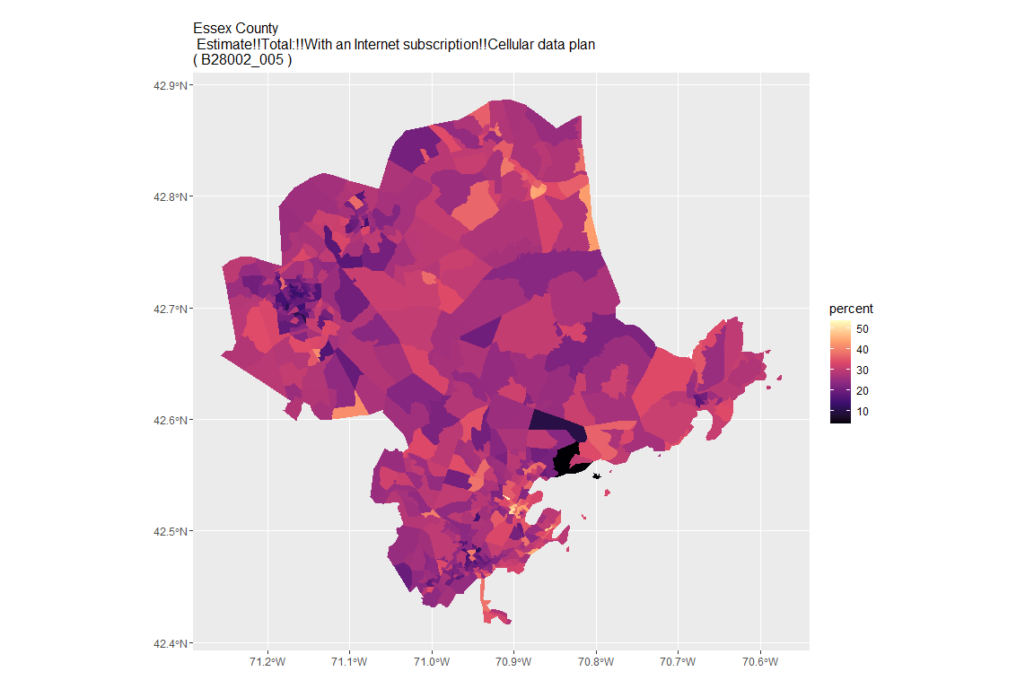

## For variable: B28002_006 : Estimate!!Total:!!With an Internet subscription!!Cellular data plan!!Cellular data plan with no other type of Internet subscription

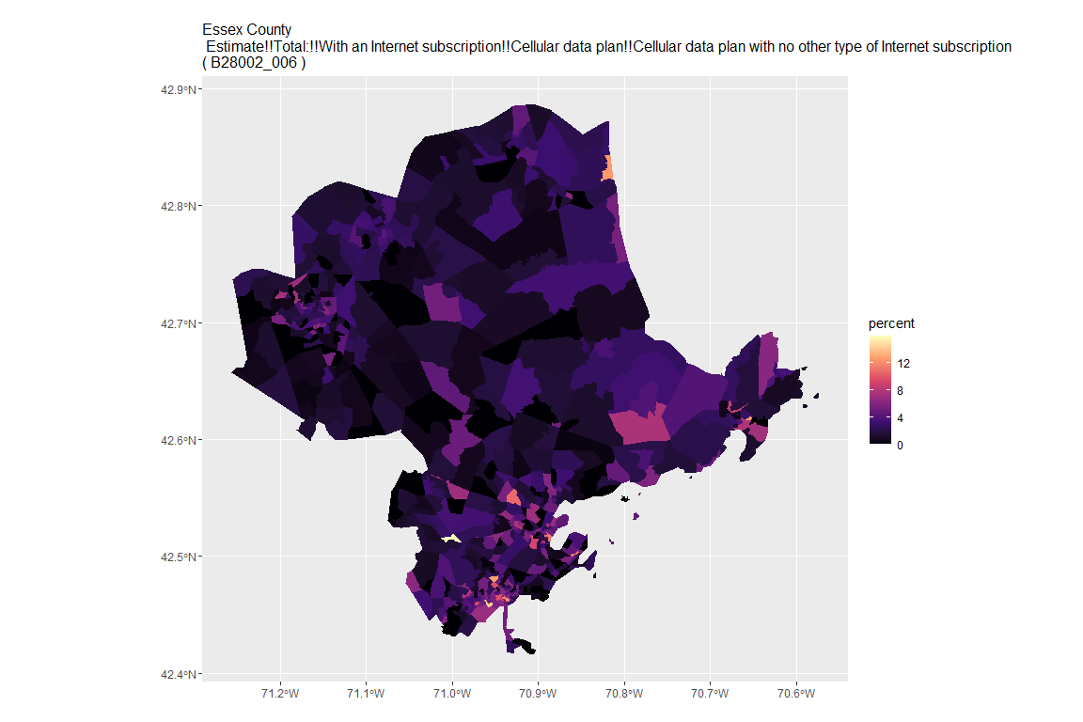

## For variable: B28002_007 : Estimate!!Total:!!With an Internet subscription!!Broadband such as cable, fiber optic or DSL

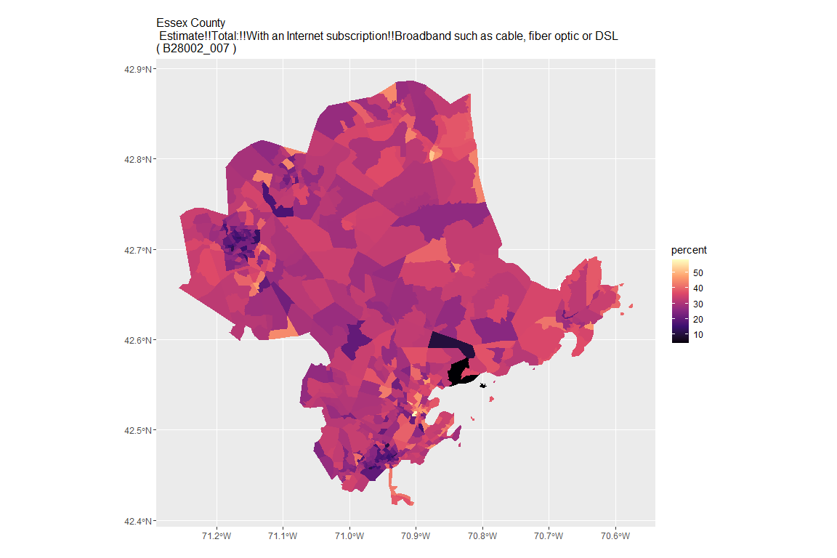

## For variable: B28002_008 : Estimate!!Total:!!With an Internet subscription!!Broadband such as cable, fiber optic or DSL!!Broadband such as cable, fiber optic or DSL with no other type of Internet subscription

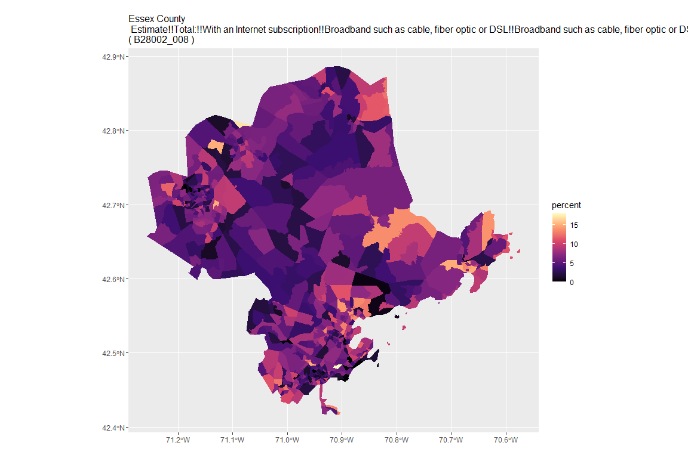

## For variable: B28002_009 : Estimate!!Total:!!With an Internet subscription!!Satellite Internet service

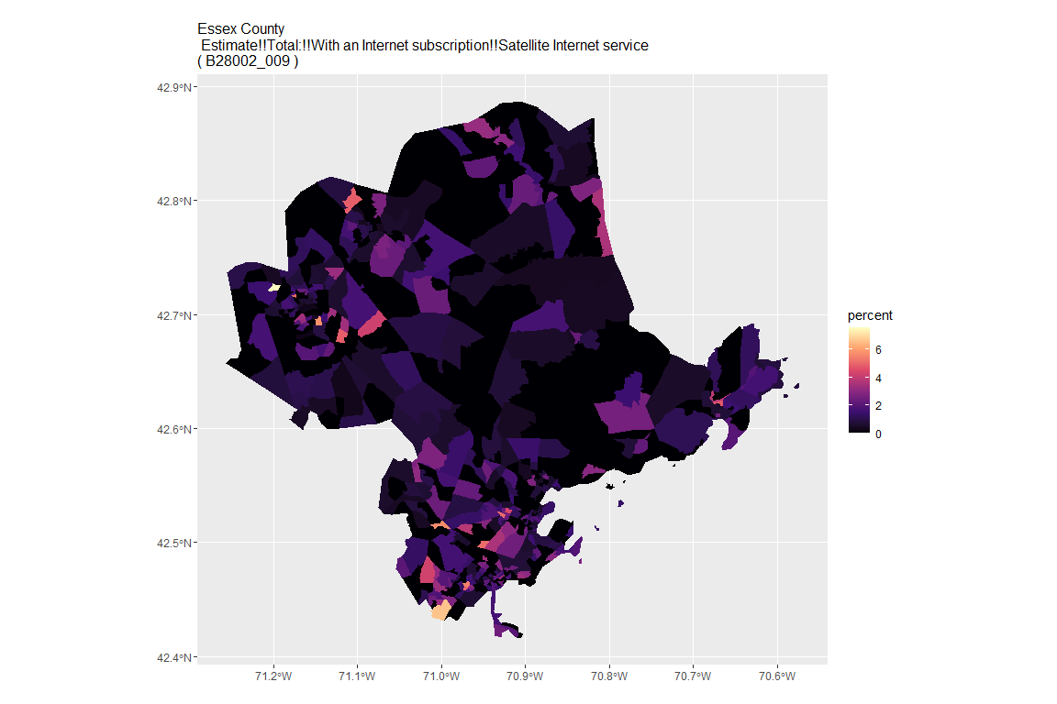

## For variable: B28002_010 : Estimate!!Total:!!With an Internet subscription!!Satellite Internet service!!Satellite Internet service with no other type of Internet subscription

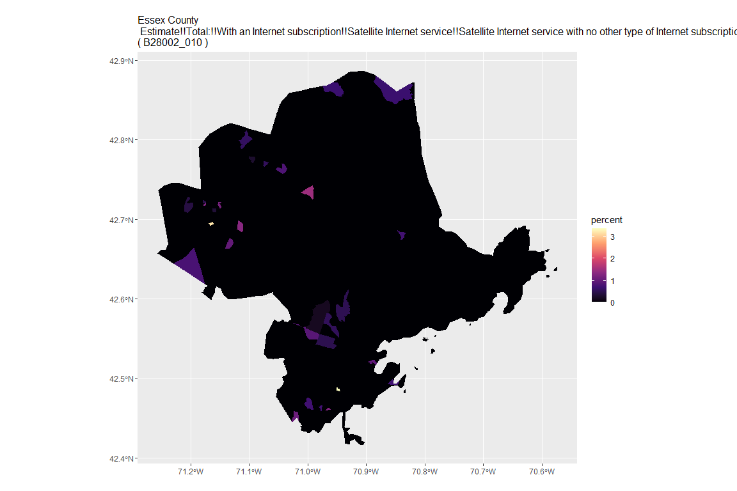

## For variable: B28002_011 : Estimate!!Total:!!With an Internet subscription!!Other service with no other type of Internet subscription

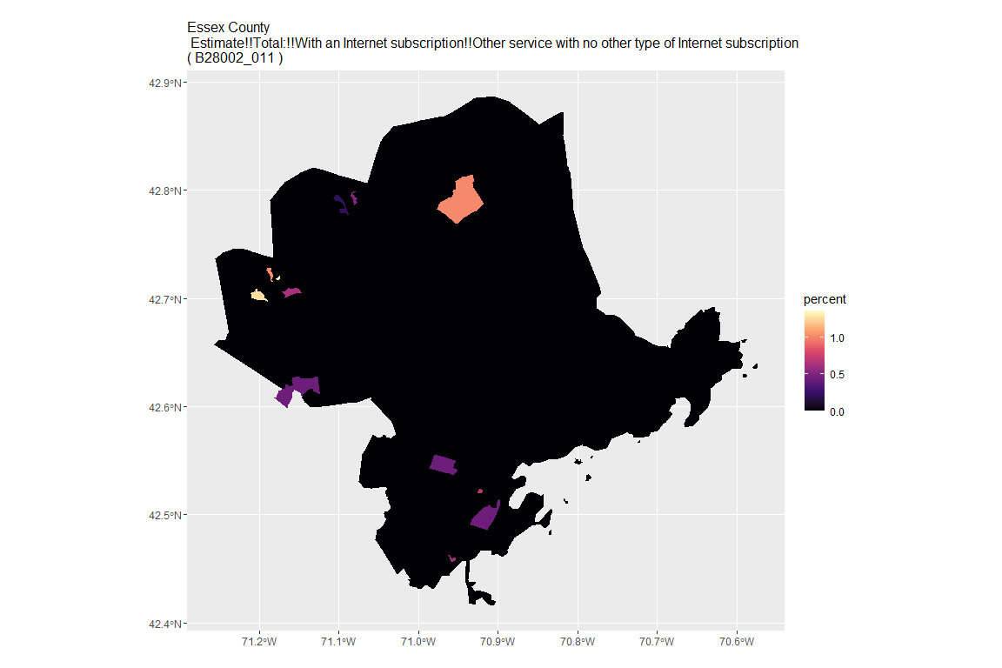

## For variable: B28002_012 : Estimate!!Total:!!Internet access without a subscription

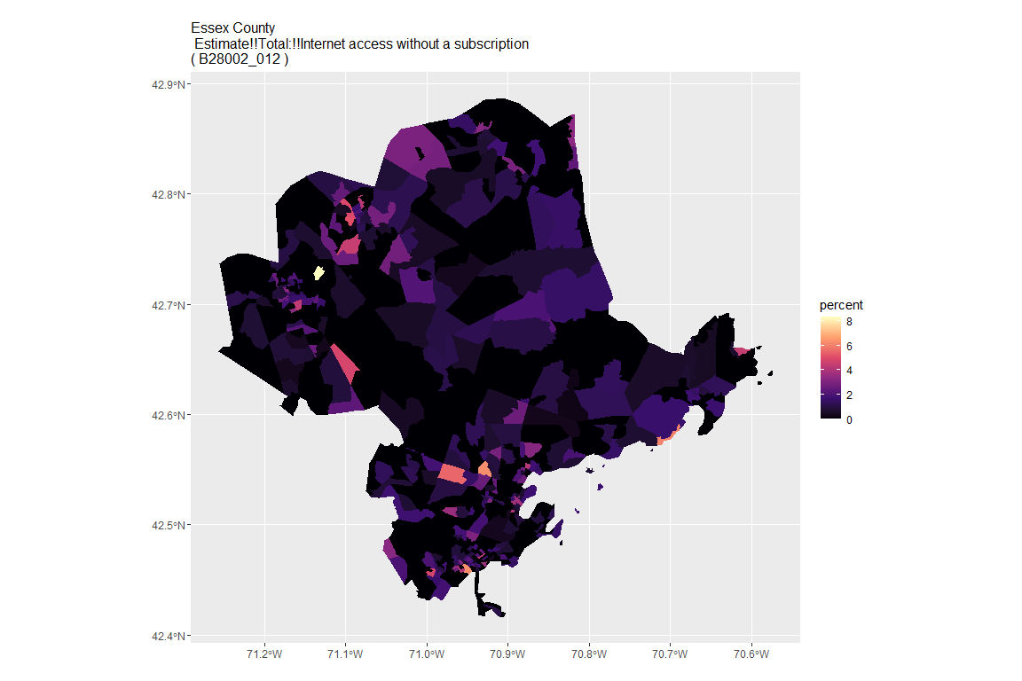

## For variable: B28002_013 : Estimate!!Total:!!No Internet access

## For county: Franklin County

## Getting data from the 2015-2019 5-year ACS  
## Downloading feature geometry from the Census website. To cache shapefiles for use in future sessions, set `options(tigris_use_cache = TRUE)`.

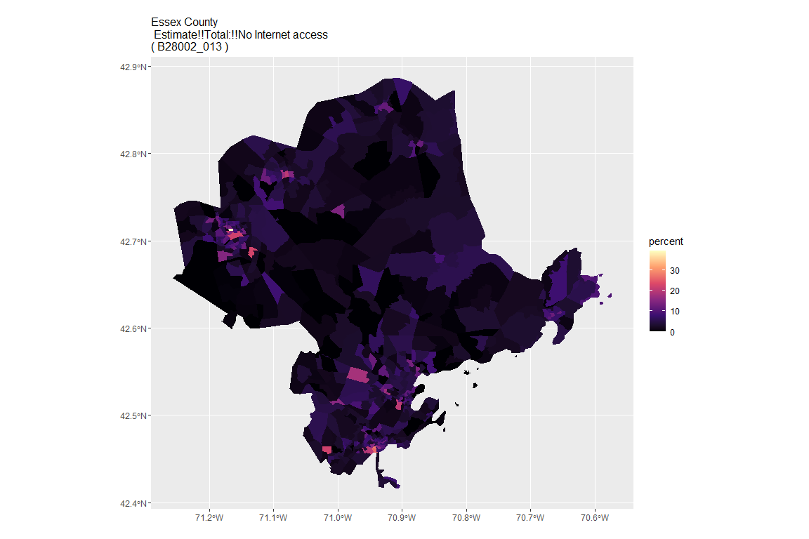

## For variable: B28002_001 : Estimate!!Total:

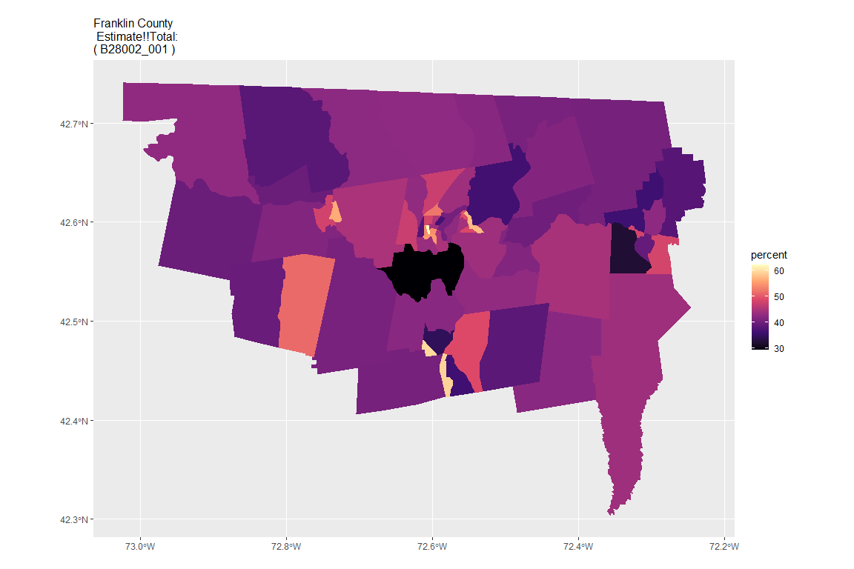

## For variable: B28002_002 : Estimate!!Total:!!With an Internet subscription

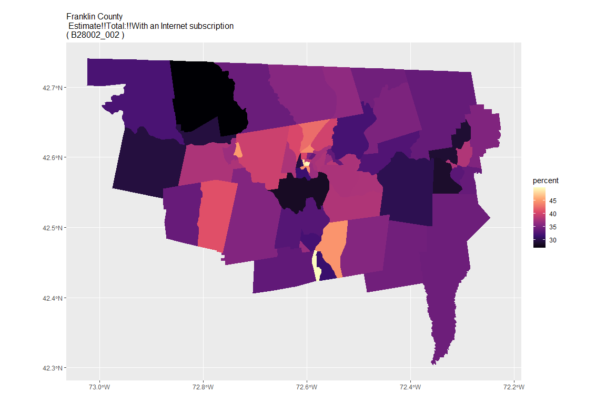

## For variable: B28002_003 : Estimate!!Total:!!With an Internet subscription!!Dial-up with no other type of Internet subscription

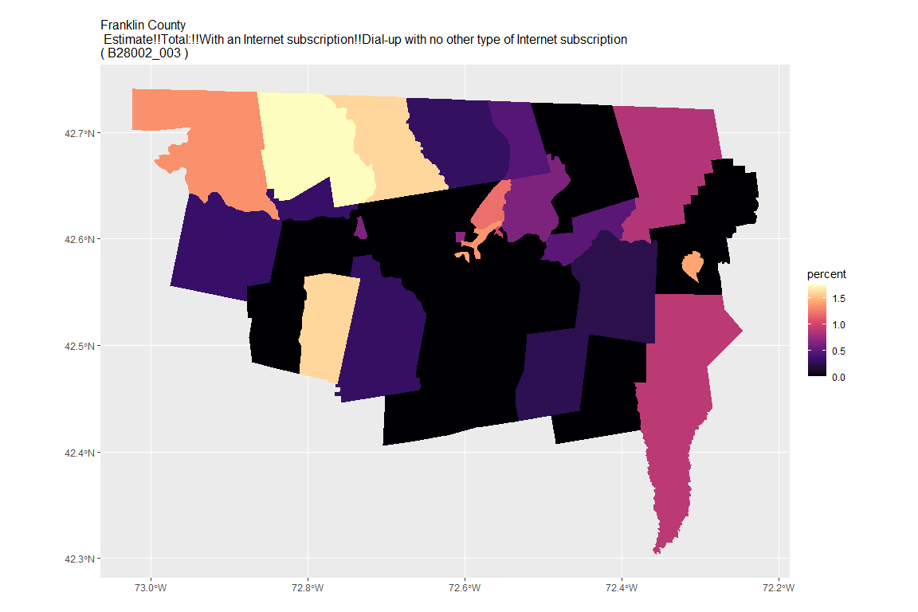

## For variable: B28002_004 : Estimate!!Total:!!With an Internet subscription!!Broadband of any type

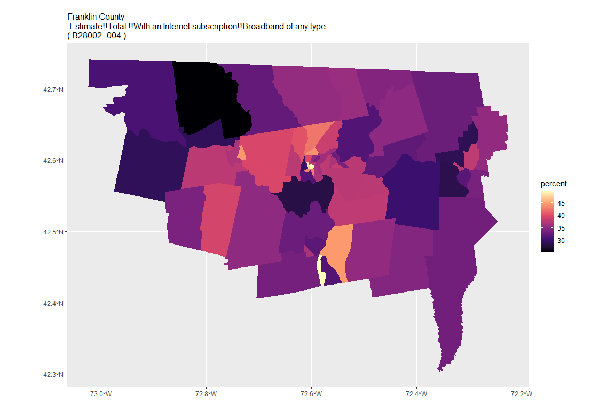

## For variable: B28002_005 : Estimate!!Total:!!With an Internet subscription!!Cellular data plan

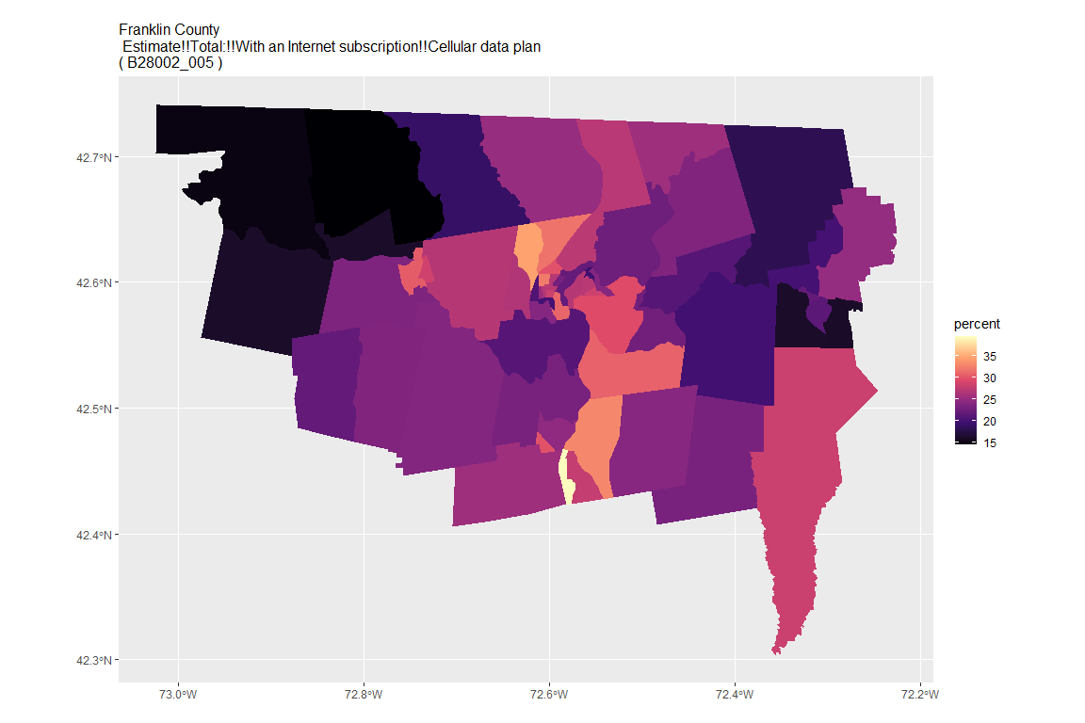

## For variable: B28002_006 : Estimate!!Total:!!With an Internet subscription!!Cellular data plan!!Cellular data plan with no other type of Internet subscription

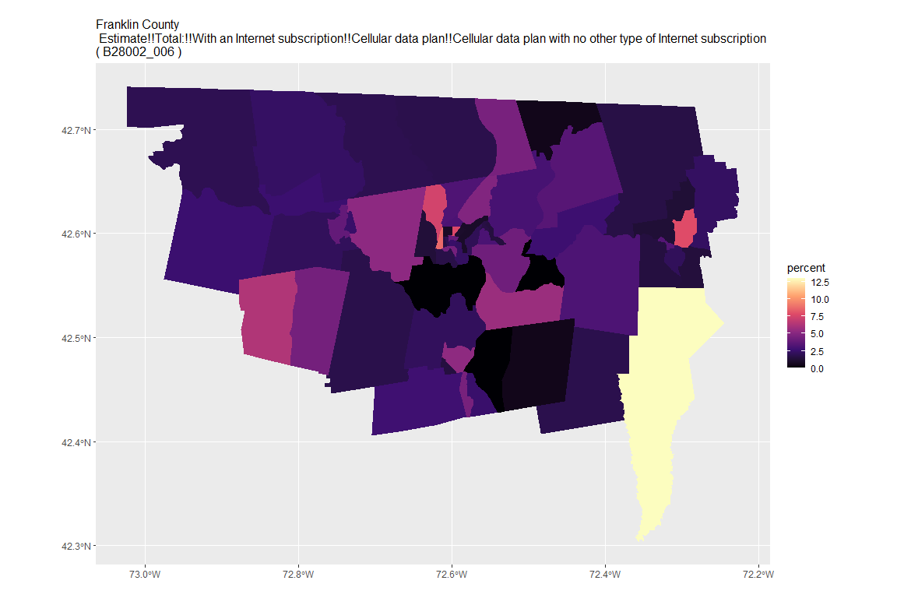

## For variable: B28002_007 : Estimate!!Total:!!With an Internet subscription!!Broadband such as cable, fiber optic or DSL

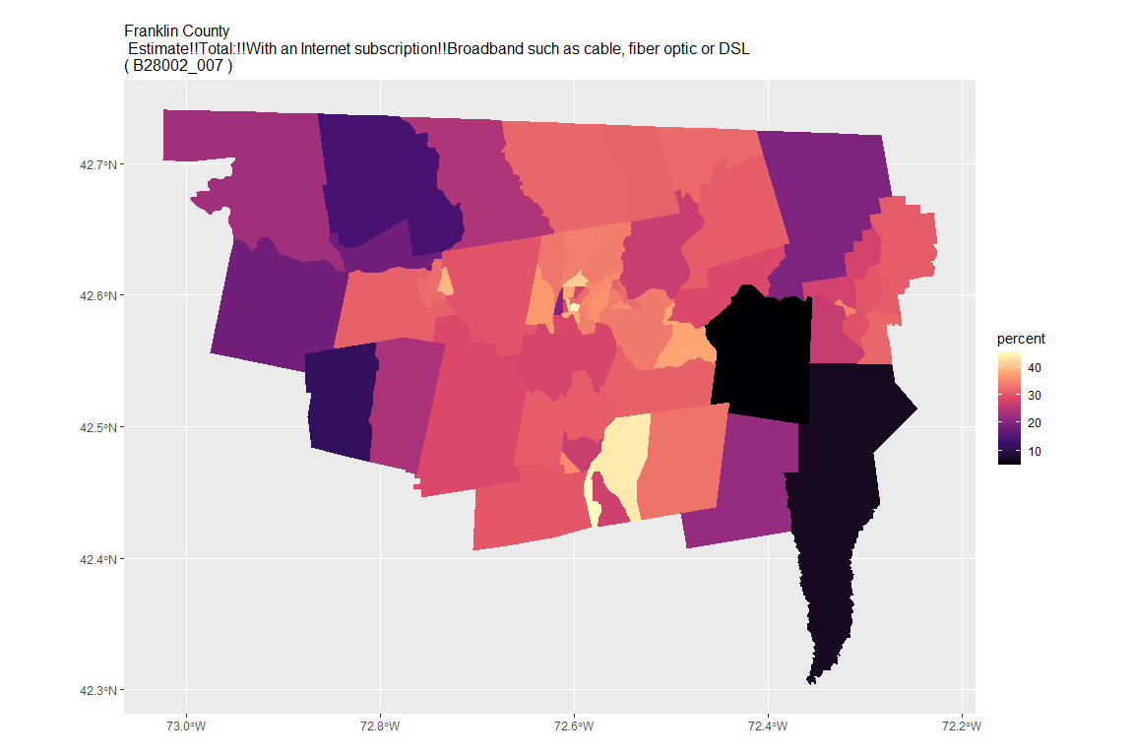

## For variable: B28002_008 : Estimate!!Total:!!With an Internet subscription!!Broadband such as cable, fiber optic or DSL!!Broadband such as cable, fiber optic or DSL with no other type of Internet subscription

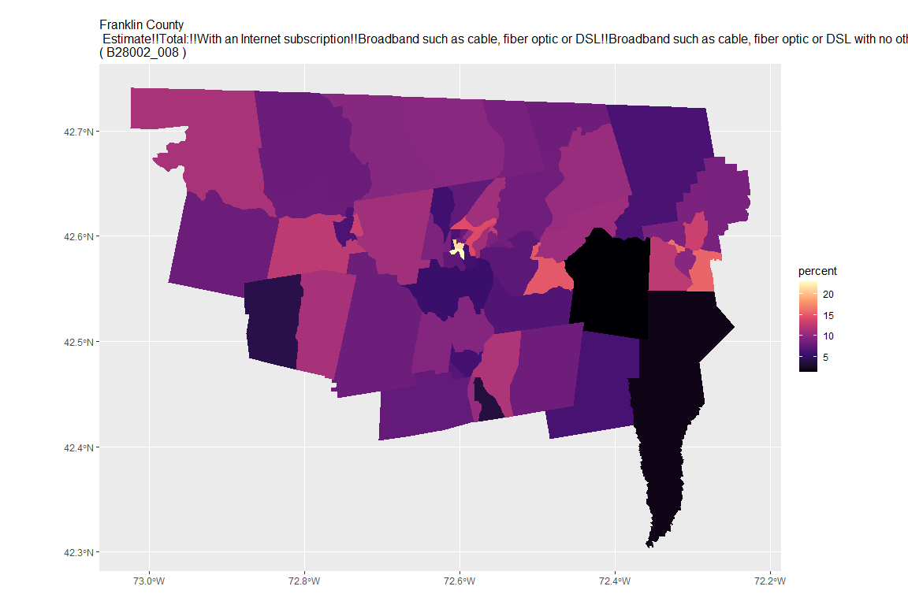

## For variable: B28002_009 : Estimate!!Total:!!With an Internet subscription!!Satellite Internet service

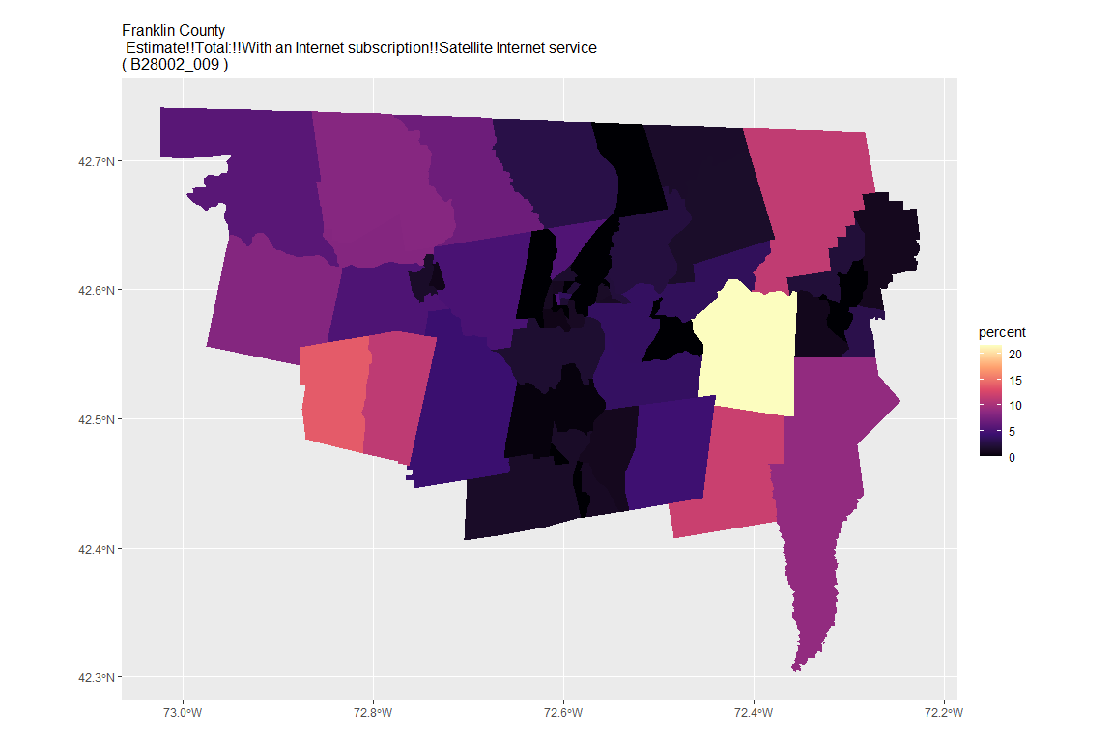

## For variable: B28002_010 : Estimate!!Total:!!With an Internet subscription!!Satellite Internet service!!Satellite Internet service with no other type of Internet subscription

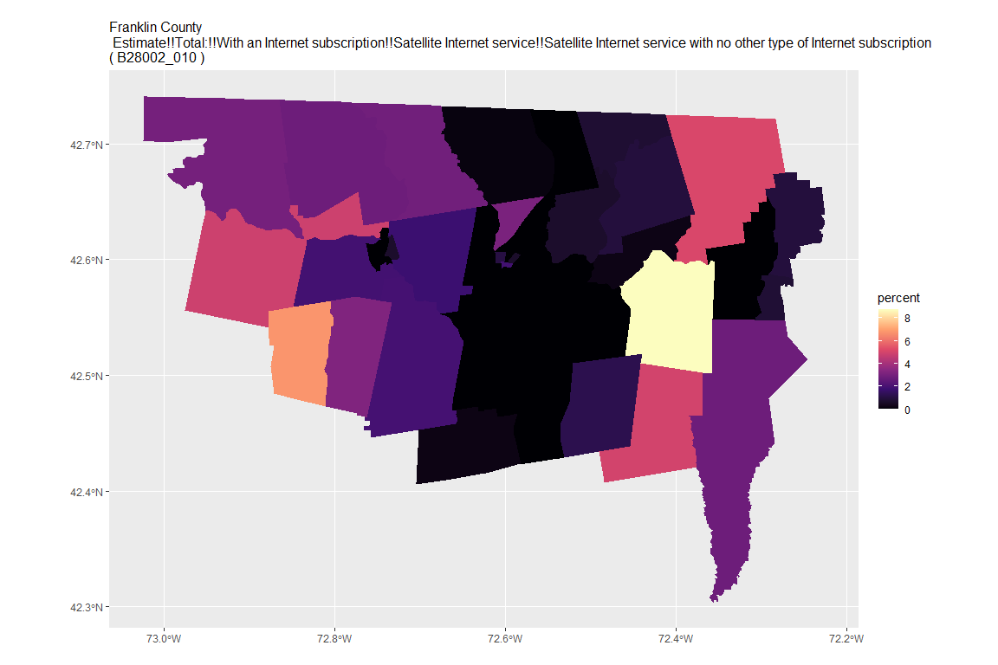

## For variable: B28002_011 : Estimate!!Total:!!With an Internet subscription!!Other service with no other type of Internet subscription

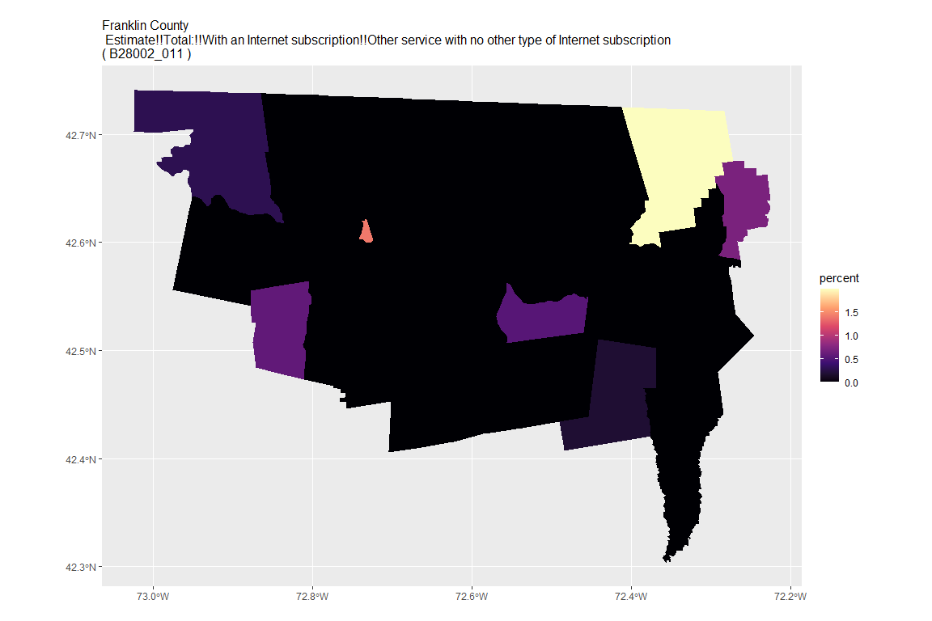

## For variable: B28002_012 : Estimate!!Total:!!Internet access without a subscription

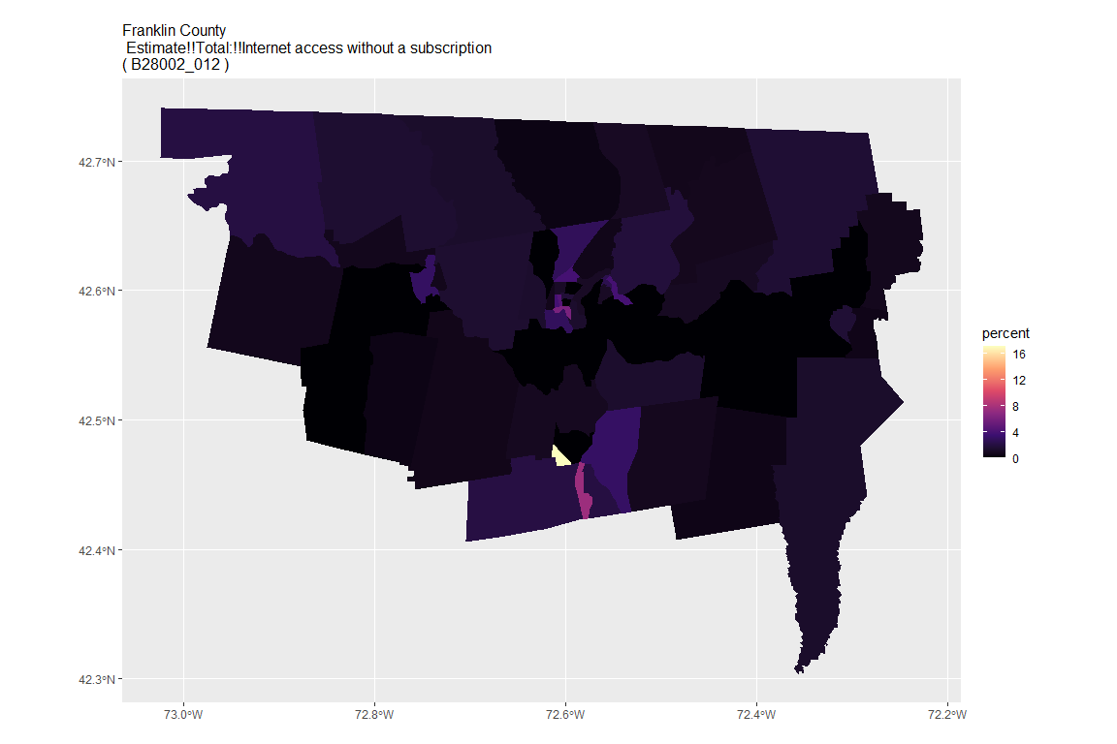

## For variable: B28002_013 : Estimate!!Total:!!No Internet access

## For county: Hampden County

## Getting data from the 2015-2019 5-year ACS  
## Downloading feature geometry from the Census website. To cache shapefiles for use in future sessions, set `options(tigris_use_cache = TRUE)`.

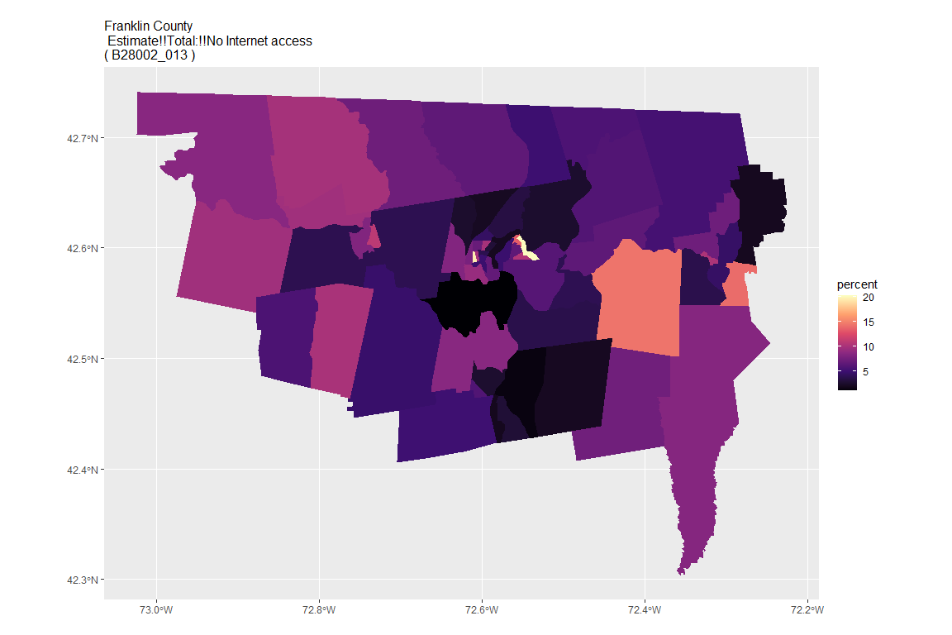

## For variable: B28002_001 : Estimate!!Total:

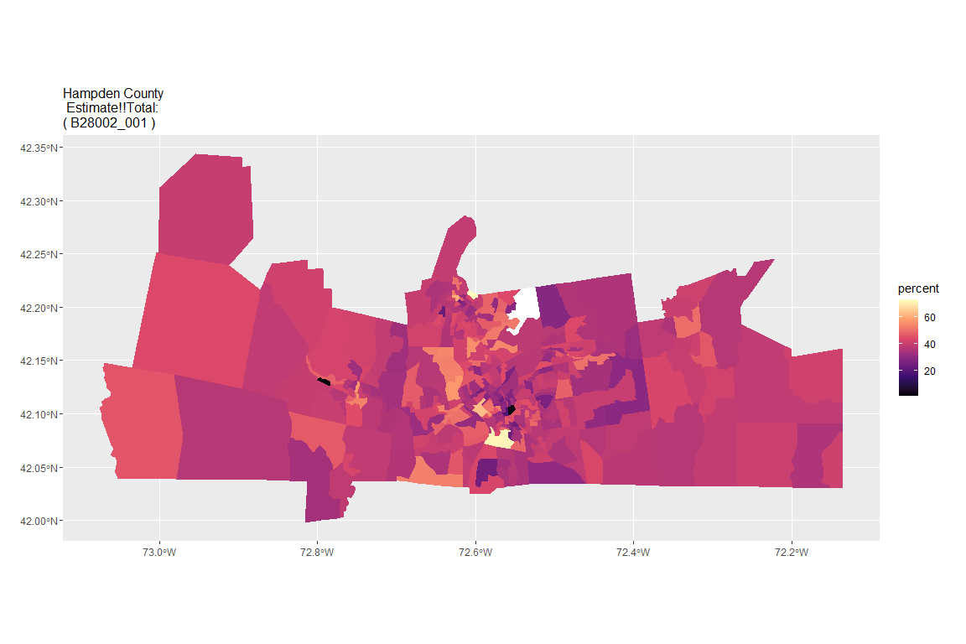

## For variable: B28002_002 : Estimate!!Total:!!With an Internet subscription

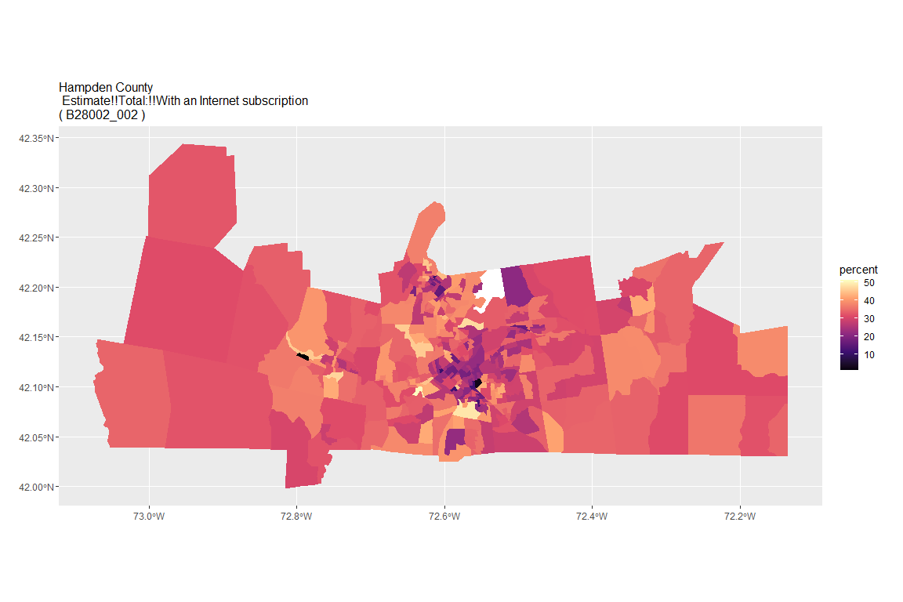

## For variable: B28002_003 : Estimate!!Total:!!With an Internet subscription!!Dial-up with no other type of Internet subscription

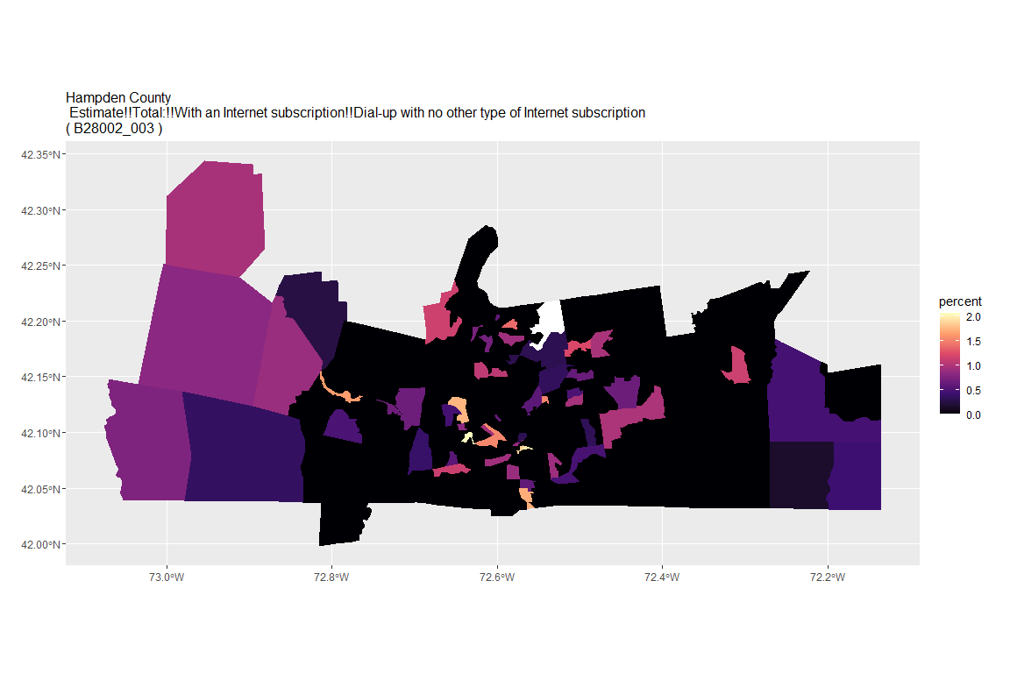

## For variable: B28002_004 : Estimate!!Total:!!With an Internet subscription!!Broadband of any type

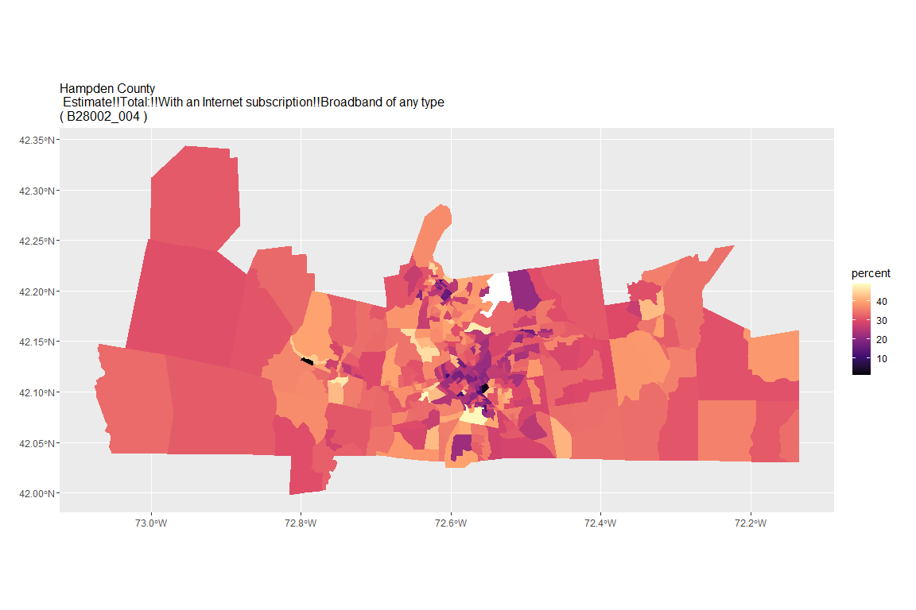

## For variable: B28002_005 : Estimate!!Total:!!With an Internet subscription!!Cellular data plan

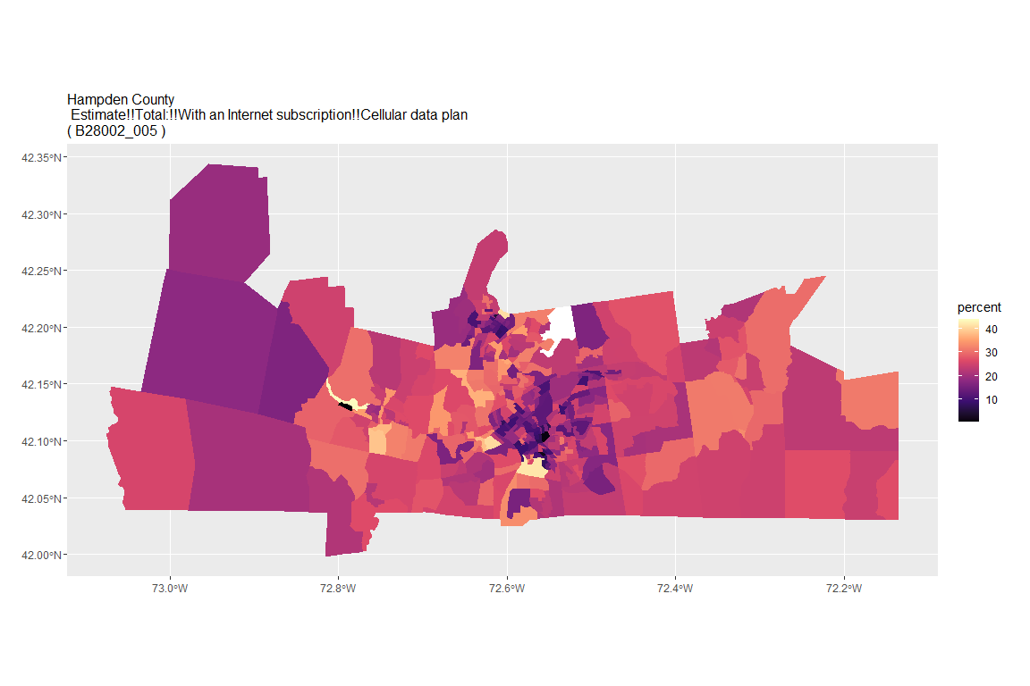

## For variable: B28002_006 : Estimate!!Total:!!With an Internet subscription!!Cellular data plan!!Cellular data plan with no other type of Internet subscription

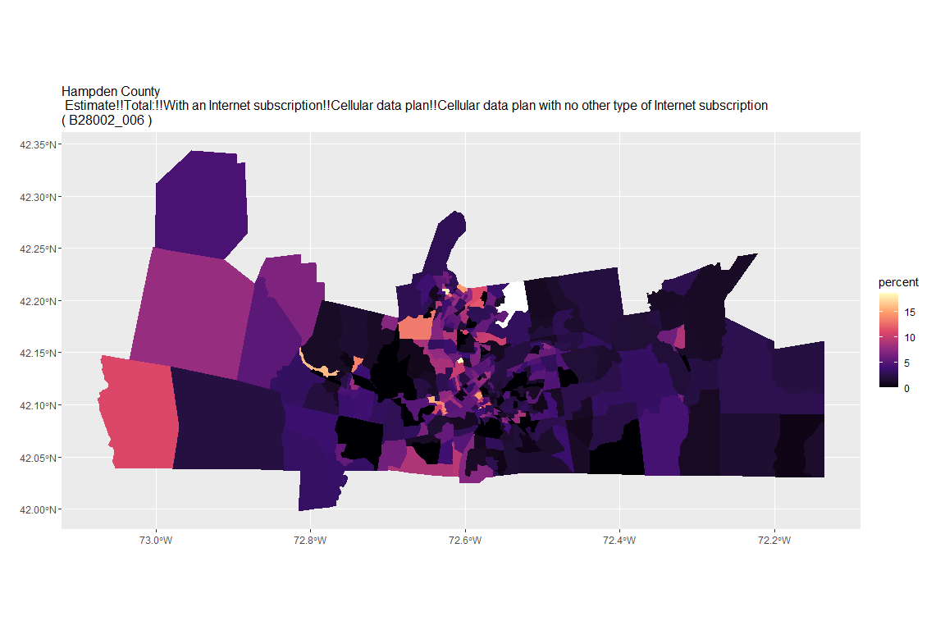

## For variable: B28002_007 : Estimate!!Total:!!With an Internet subscription!!Broadband such as cable, fiber optic or DSL

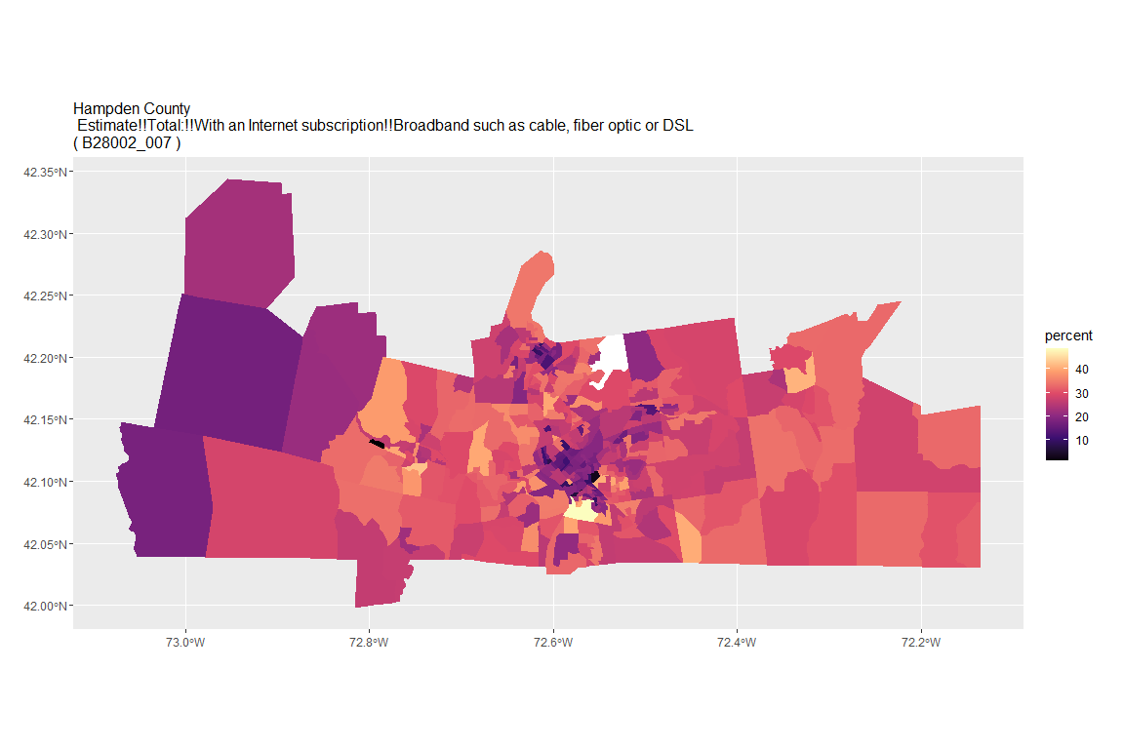

## For variable: B28002_008 : Estimate!!Total:!!With an Internet subscription!!Broadband such as cable, fiber optic or DSL!!Broadband such as cable, fiber optic or DSL with no other type of Internet subscription

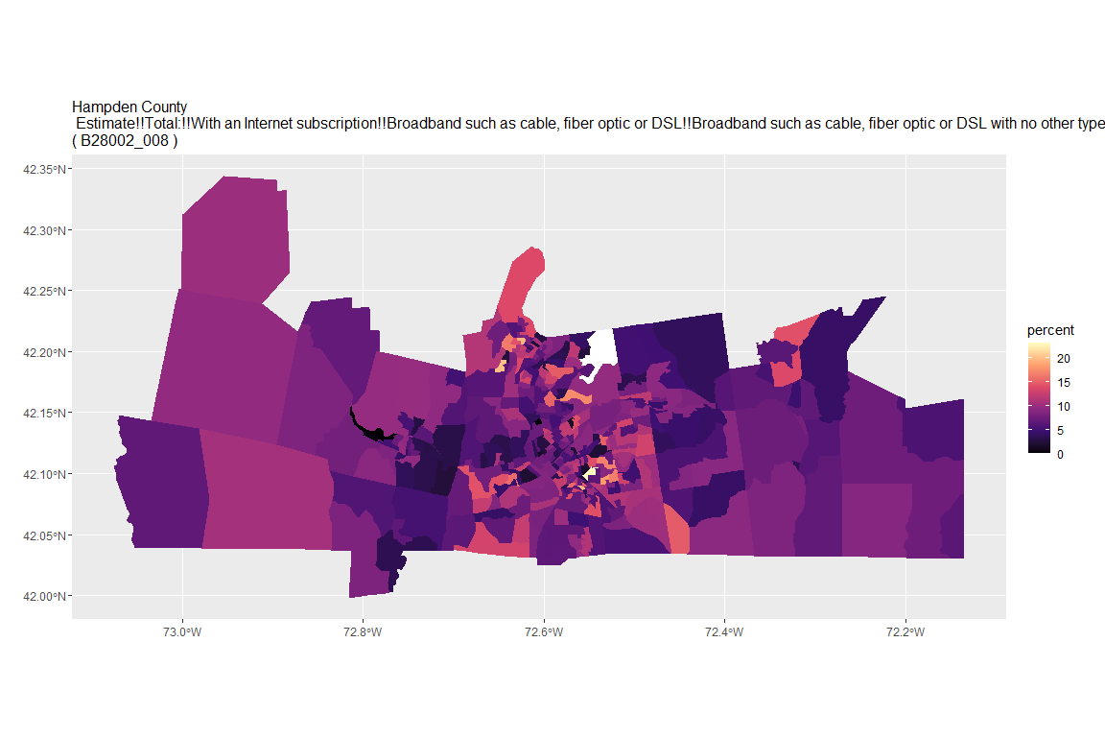

## For variable: B28002_009 : Estimate!!Total:!!With an Internet subscription!!Satellite Internet service

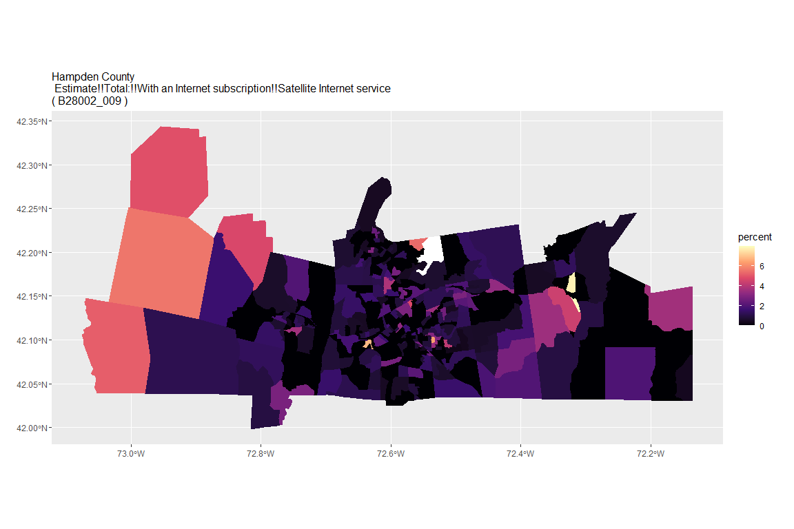

## For variable: B28002_010 : Estimate!!Total:!!With an Internet subscription!!Satellite Internet service!!Satellite Internet service with no other type of Internet subscription

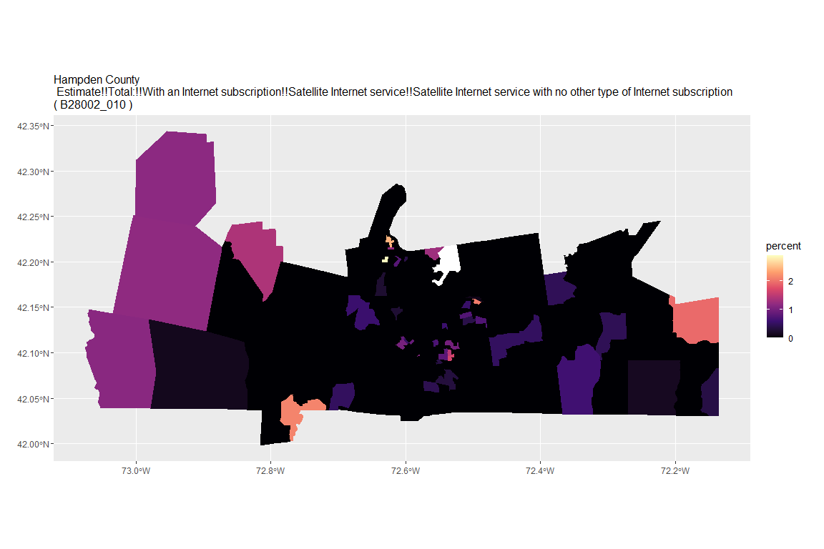

## For variable: B28002_011 : Estimate!!Total:!!With an Internet subscription!!Other service with no other type of Internet subscription

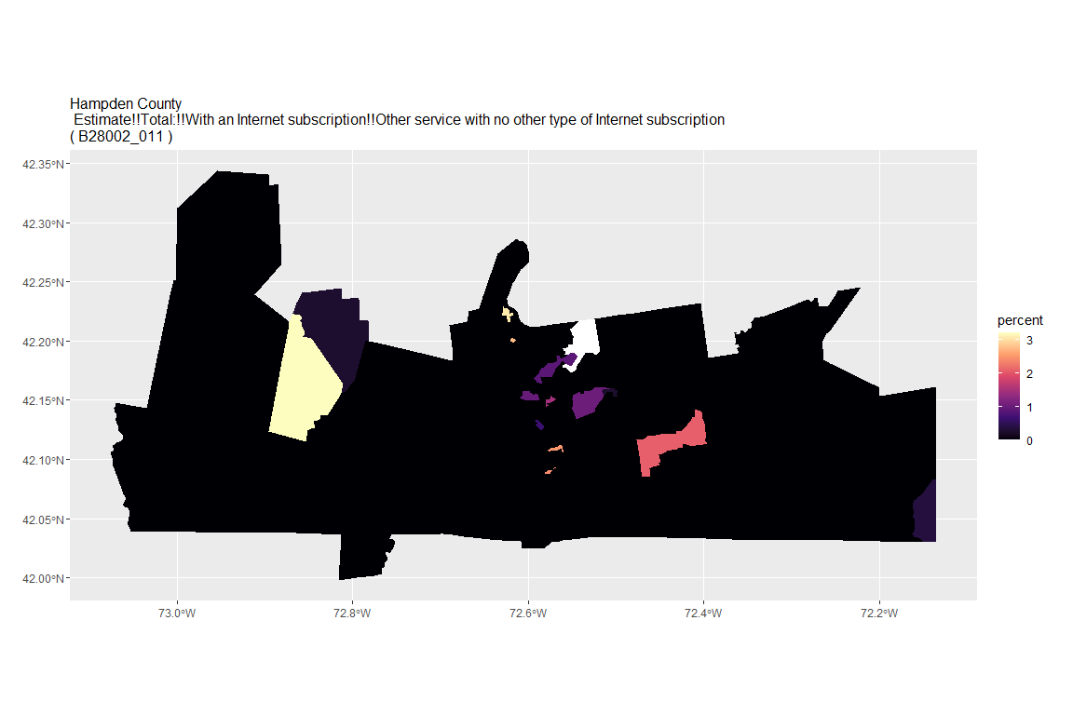

## For variable: B28002_012 : Estimate!!Total:!!Internet access without a subscription

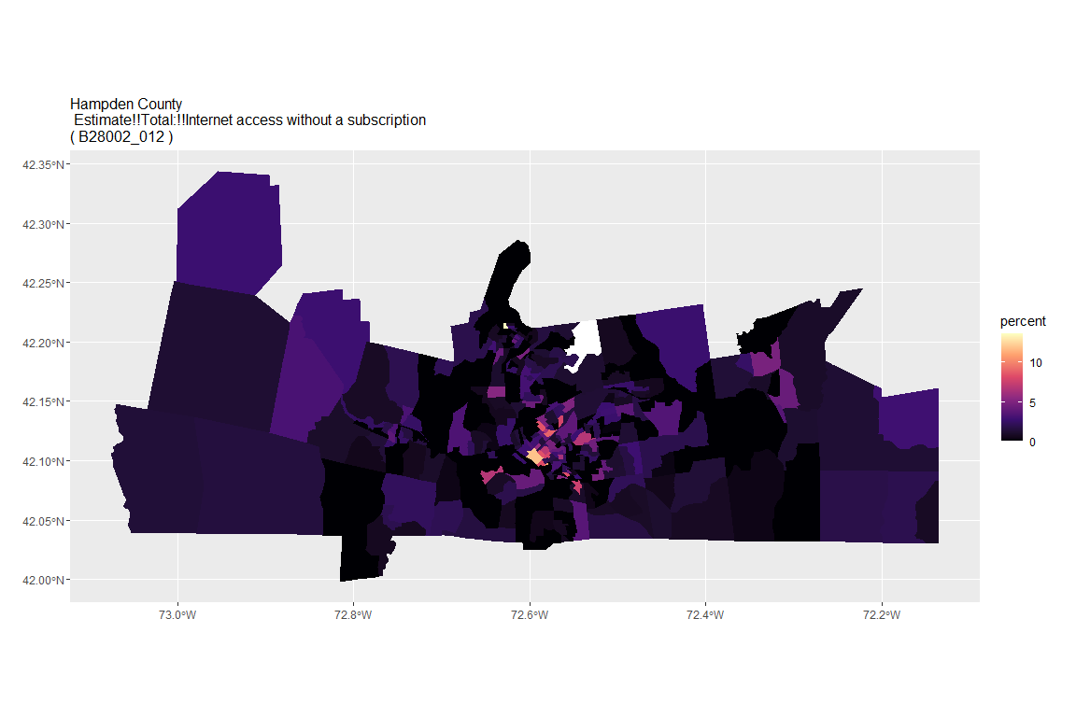

## For variable: B28002_013 : Estimate!!Total:!!No Internet access

## For county: Hampshire County

## Getting data from the 2015-2019 5-year ACS  
## Downloading feature geometry from the Census website. To cache shapefiles for use in future sessions, set `options(tigris_use_cache = TRUE)`.

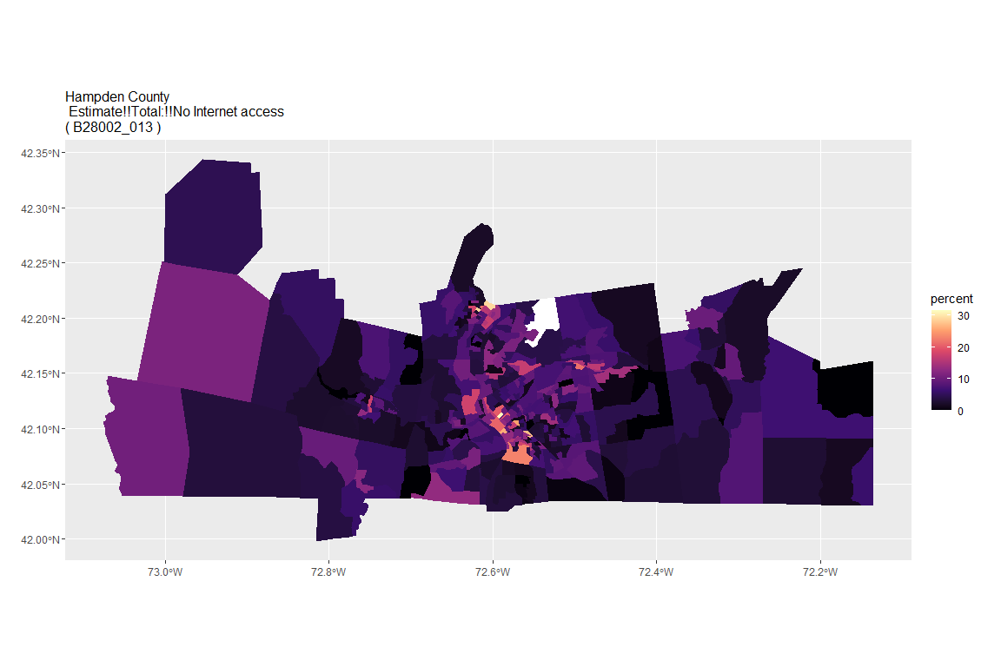

## For variable: B28002_001 : Estimate!!Total:

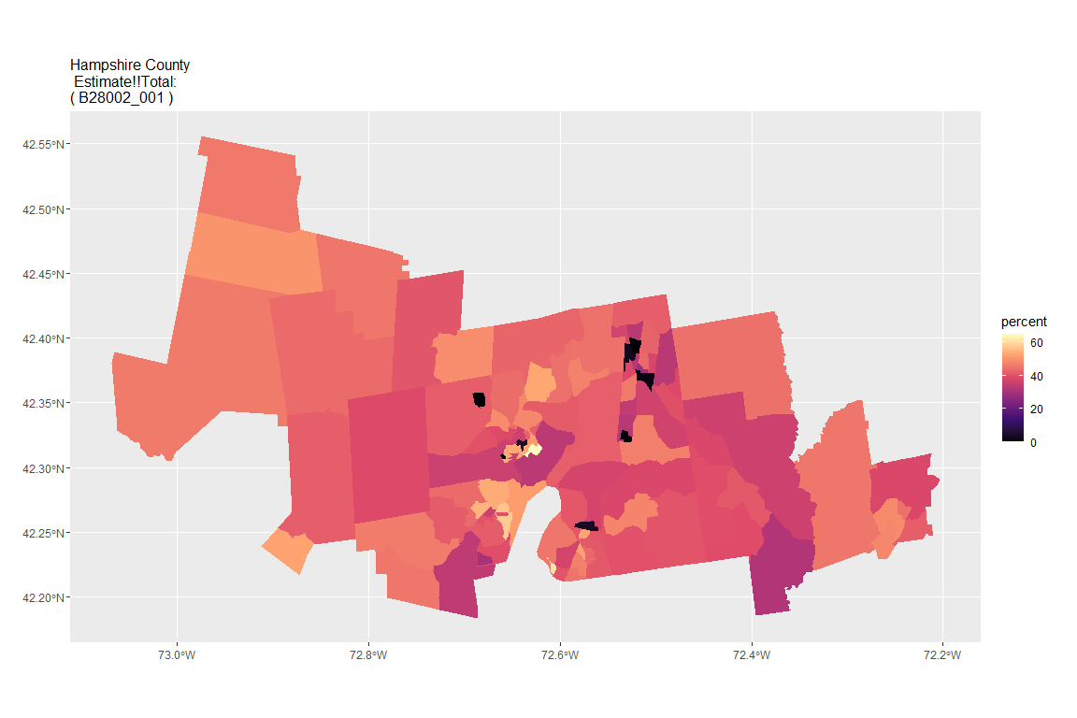

## For variable: B28002_002 : Estimate!!Total:!!With an Internet subscription

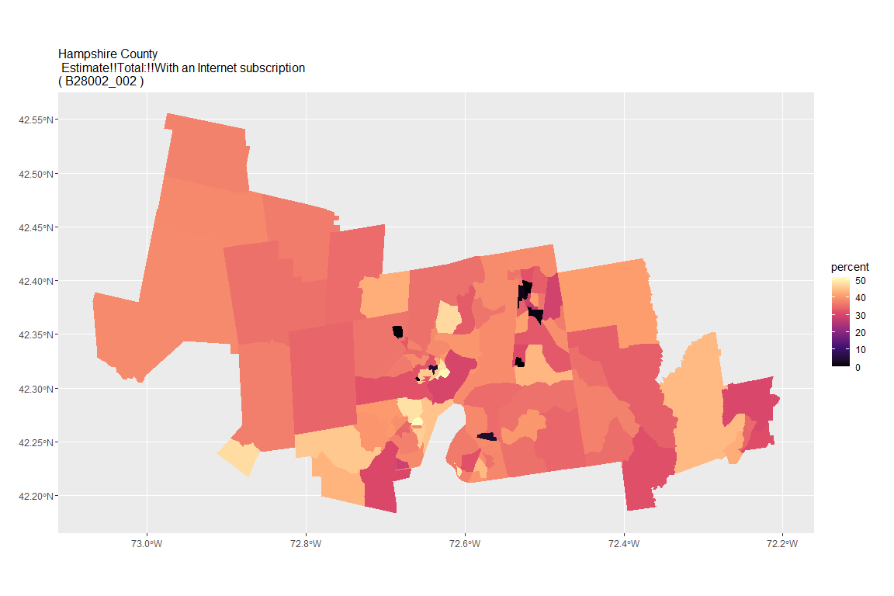

## For variable: B28002_003 : Estimate!!Total:!!With an Internet subscription!!Dial-up with no other type of Internet subscription

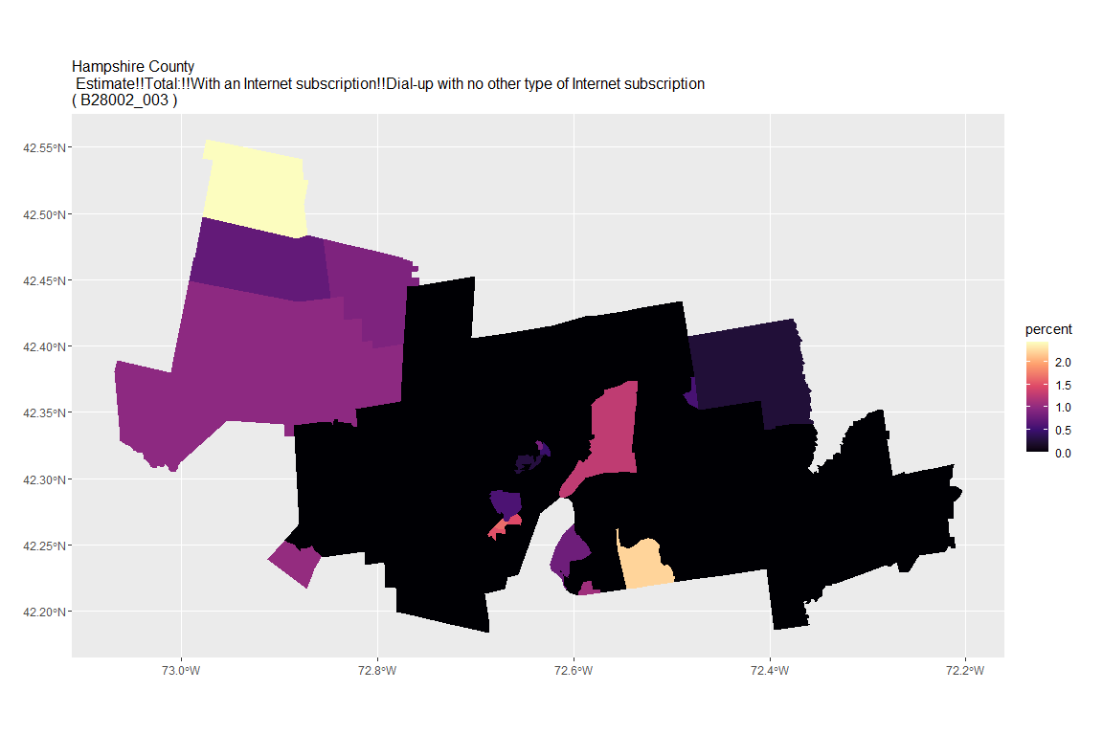

## For variable: B28002_004 : Estimate!!Total:!!With an Internet subscription!!Broadband of any type

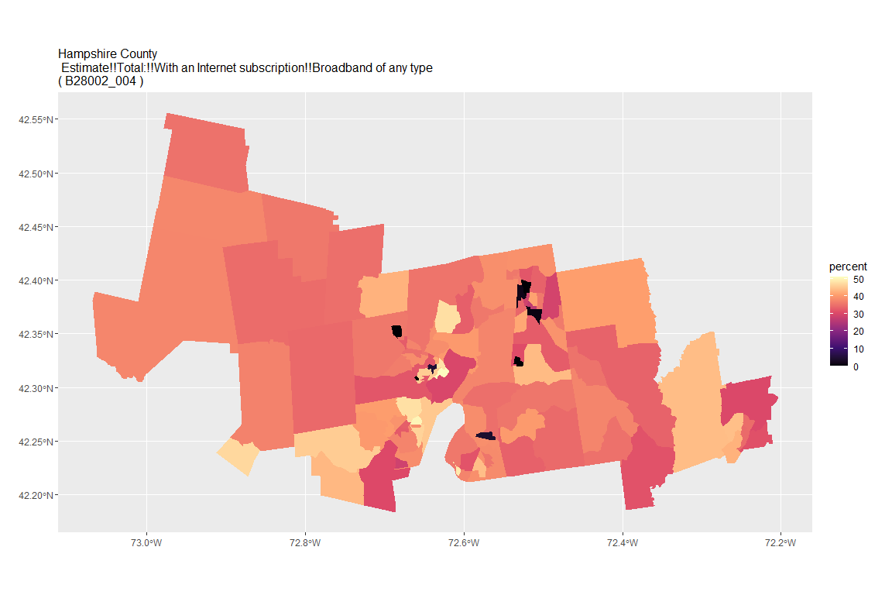

## For variable: B28002_005 : Estimate!!Total:!!With an Internet subscription!!Cellular data plan

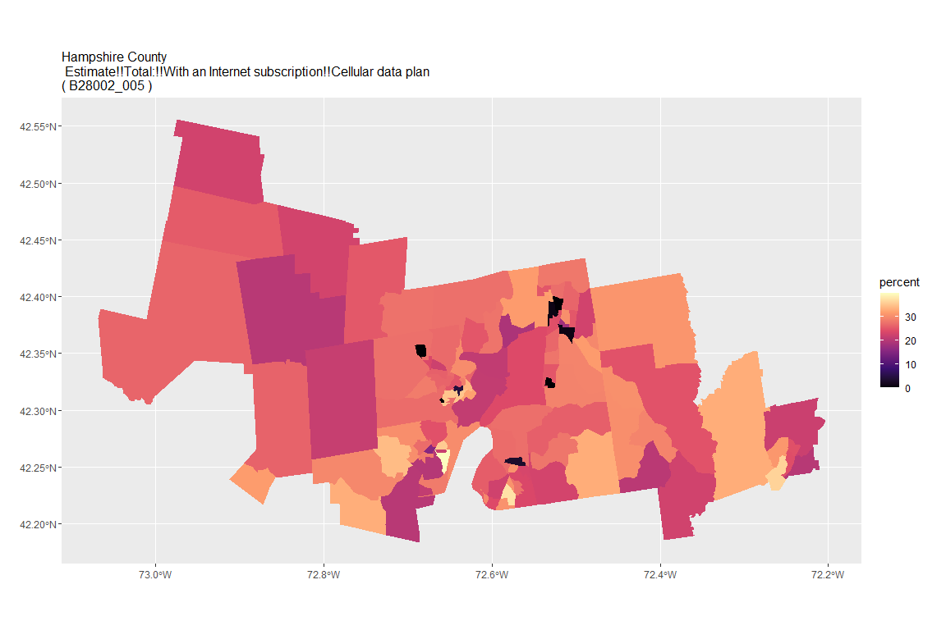

## For variable: B28002_006 : Estimate!!Total:!!With an Internet subscription!!Cellular data plan!!Cellular data plan with no other type of Internet subscription

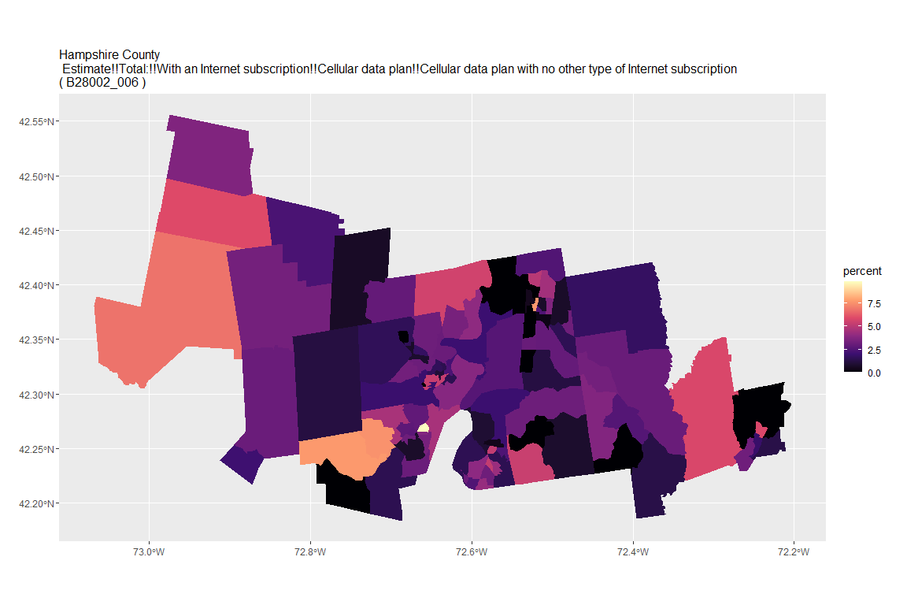

## For variable: B28002_007 : Estimate!!Total:!!With an Internet subscription!!Broadband such as cable, fiber optic or DSL

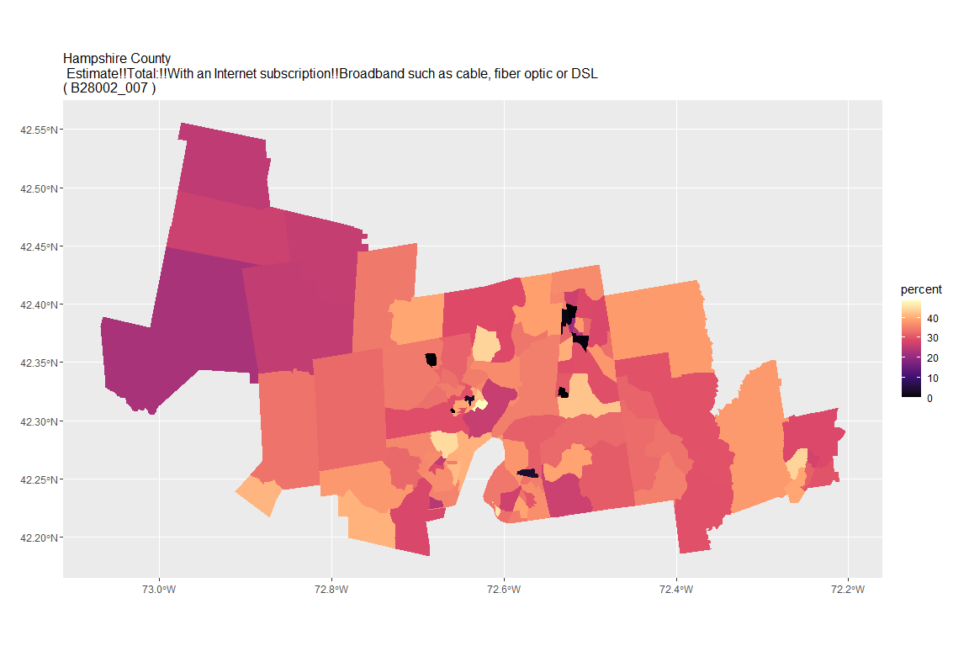

## For variable: B28002_008 : Estimate!!Total:!!With an Internet subscription!!Broadband such as cable, fiber optic or DSL!!Broadband such as cable, fiber optic or DSL with no other type of Internet subscription

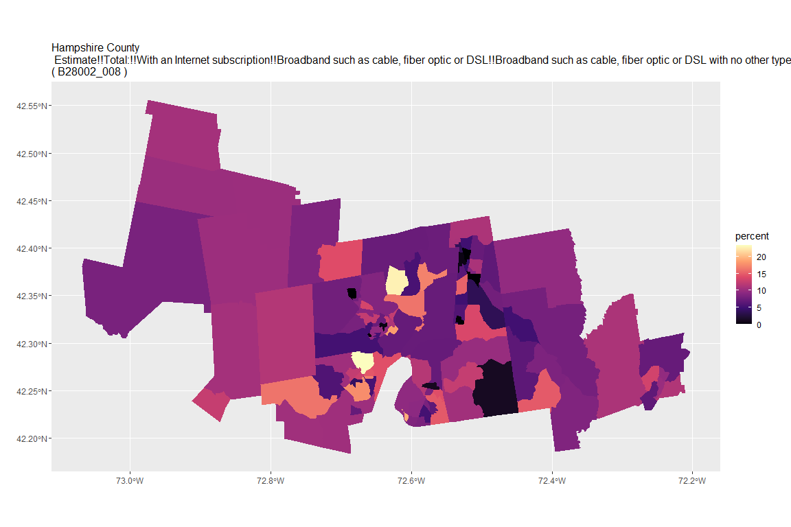

## For variable: B28002_009 : Estimate!!Total:!!With an Internet subscription!!Satellite Internet service

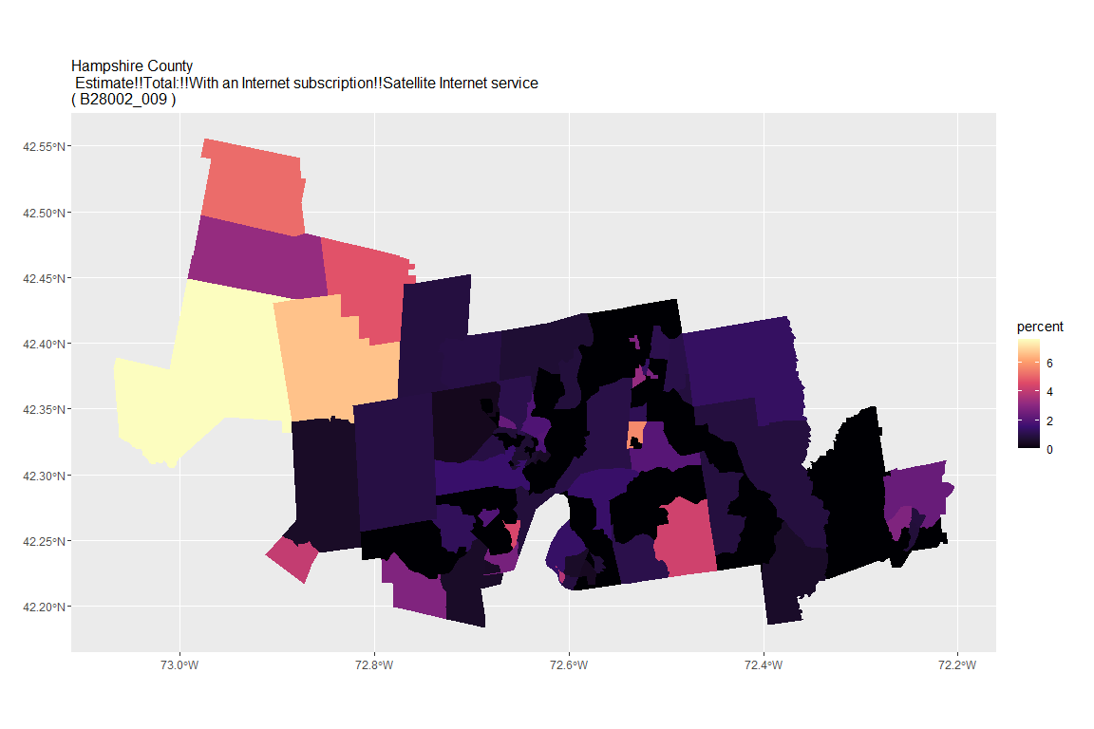

## For variable: B28002_010 : Estimate!!Total:!!With an Internet subscription!!Satellite Internet service!!Satellite Internet service with no other type of Internet subscription

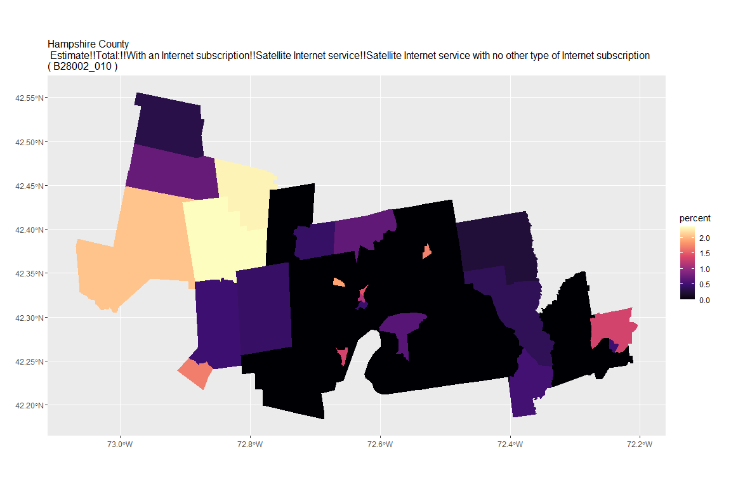

## For variable: B28002_011 : Estimate!!Total:!!With an Internet subscription!!Other service with no other type of Internet subscription

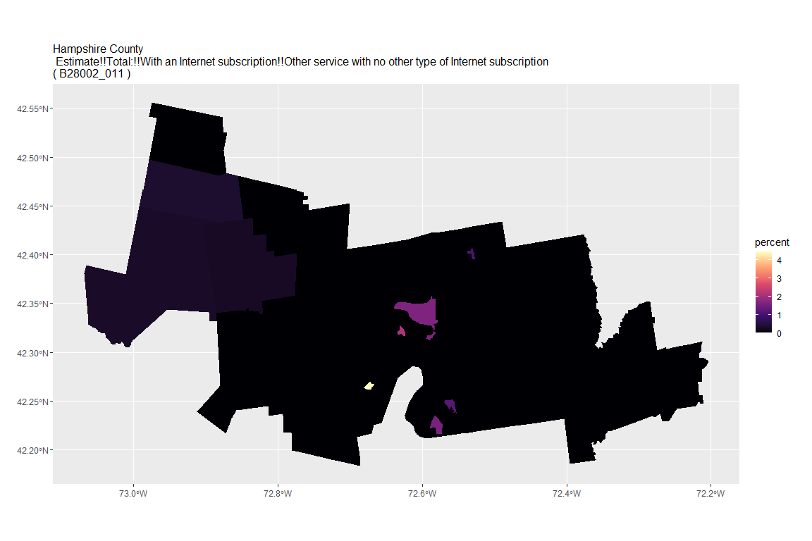

## For variable: B28002_012 : Estimate!!Total:!!Internet access without a subscription

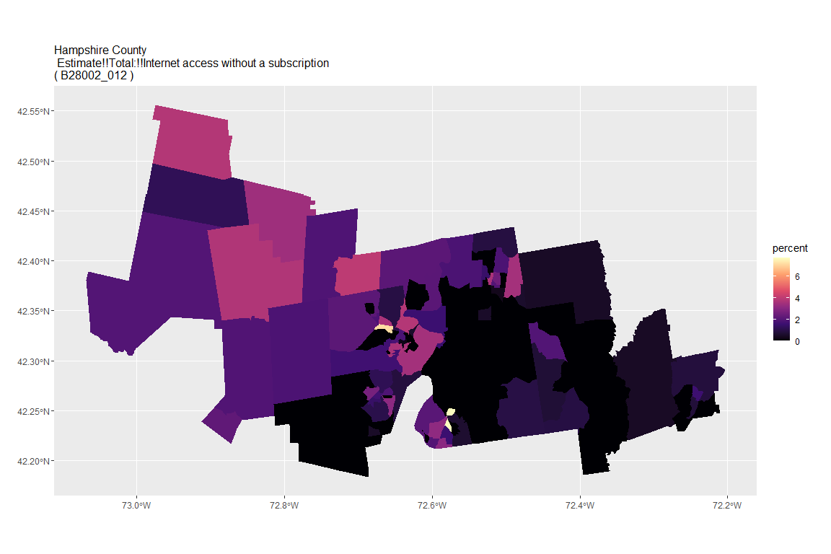

## For variable: B28002_013 : Estimate!!Total:!!No Internet access

## For county: Middlesex County

## Getting data from the 2015-2019 5-year ACS  
## Downloading feature geometry from the Census website. To cache shapefiles for use in future sessions, set `options(tigris_use_cache = TRUE)`.

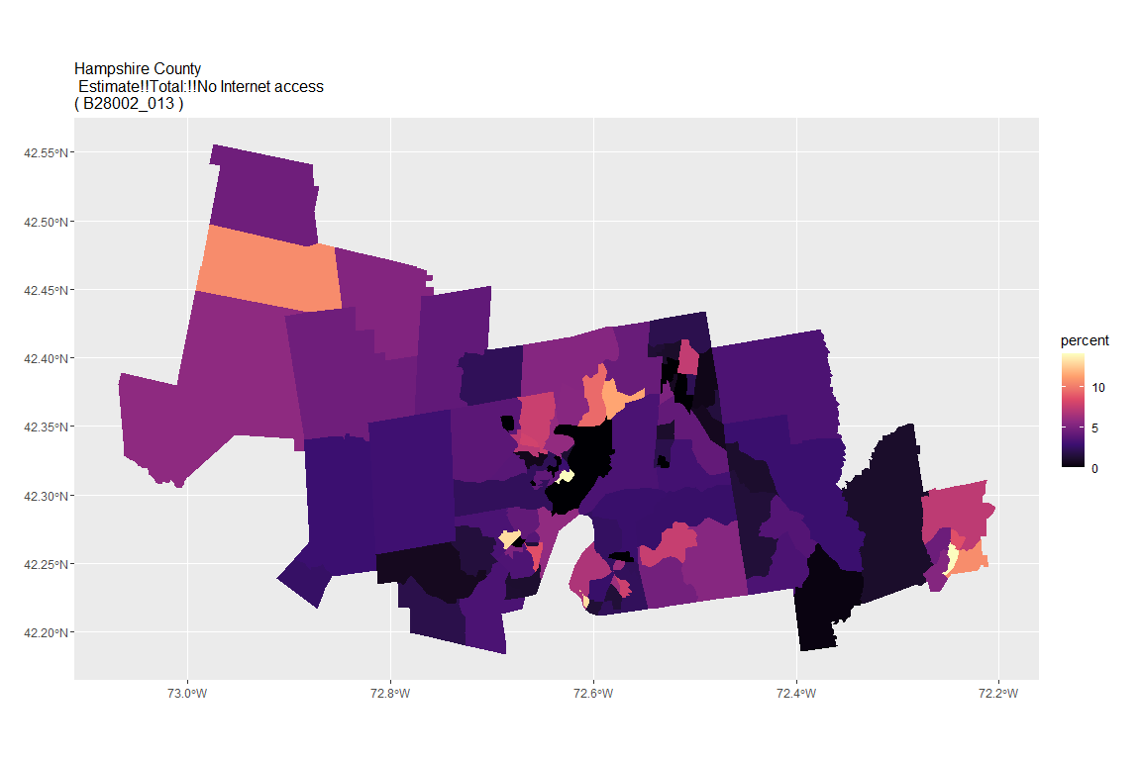

## For variable: B28002_001 : Estimate!!Total:

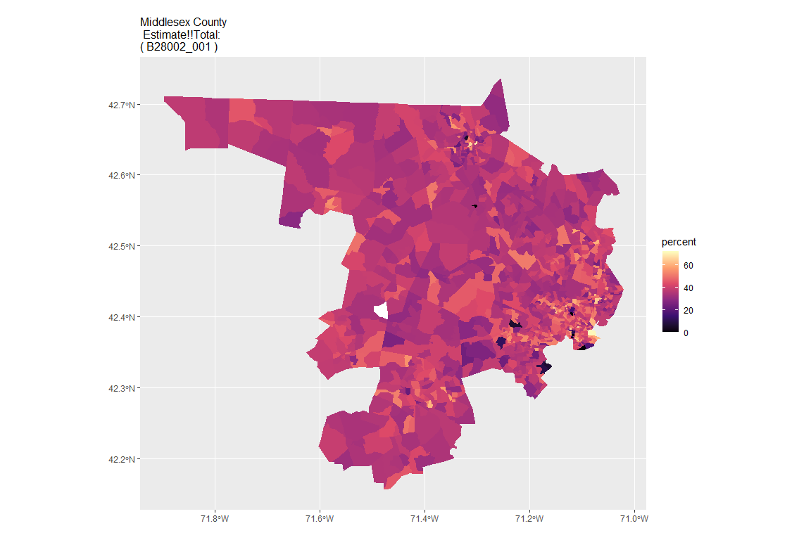

## For variable: B28002_002 : Estimate!!Total:!!With an Internet subscription

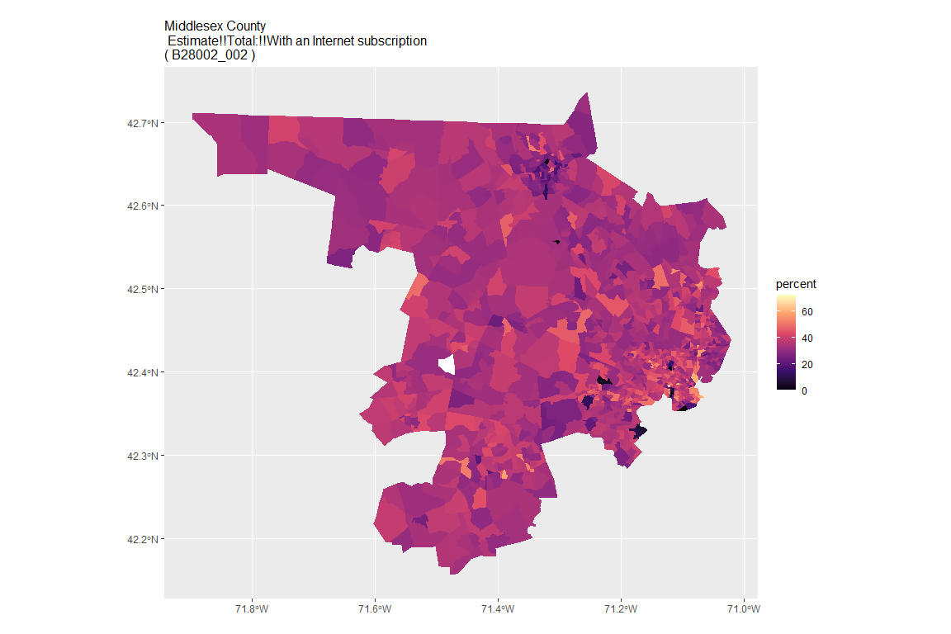

## For variable: B28002_003 : Estimate!!Total:!!With an Internet subscription!!Dial-up with no other type of Internet subscription

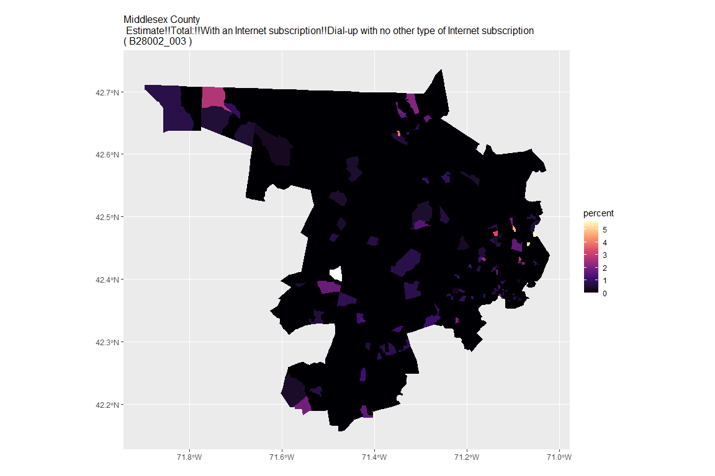

## For variable: B28002_004 : Estimate!!Total:!!With an Internet subscription!!Broadband of any type

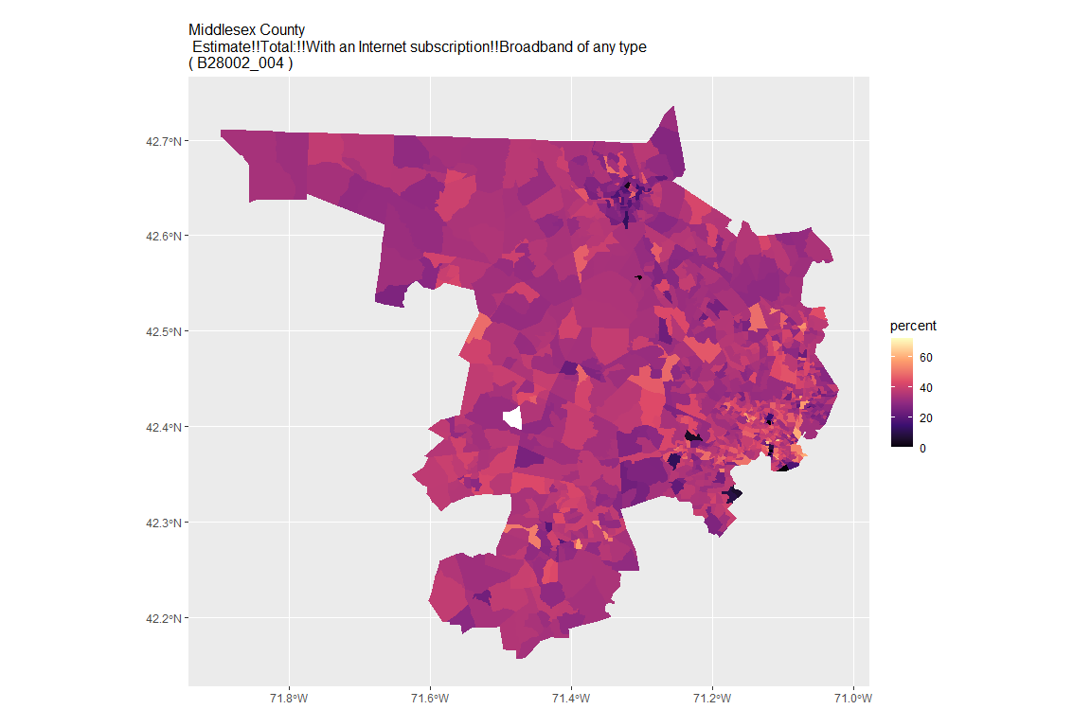

## For variable: B28002_005 : Estimate!!Total:!!With an Internet subscription!!Cellular data plan

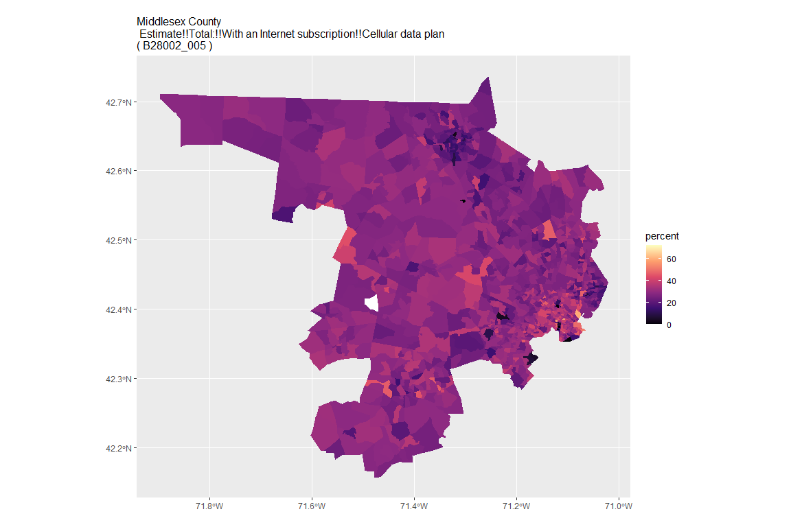

## For variable: B28002_006 : Estimate!!Total:!!With an Internet subscription!!Cellular data plan!!Cellular data plan with no other type of Internet subscription

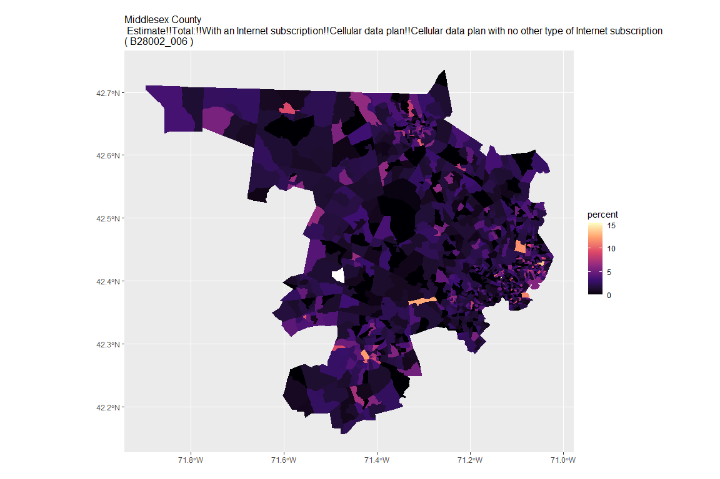

## For variable: B28002_007 : Estimate!!Total:!!With an Internet subscription!!Broadband such as cable, fiber optic or DSL

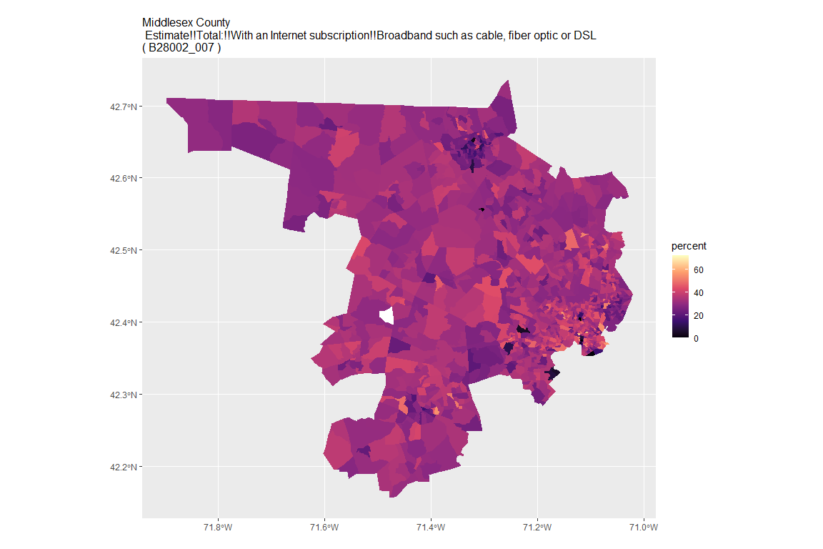

## For variable: B28002_008 : Estimate!!Total:!!With an Internet subscription!!Broadband such as cable, fiber optic or DSL!!Broadband such as cable, fiber optic or DSL with no other type of Internet subscription

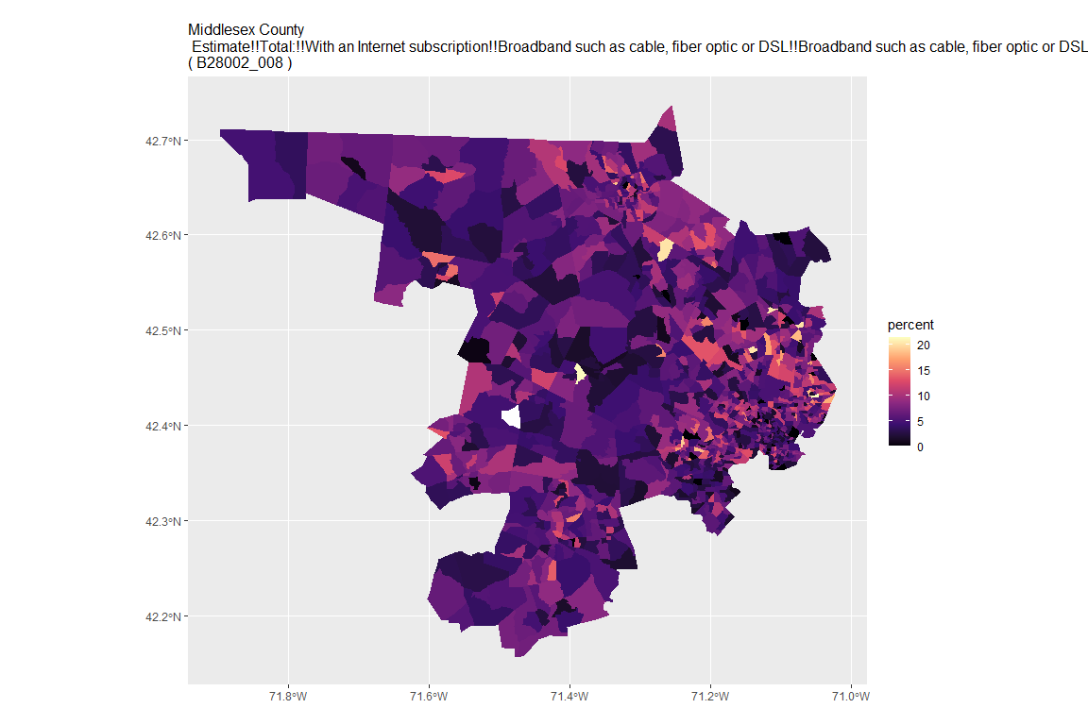

## For variable: B28002_009 : Estimate!!Total:!!With an Internet subscription!!Satellite Internet service

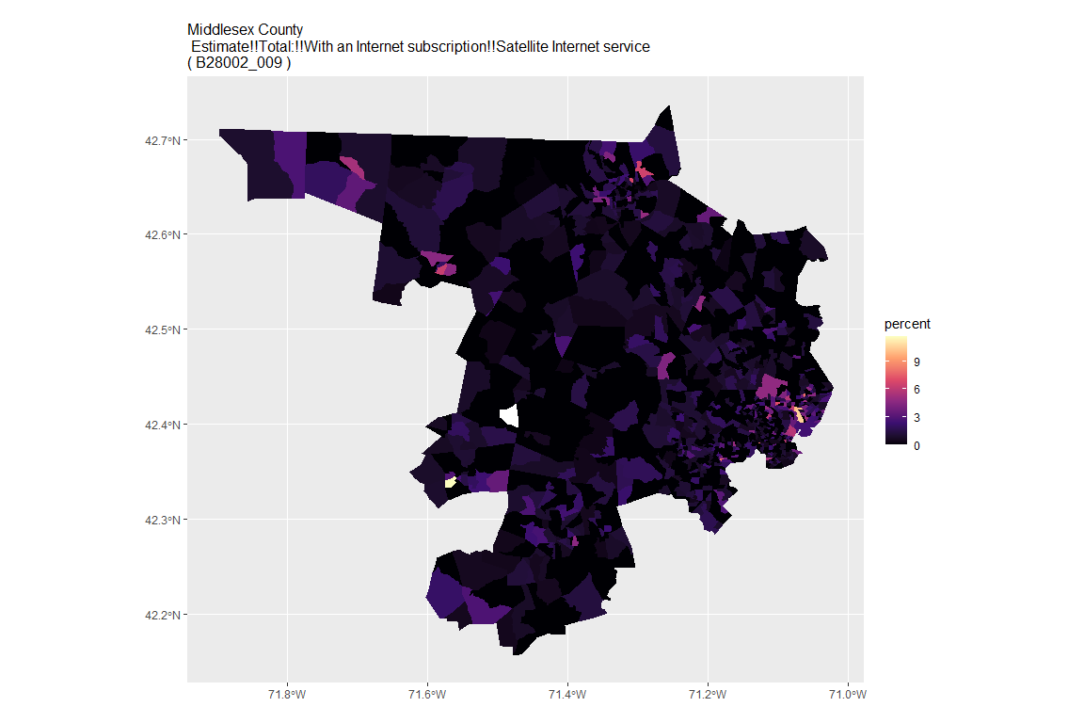

## For variable: B28002_010 : Estimate!!Total:!!With an Internet subscription!!Satellite Internet service!!Satellite Internet service with no other type of Internet subscription

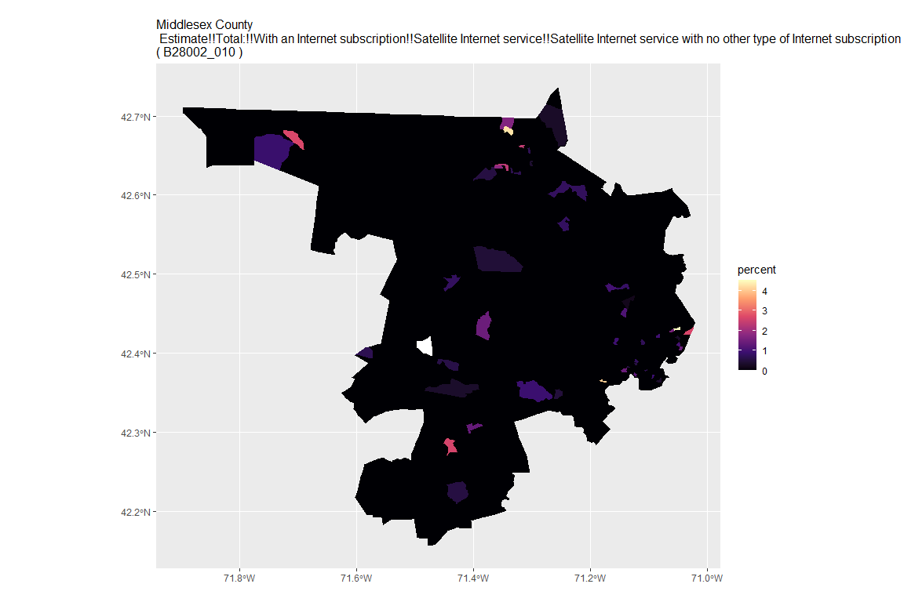

## For variable: B28002_011 : Estimate!!Total:!!With an Internet subscription!!Other service with no other type of Internet subscription

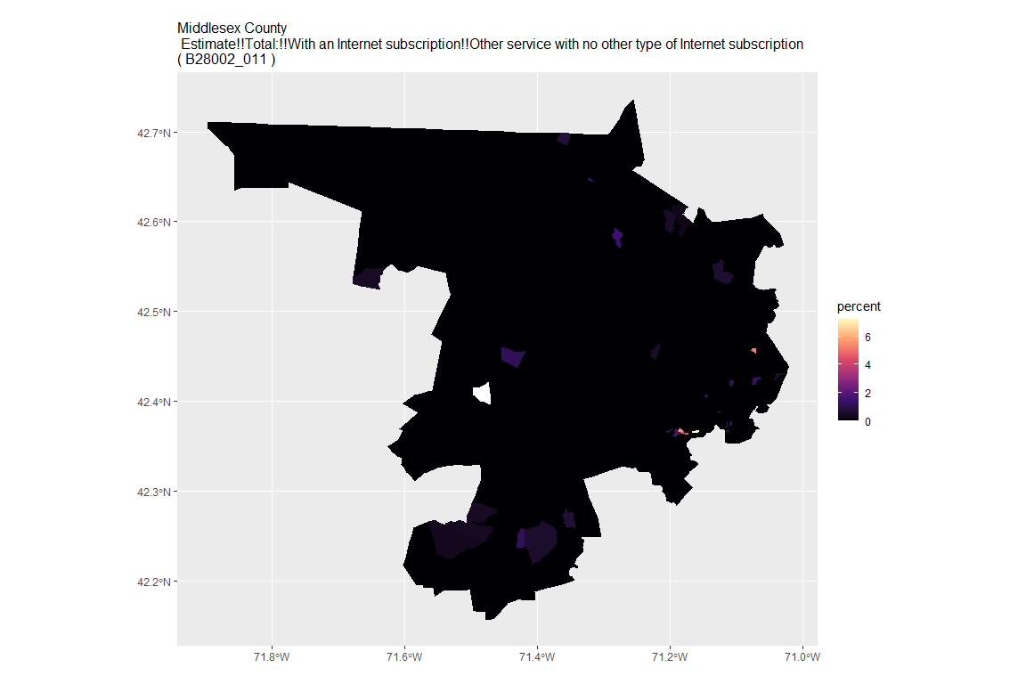

## For variable: B28002_012 : Estimate!!Total:!!Internet access without a subscription

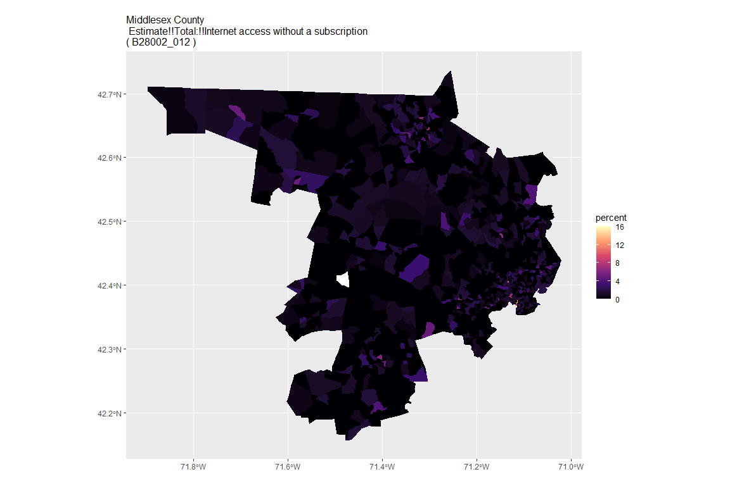

## For variable: B28002_013 : Estimate!!Total:!!No Internet access

## For county: Nantucket County

## Getting data from the 2015-2019 5-year ACS  
## Downloading feature geometry from the Census website. To cache shapefiles for use in future sessions, set `options(tigris_use_cache = TRUE)`.

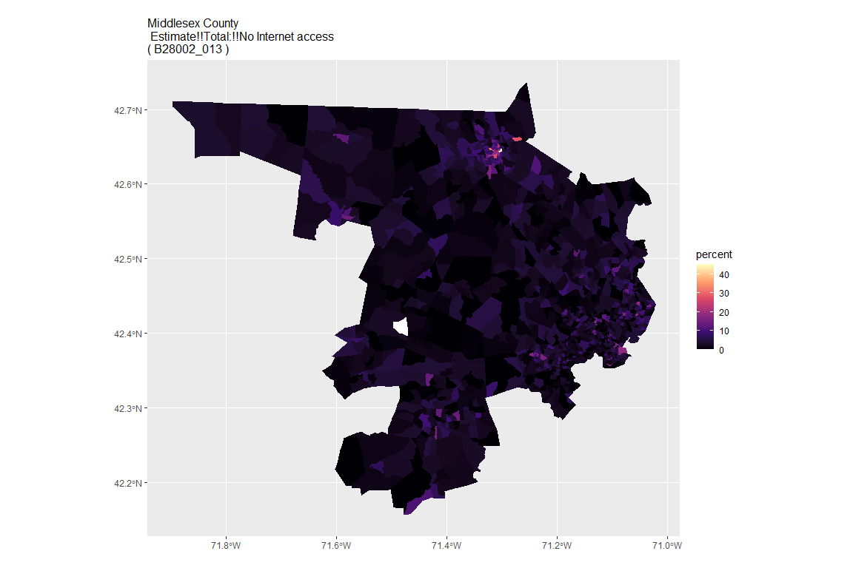

## For variable: B28002_001 : Estimate!!Total:

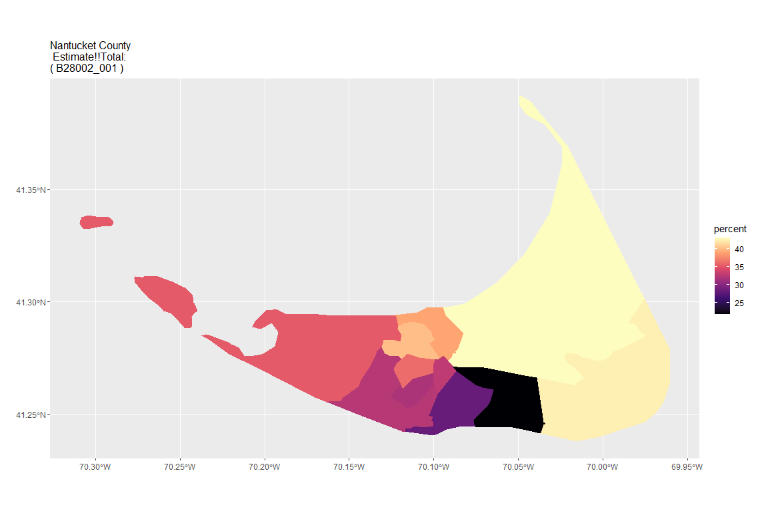

## For variable: B28002_002 : Estimate!!Total:!!With an Internet subscription

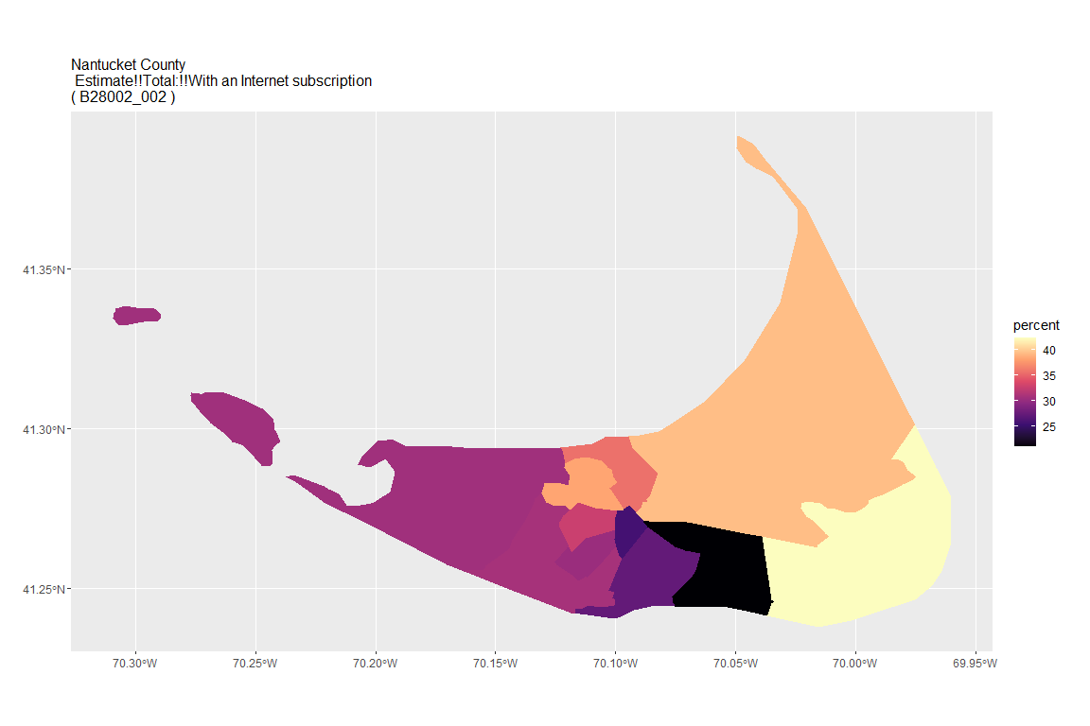

## For variable: B28002_003 : Estimate!!Total:!!With an Internet subscription!!Dial-up with no other type of Internet subscription

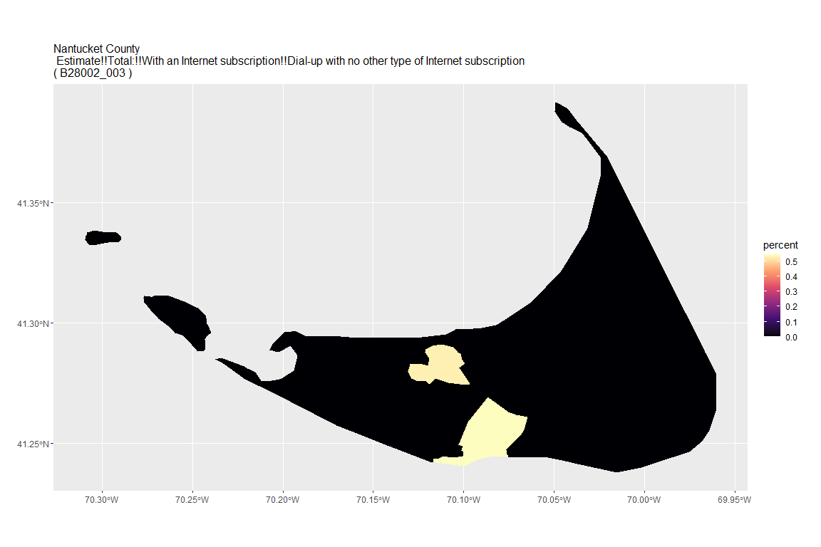

## For variable: B28002_004 : Estimate!!Total:!!With an Internet subscription!!Broadband of any type

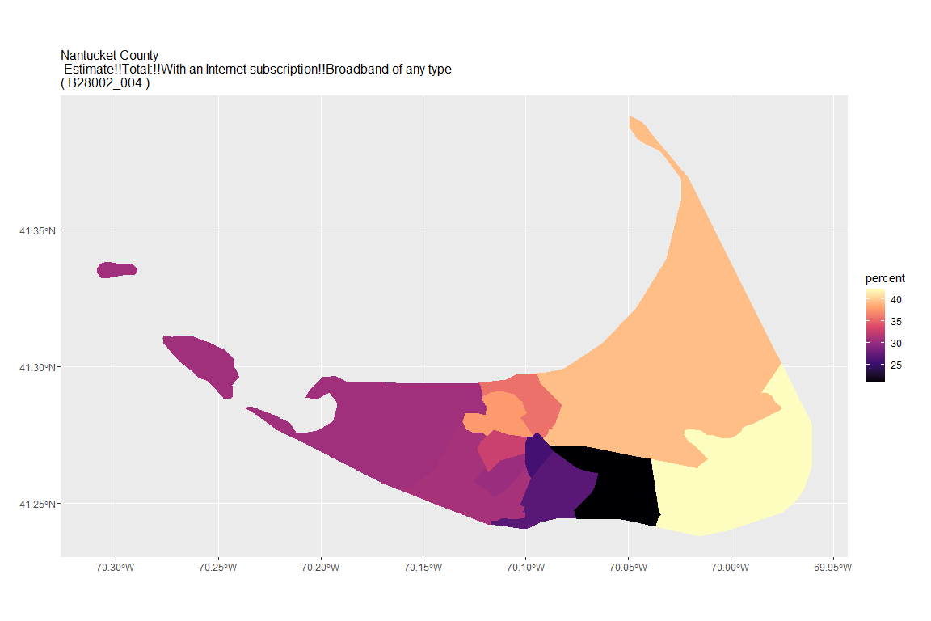

## For variable: B28002_005 : Estimate!!Total:!!With an Internet subscription!!Cellular data plan

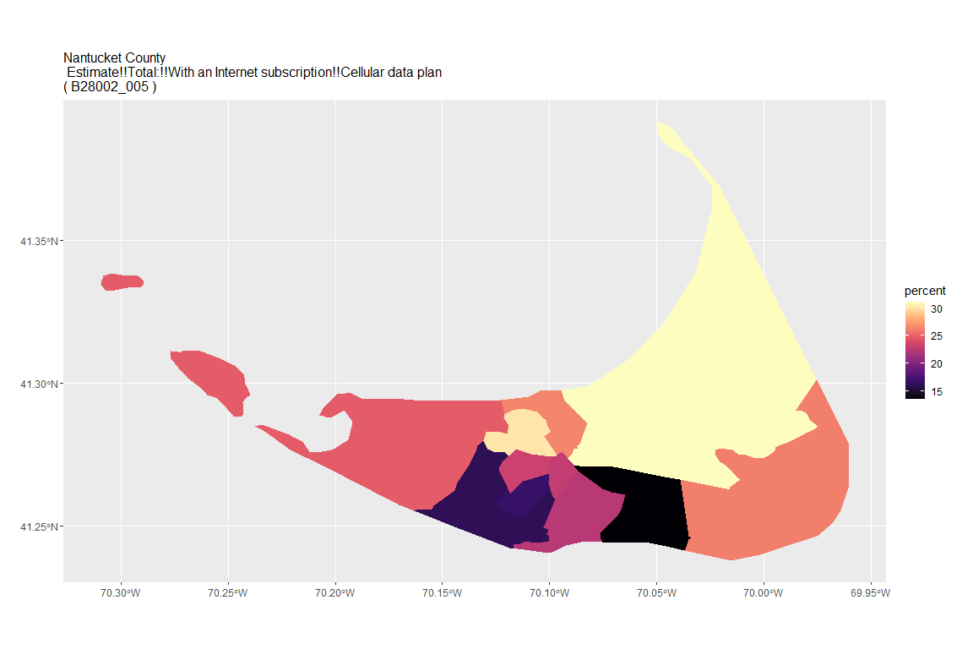

## For variable: B28002_006 : Estimate!!Total:!!With an Internet subscription!!Cellular data plan!!Cellular data plan with no other type of Internet subscription

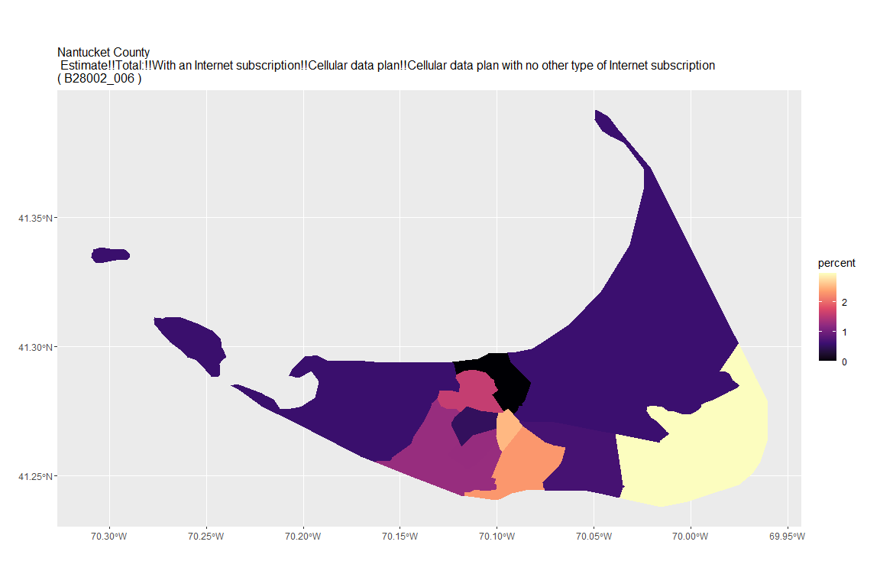

## For variable: B28002_007 : Estimate!!Total:!!With an Internet subscription!!Broadband such as cable, fiber optic or DSL

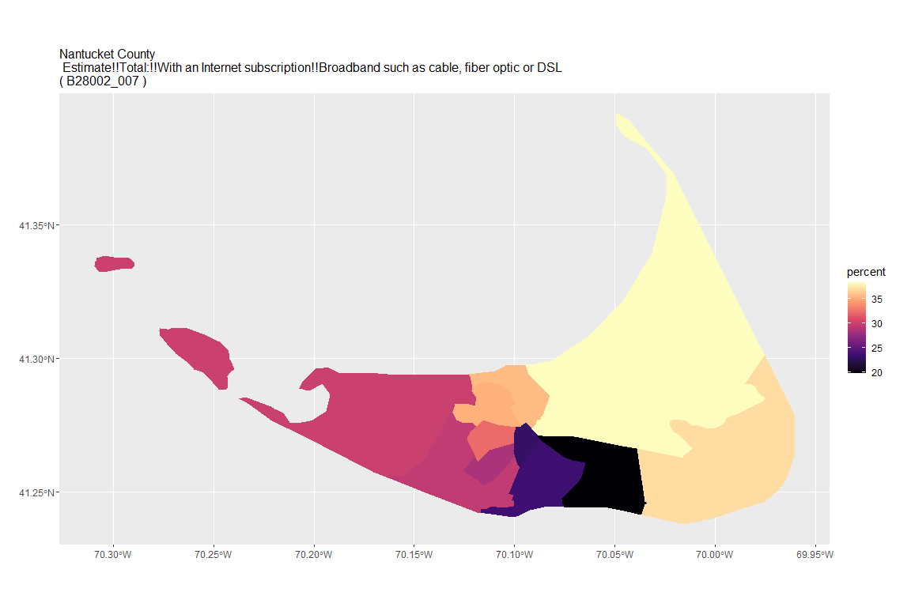

## For variable: B28002_008 : Estimate!!Total:!!With an Internet subscription!!Broadband such as cable, fiber optic or DSL!!Broadband such as cable, fiber optic or DSL with no other type of Internet subscription

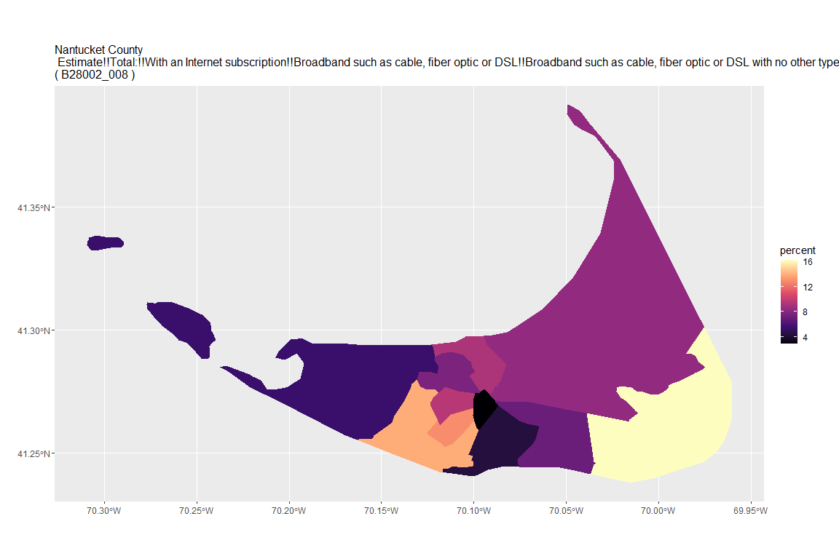

## For variable: B28002_009 : Estimate!!Total:!!With an Internet subscription!!Satellite Internet service

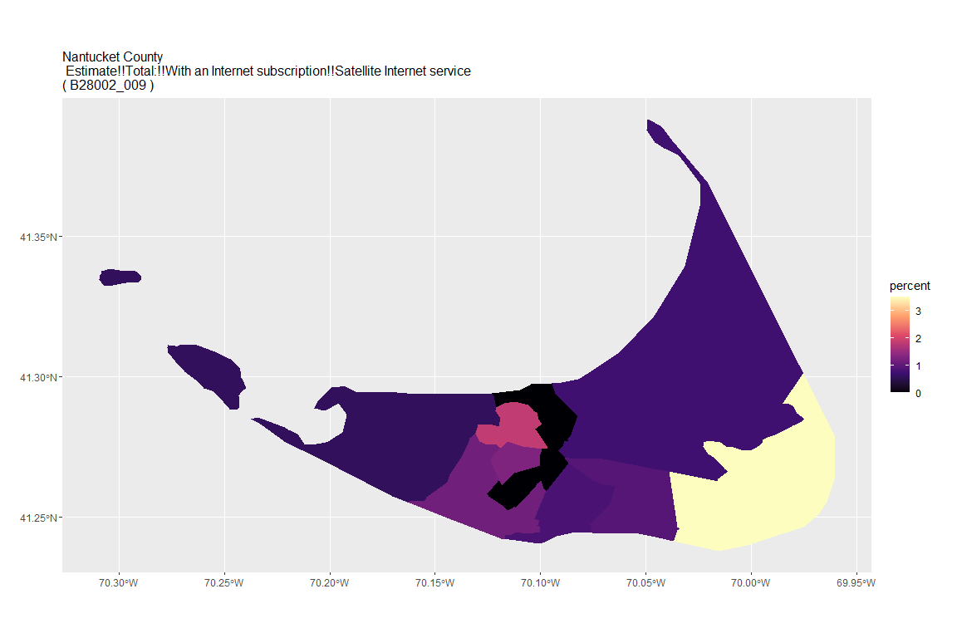

## For variable: B28002_010 : Estimate!!Total:!!With an Internet subscription!!Satellite Internet service!!Satellite Internet service with no other type of Internet subscription

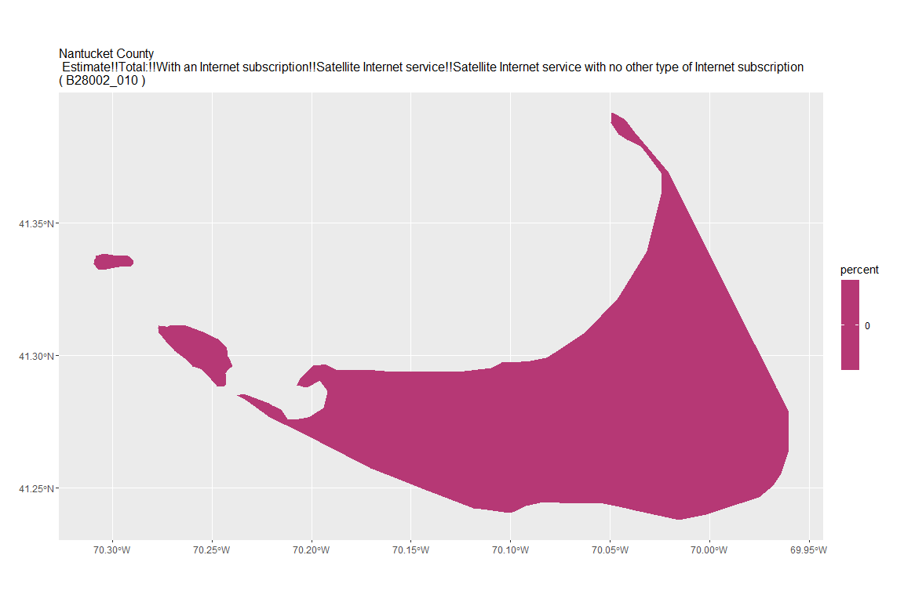

## For variable: B28002_011 : Estimate!!Total:!!With an Internet subscription!!Other service with no other type of Internet subscription

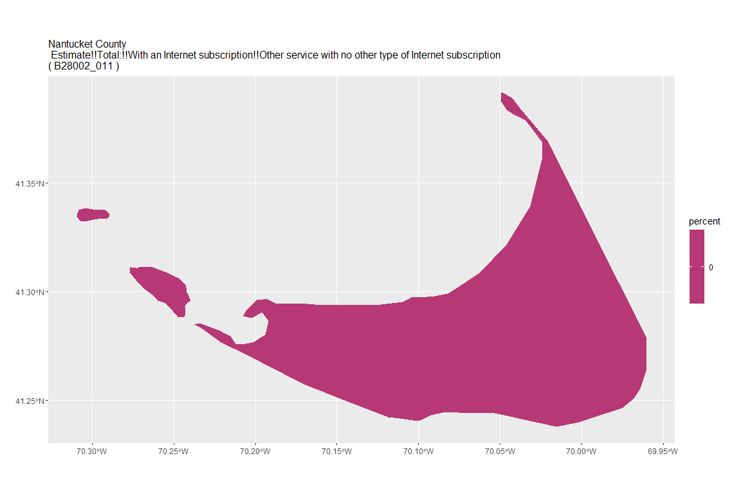

## For variable: B28002_012 : Estimate!!Total:!!Internet access without a subscription

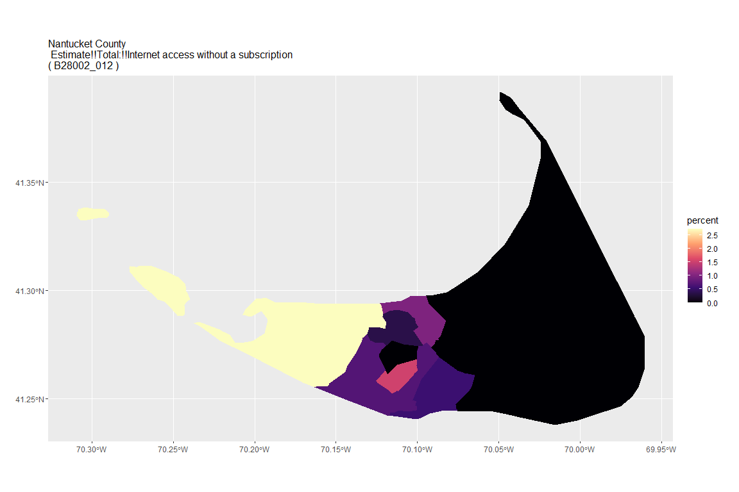

## For variable: B28002_013 : Estimate!!Total:!!No Internet access

## For county: Norfolk County

## Getting data from the 2015-2019 5-year ACS  
## Downloading feature geometry from the Census website. To cache shapefiles for use in future sessions, set `options(tigris_use_cache = TRUE)`.

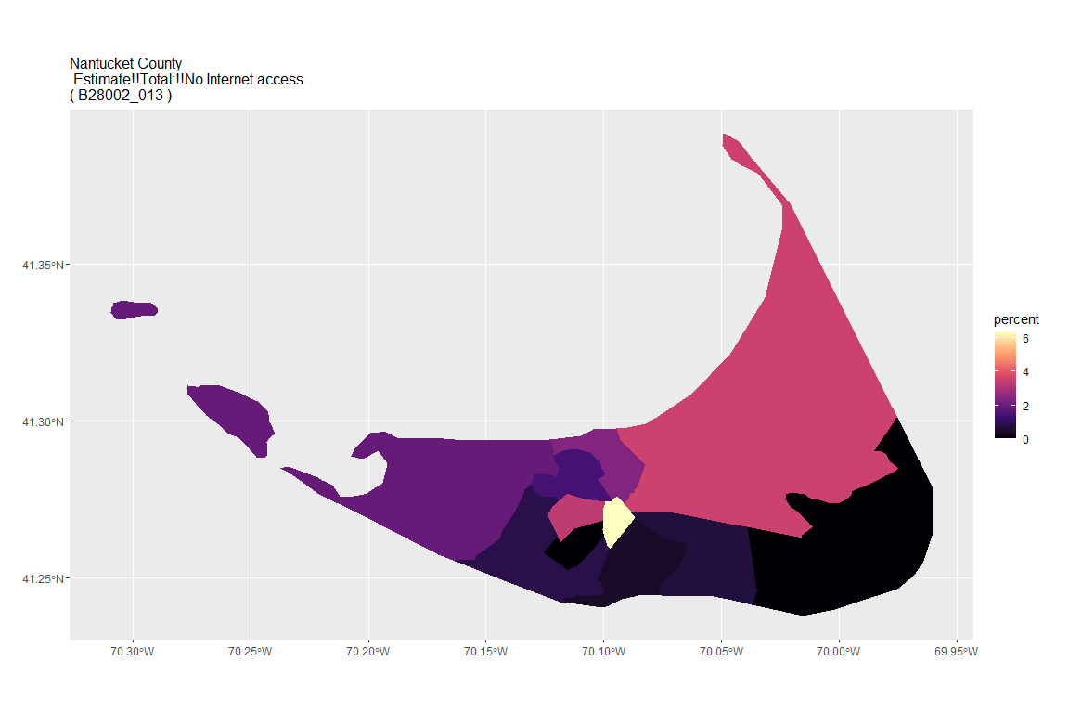

## For variable: B28002_001 : Estimate!!Total:

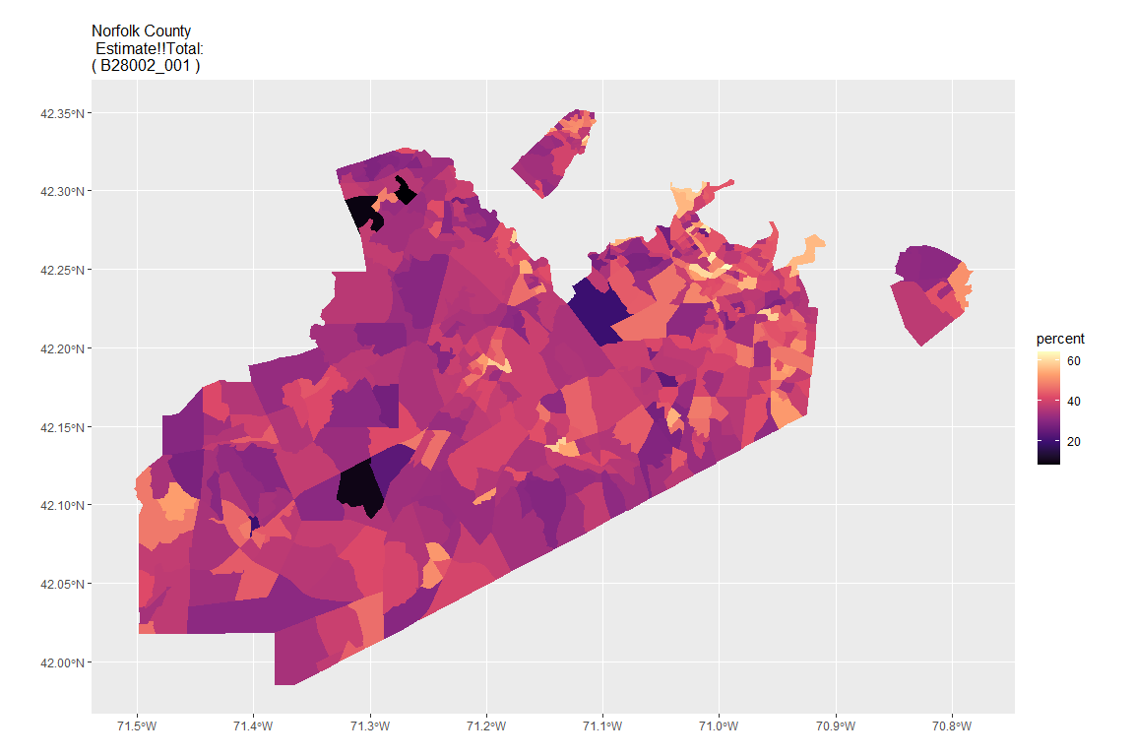

## For variable: B28002_002 : Estimate!!Total:!!With an Internet subscription

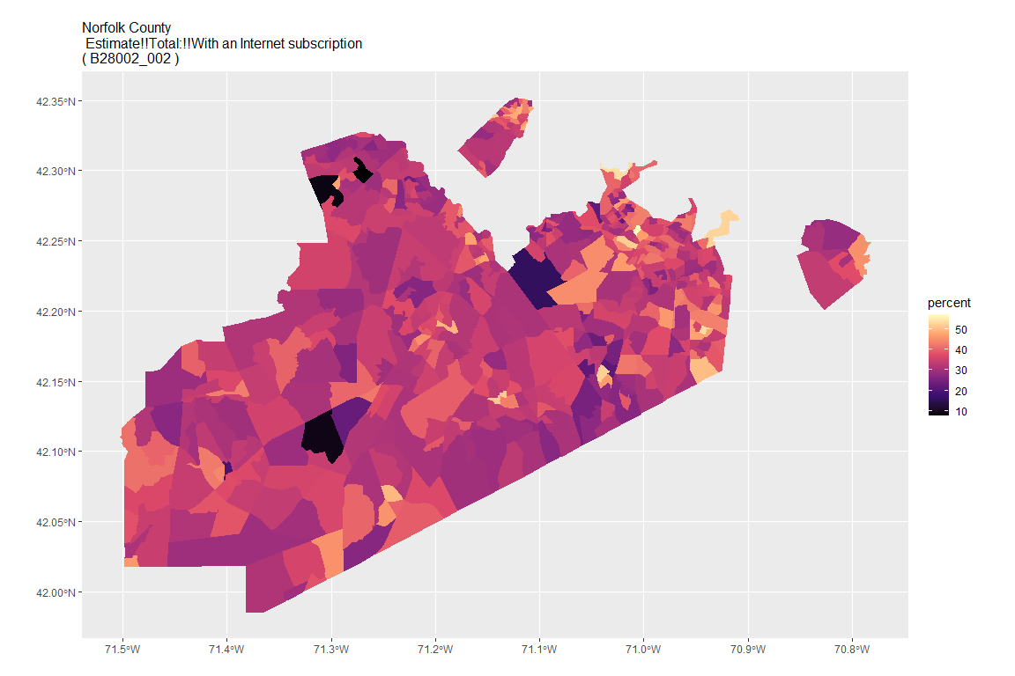

## For variable: B28002_003 : Estimate!!Total:!!With an Internet subscription!!Dial-up with no other type of Internet subscription

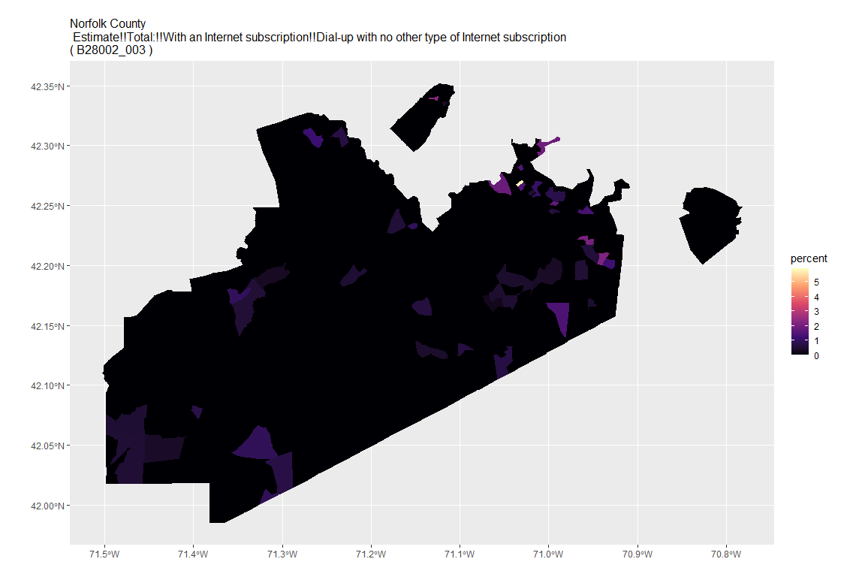

## For variable: B28002_004 : Estimate!!Total:!!With an Internet subscription!!Broadband of any type

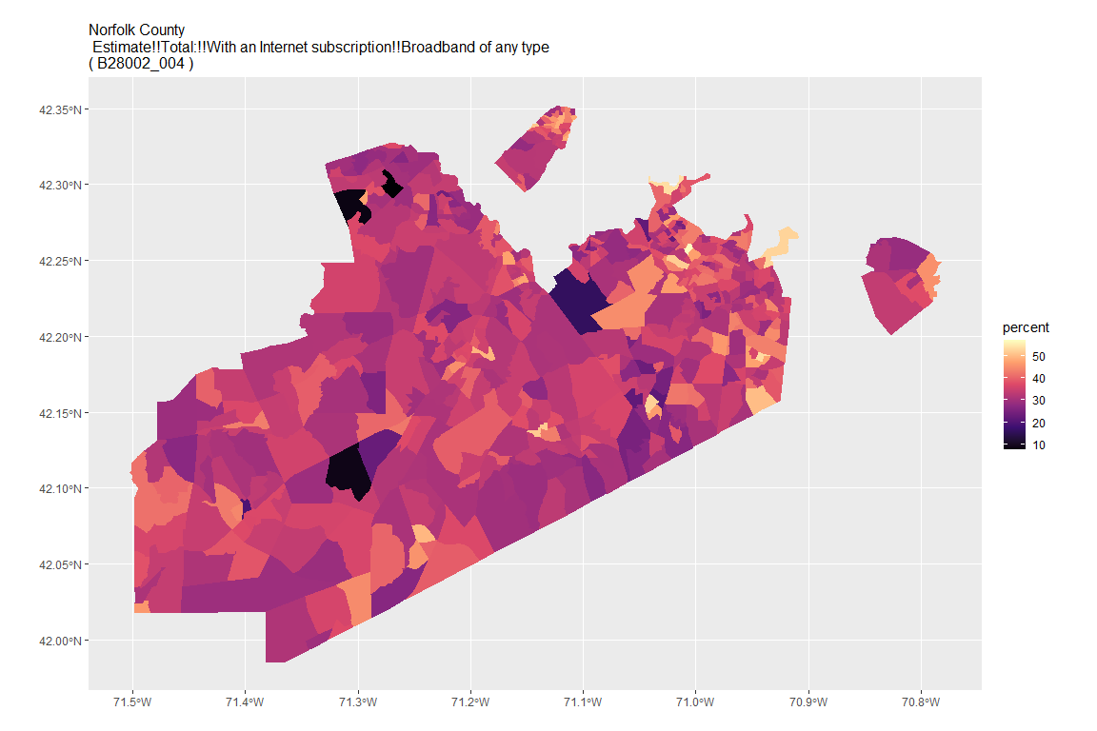

## For variable: B28002_005 : Estimate!!Total:!!With an Internet subscription!!Cellular data plan

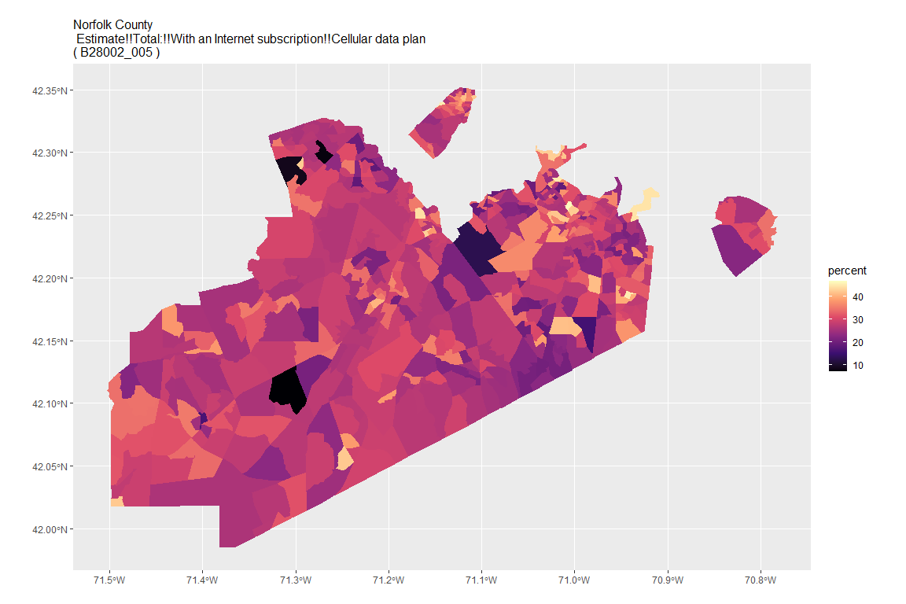

## For variable: B28002_006 : Estimate!!Total:!!With an Internet subscription!!Cellular data plan!!Cellular data plan with no other type of Internet subscription

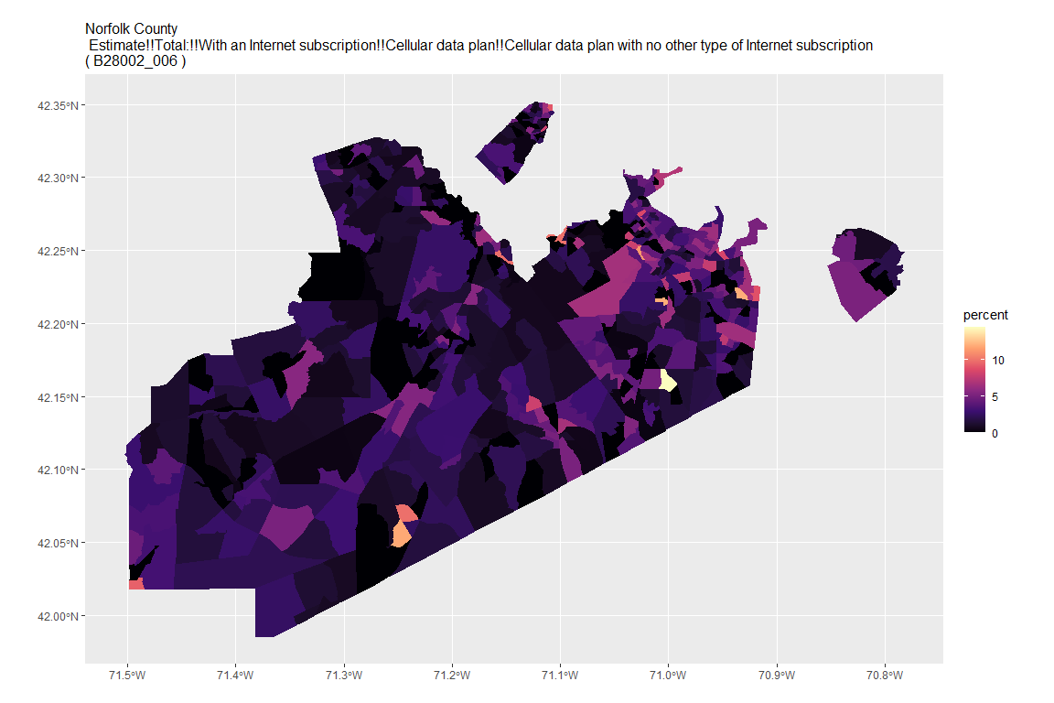

## For variable: B28002_007 : Estimate!!Total:!!With an Internet subscription!!Broadband such as cable, fiber optic or DSL

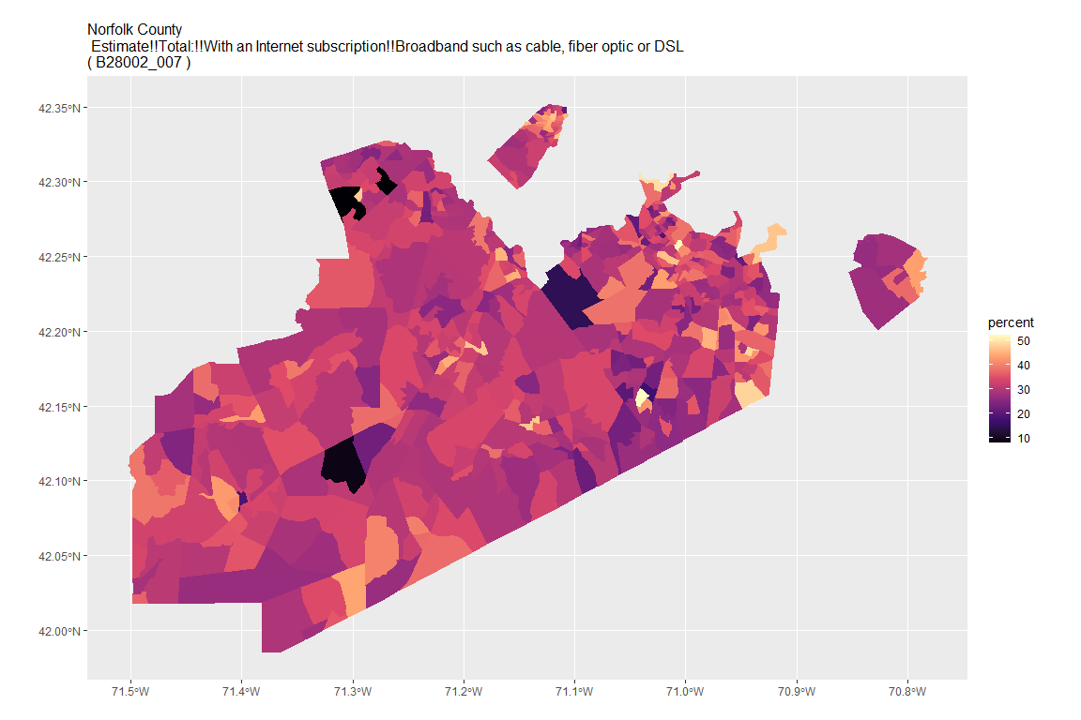

## For variable: B28002_008 : Estimate!!Total:!!With an Internet subscription!!Broadband such as cable, fiber optic or DSL!!Broadband such as cable, fiber optic or DSL with no other type of Internet subscription

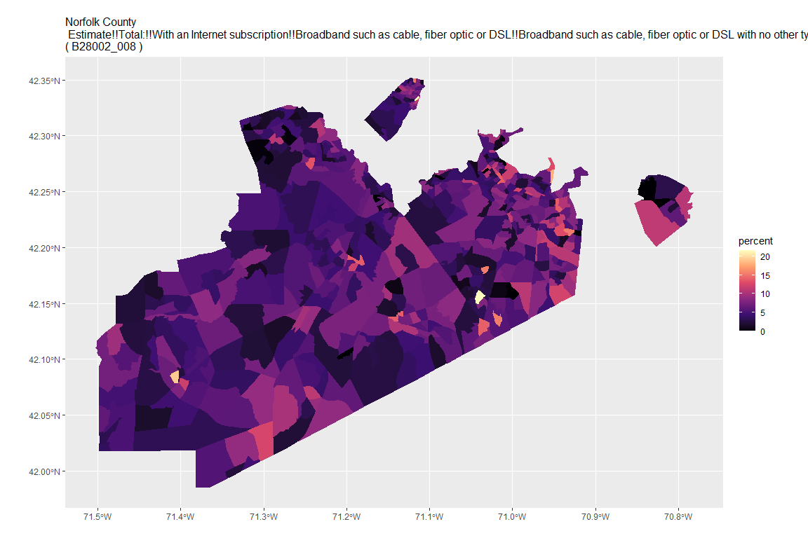

## For variable: B28002_009 : Estimate!!Total:!!With an Internet subscription!!Satellite Internet service

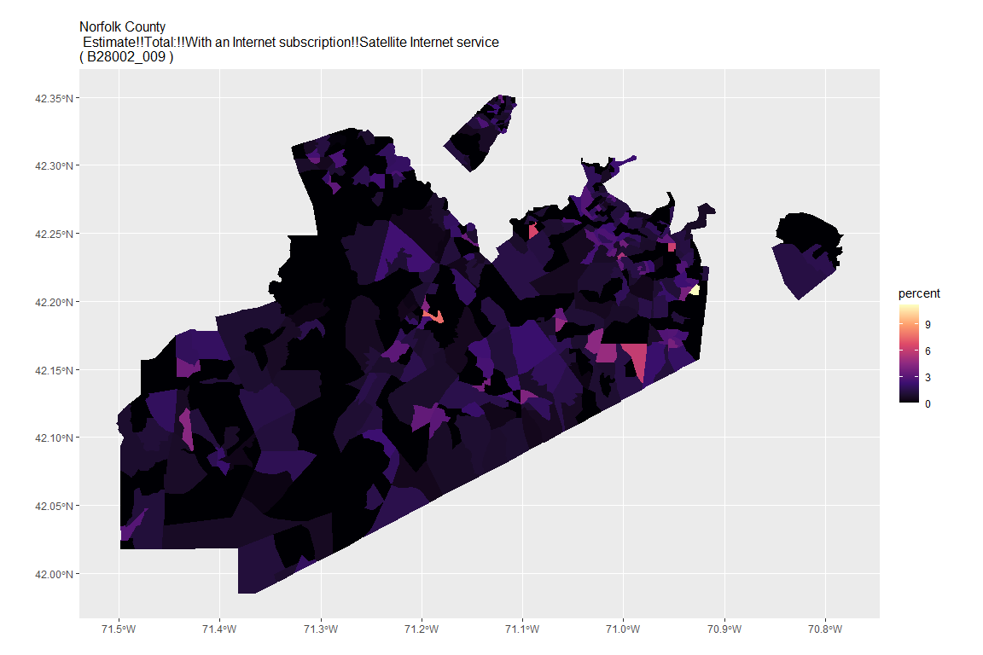

## For variable: B28002_010 : Estimate!!Total:!!With an Internet subscription!!Satellite Internet service!!Satellite Internet service with no other type of Internet subscription

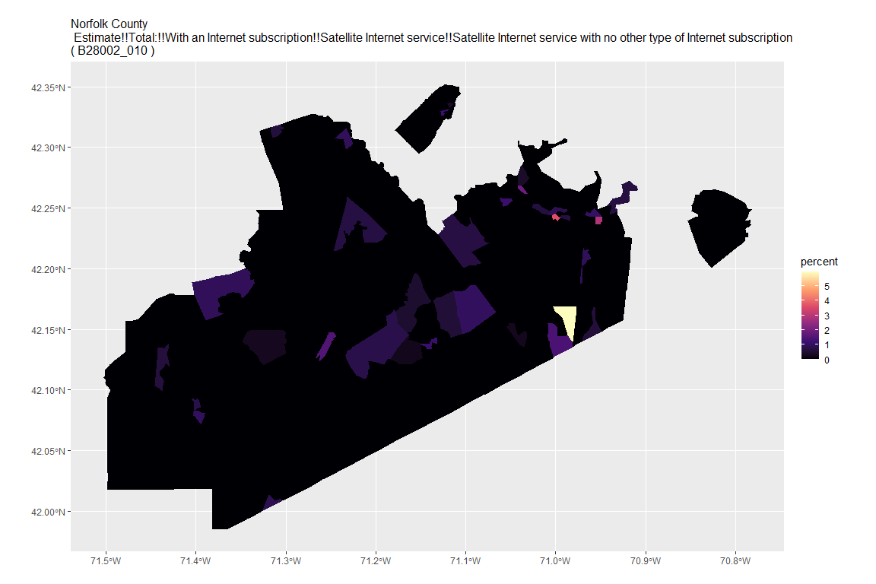

## For variable: B28002_011 : Estimate!!Total:!!With an Internet subscription!!Other service with no other type of Internet subscription

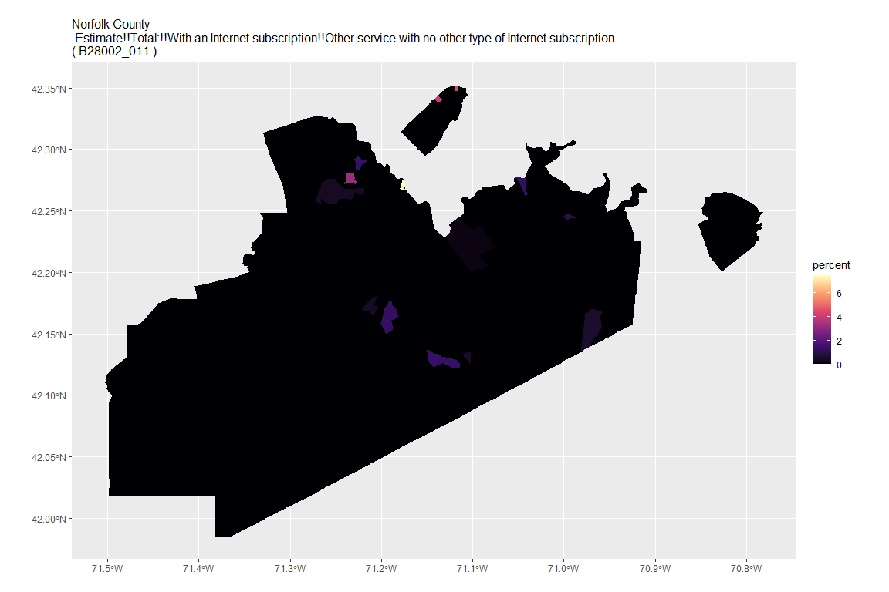

## For variable: B28002_012 : Estimate!!Total:!!Internet access without a subscription

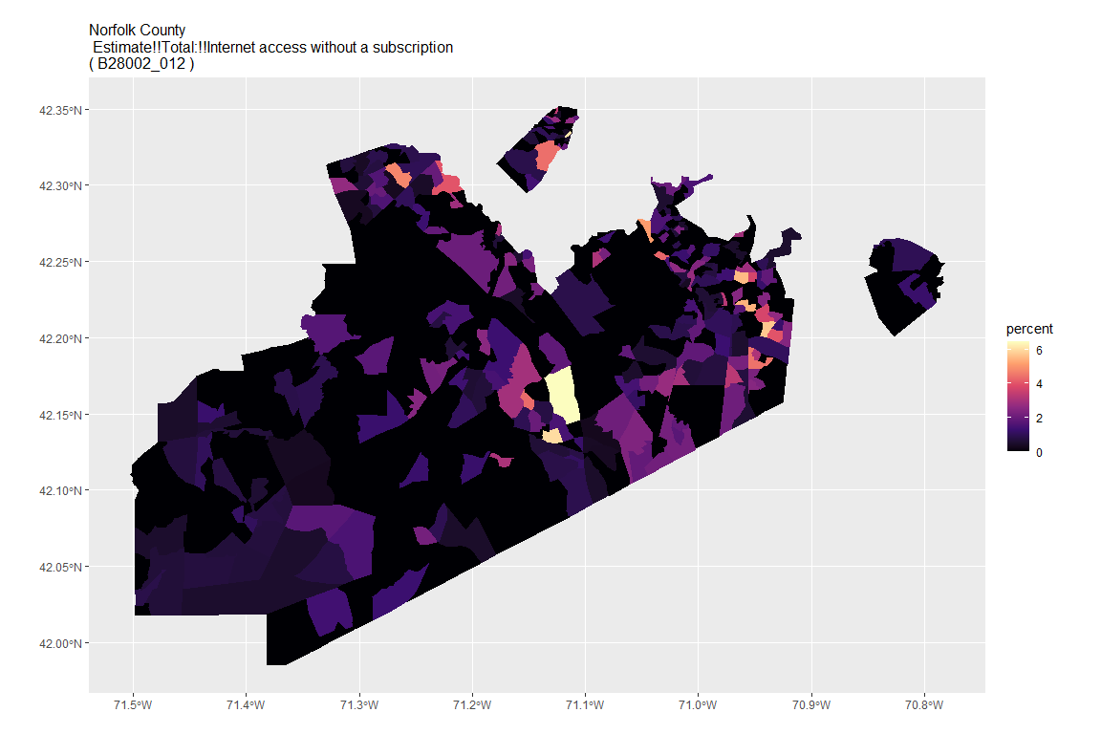

## For variable: B28002_013 : Estimate!!Total:!!No Internet access

## For county: Plymouth County

## Getting data from the 2015-2019 5-year ACS  
## Downloading feature geometry from the Census website. To cache shapefiles for use in future sessions, set `options(tigris_use_cache = TRUE)`.

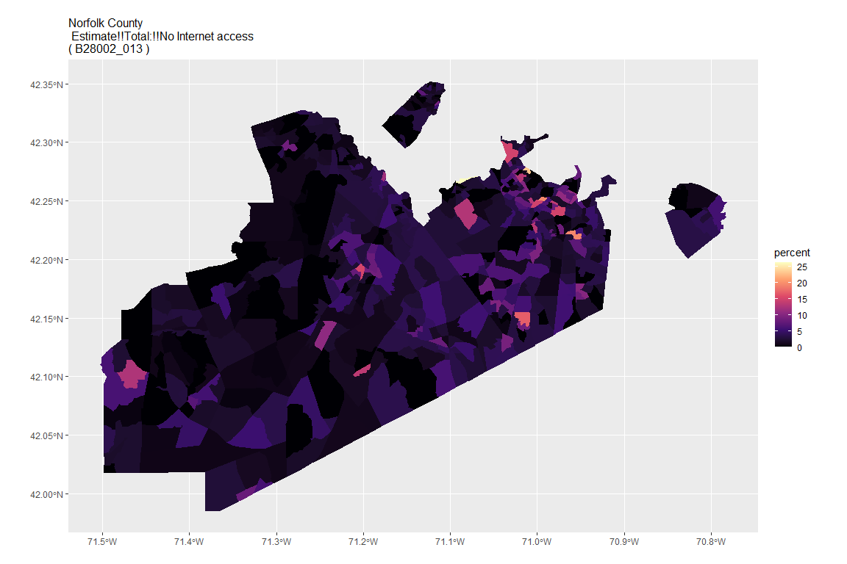

## For variable: B28002_001 : Estimate!!Total:

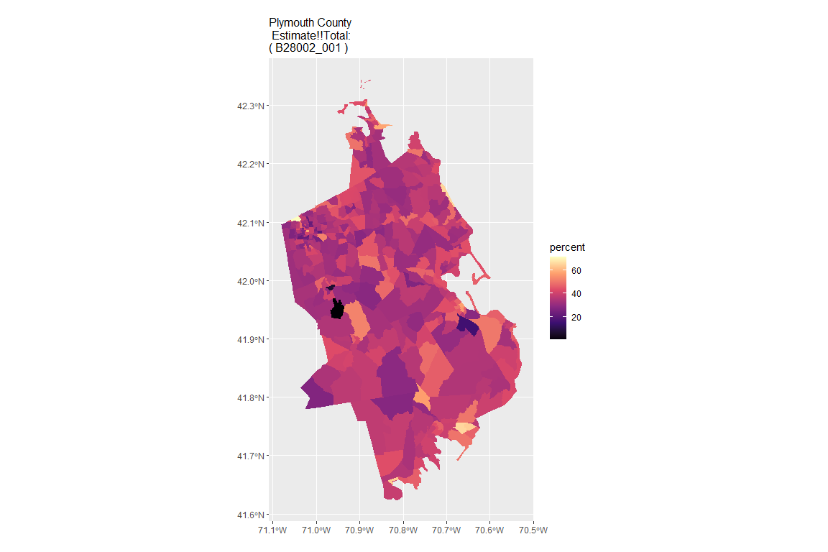

## For variable: B28002_002 : Estimate!!Total:!!With an Internet subscription

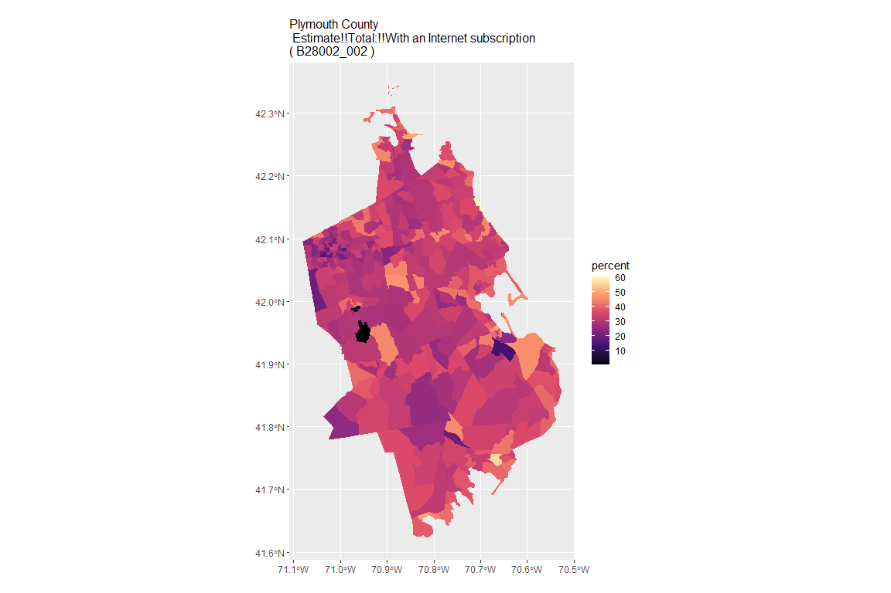

## For variable: B28002_003 : Estimate!!Total:!!With an Internet subscription!!Dial-up with no other type of Internet subscription

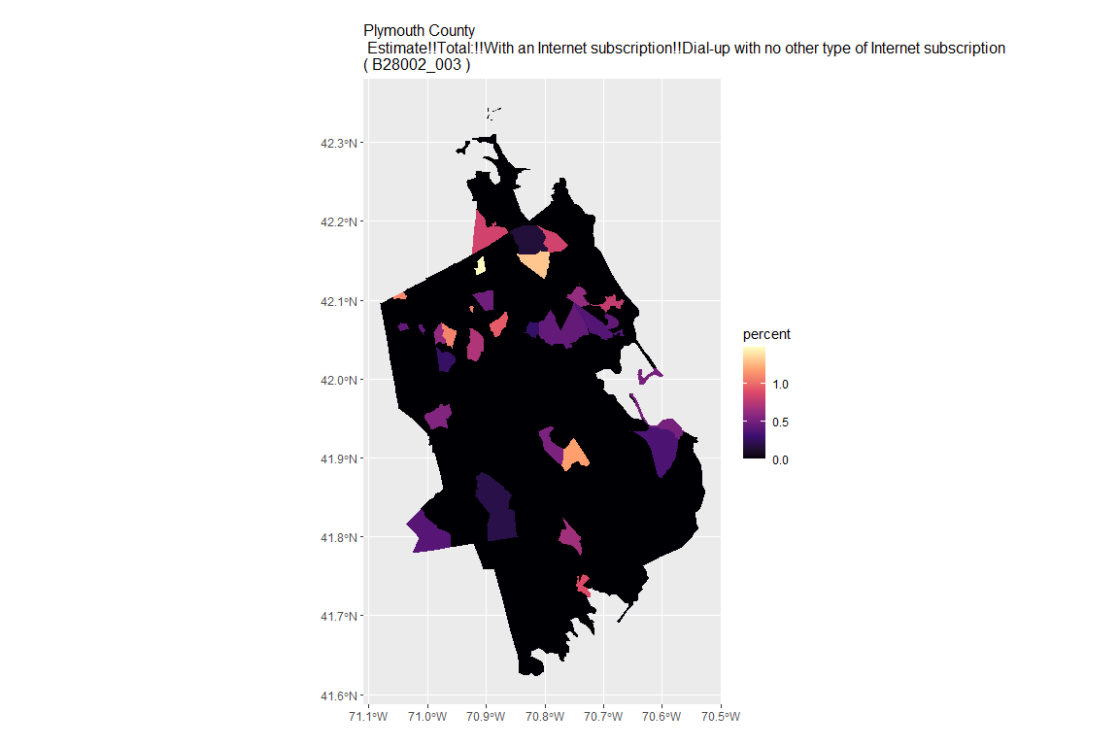

## For variable: B28002_004 : Estimate!!Total:!!With an Internet subscription!!Broadband of any type

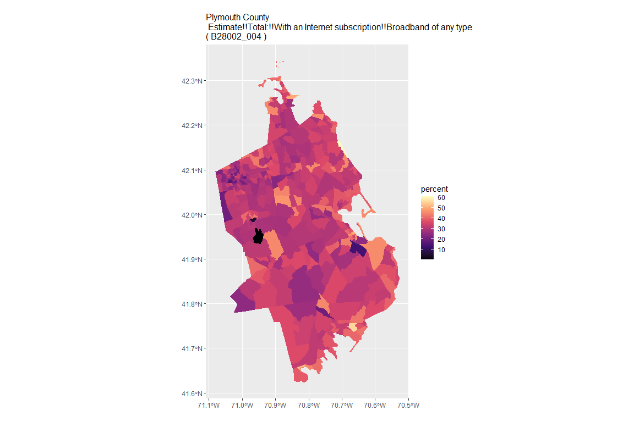

## For variable: B28002_005 : Estimate!!Total:!!With an Internet subscription!!Cellular data plan

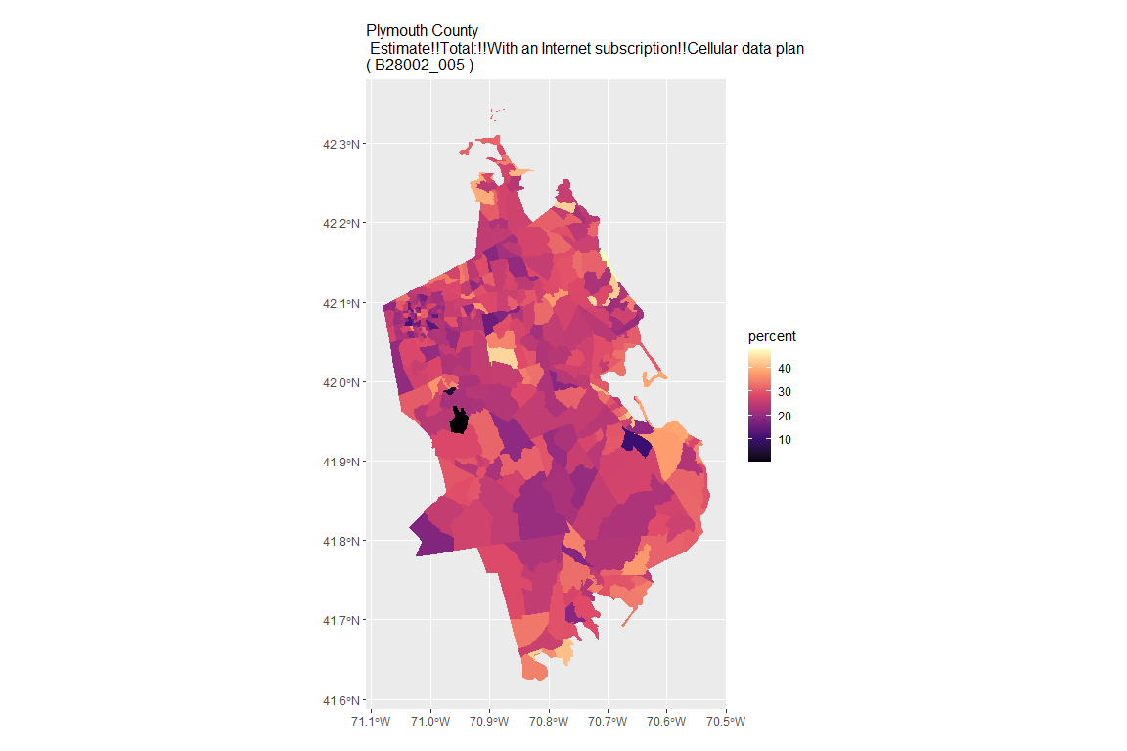

## For variable: B28002_006 : Estimate!!Total:!!With an Internet subscription!!Cellular data plan!!Cellular data plan with no other type of Internet subscription

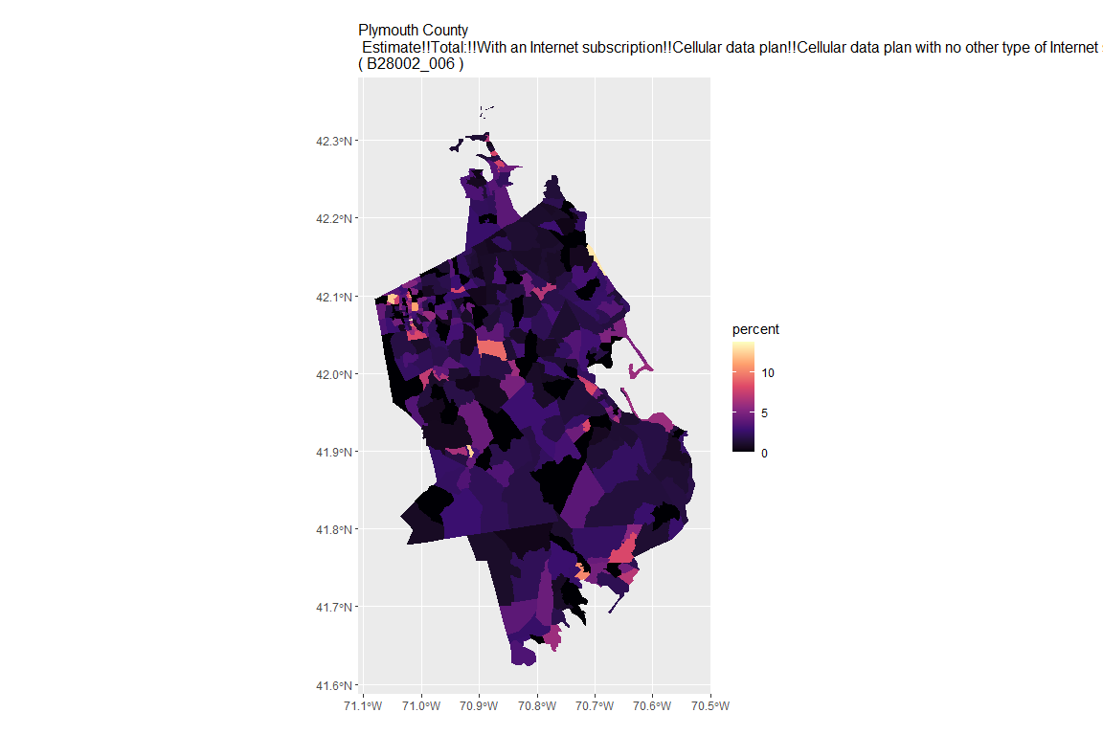

## For variable: B28002_007 : Estimate!!Total:!!With an Internet subscription!!Broadband such as cable, fiber optic or DSL

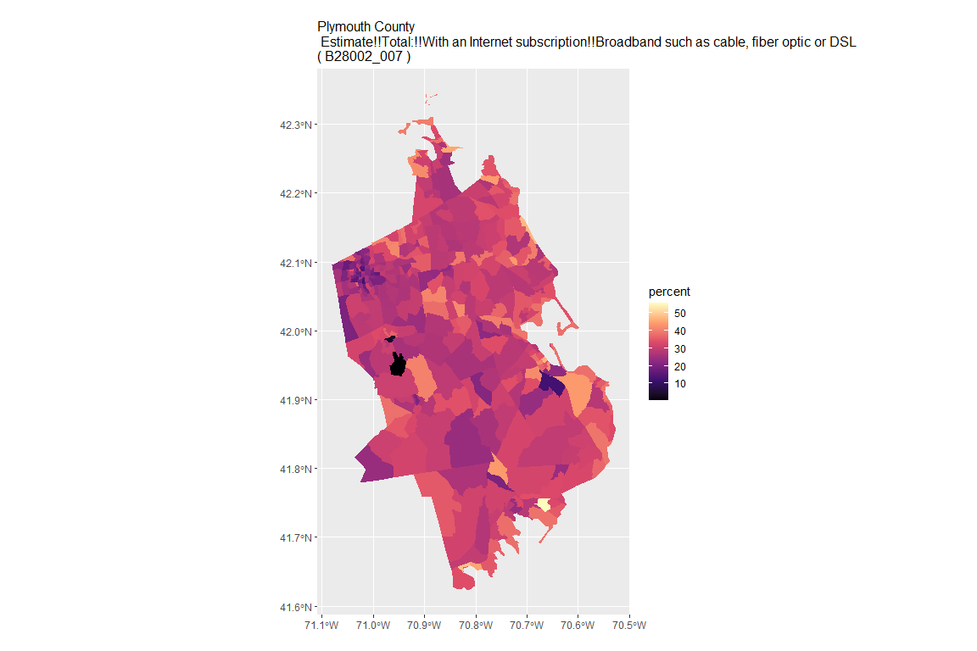

## For variable: B28002_008 : Estimate!!Total:!!With an Internet subscription!!Broadband such as cable, fiber optic or DSL!!Broadband such as cable, fiber optic or DSL with no other type of Internet subscription

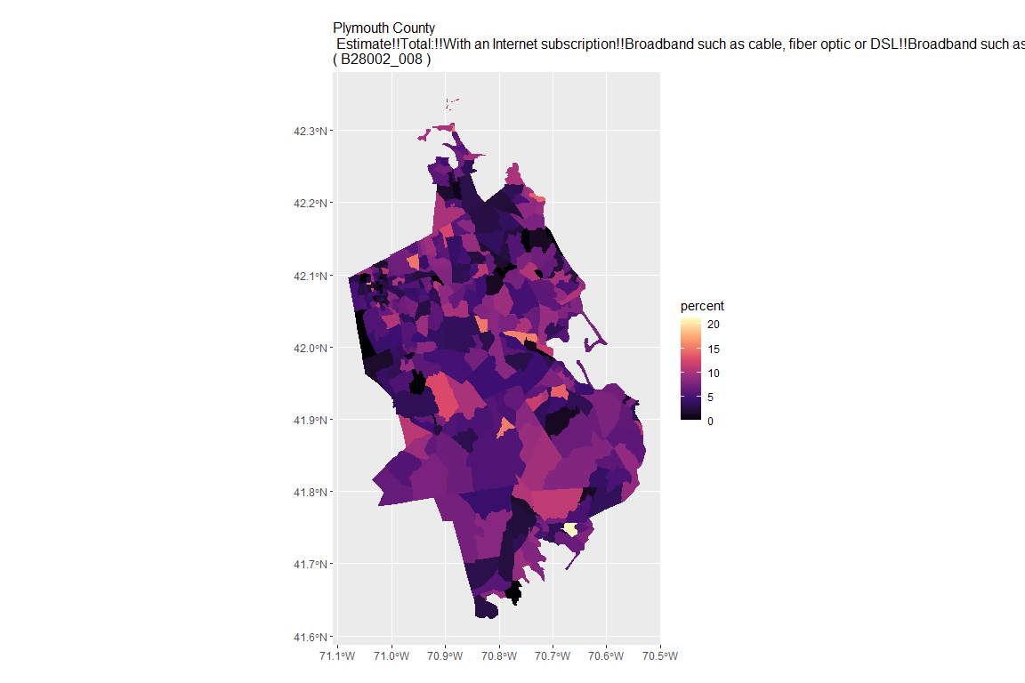

## For variable: B28002_009 : Estimate!!Total:!!With an Internet subscription!!Satellite Internet service

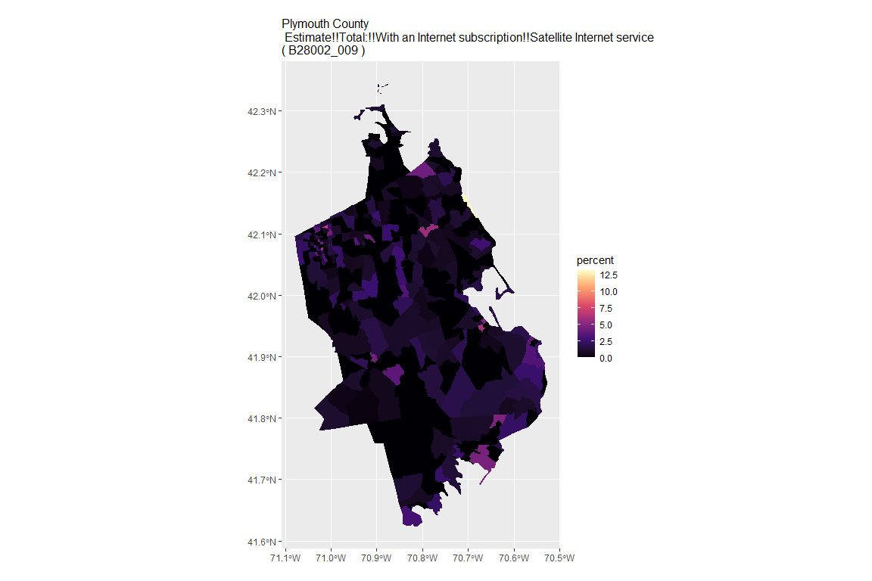

## For variable: B28002_010 : Estimate!!Total:!!With an Internet subscription!!Satellite Internet service!!Satellite Internet service with no other type of Internet subscription

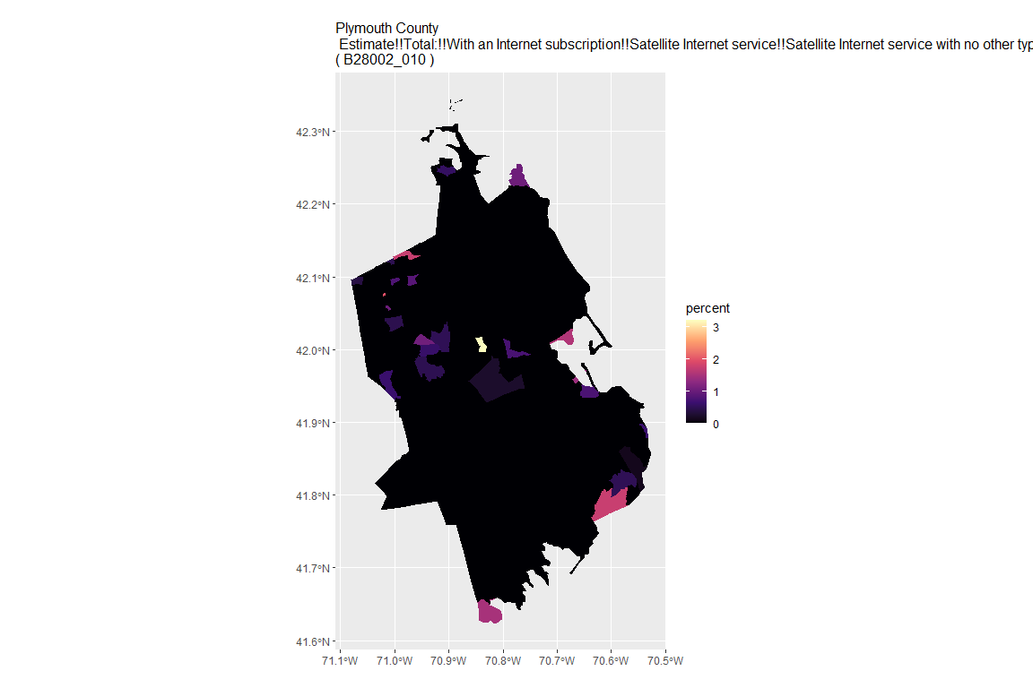

## For variable: B28002_011 : Estimate!!Total:!!With an Internet subscription!!Other service with no other type of Internet subscription

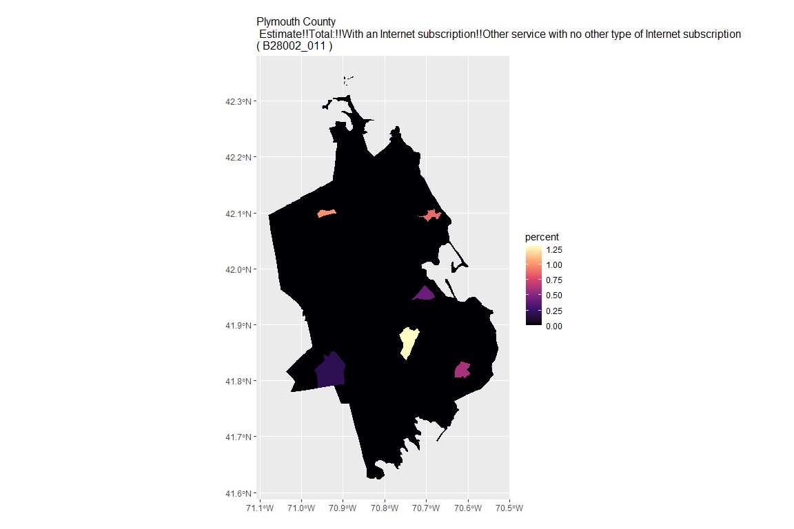

## For variable: B28002_012 : Estimate!!Total:!!Internet access without a subscription

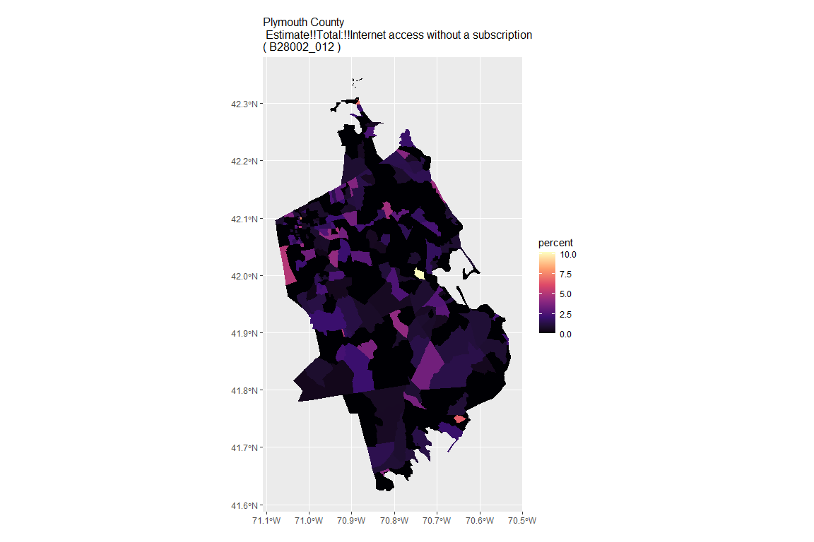

## For variable: B28002_013 : Estimate!!Total:!!No Internet access

## For county: Suffolk County

## Getting data from the 2015-2019 5-year ACS  
## Downloading feature geometry from the Census website. To cache shapefiles for use in future sessions, set `options(tigris_use_cache = TRUE)`.

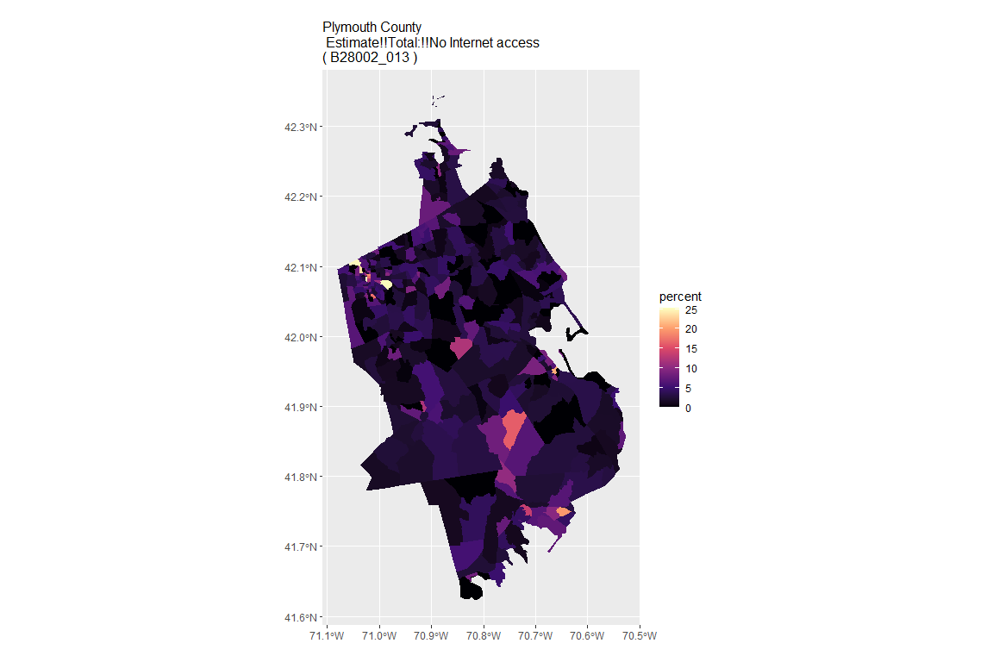

## For variable: B28002_001 : Estimate!!Total:

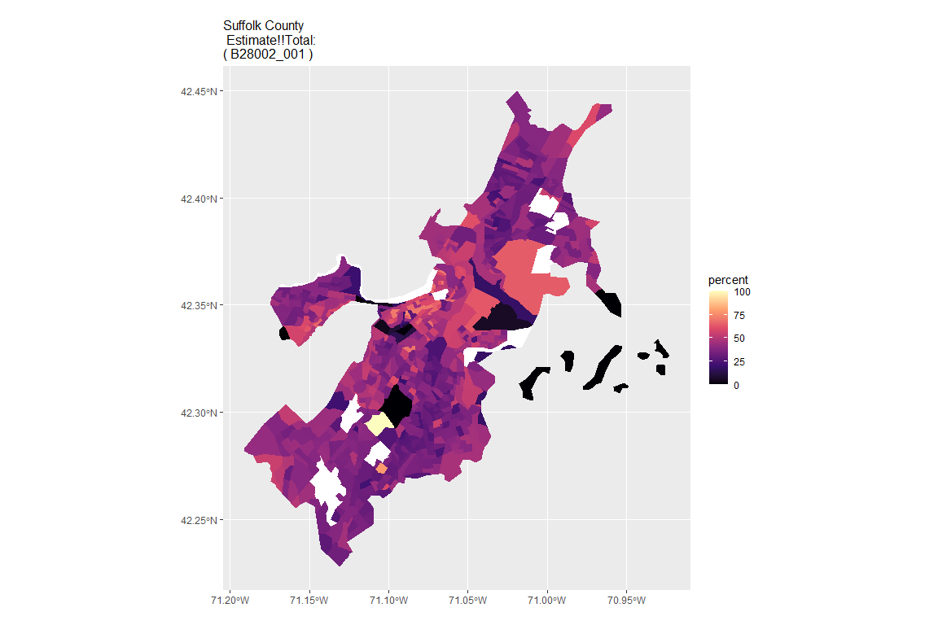

## For variable: B28002_002 : Estimate!!Total:!!With an Internet subscription

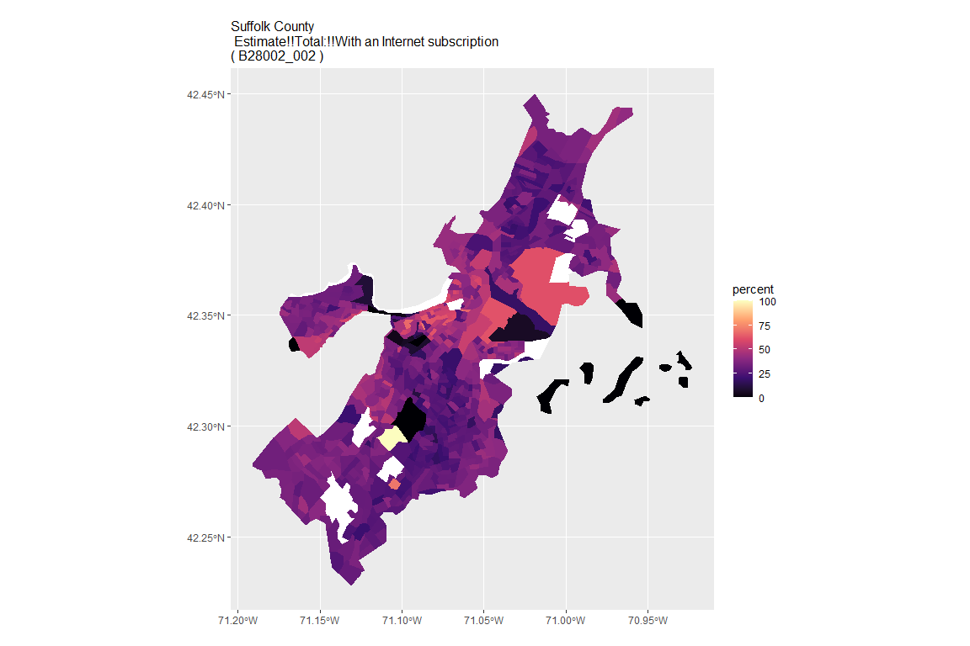

## For variable: B28002_003 : Estimate!!Total:!!With an Internet subscription!!Dial-up with no other type of Internet subscription

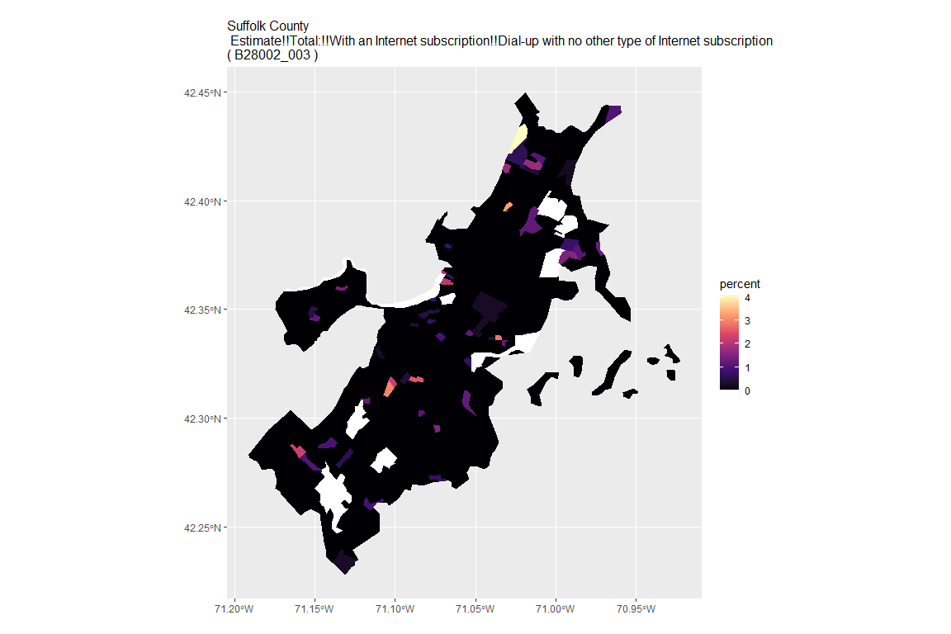

## For variable: B28002_004 : Estimate!!Total:!!With an Internet subscription!!Broadband of any type

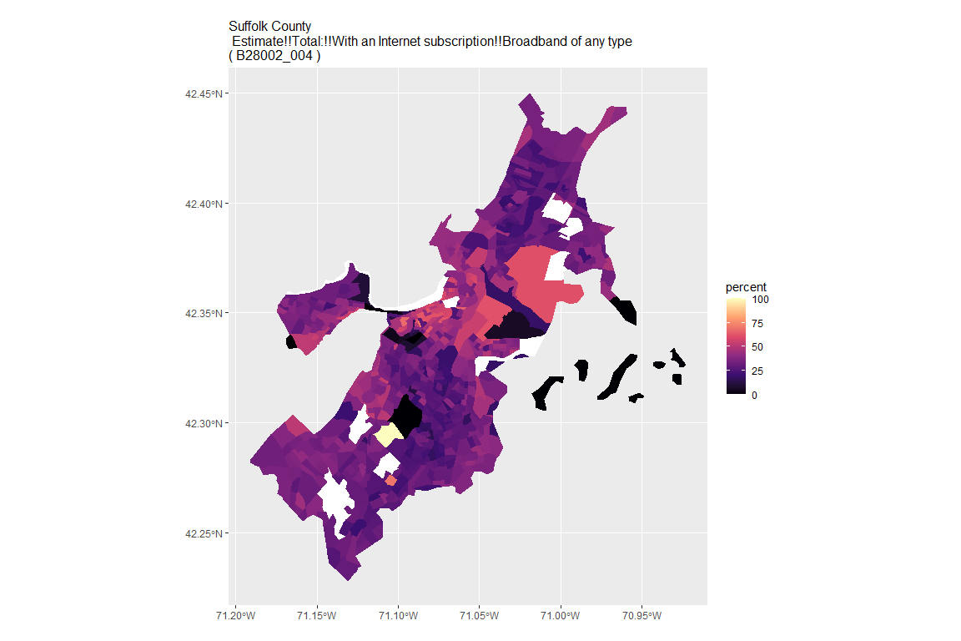

## For variable: B28002_005 : Estimate!!Total:!!With an Internet subscription!!Cellular data plan

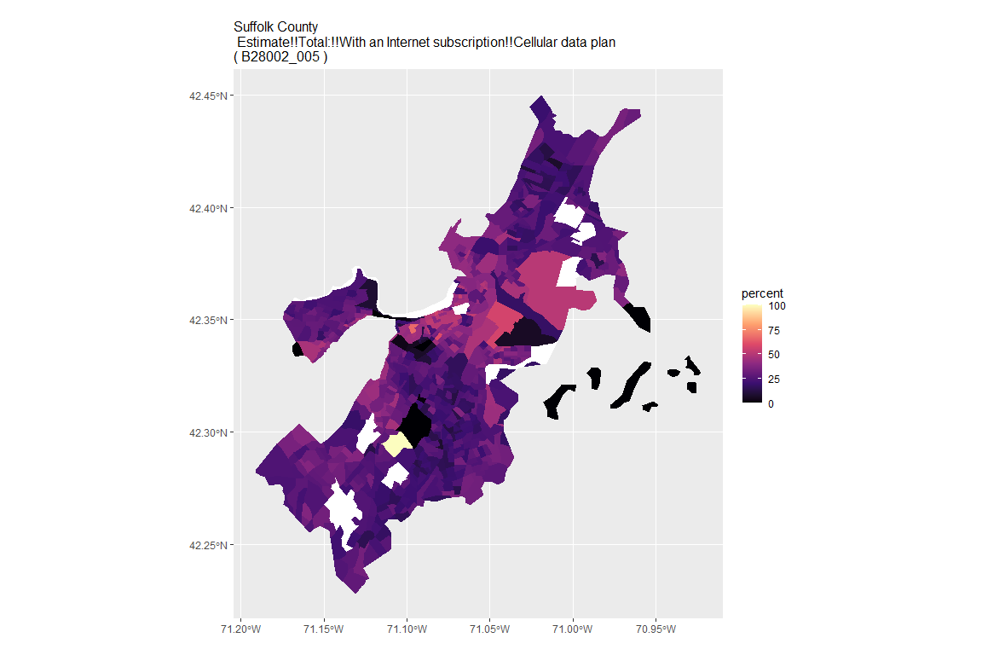

## For variable: B28002_006 : Estimate!!Total:!!With an Internet subscription!!Cellular data plan!!Cellular data plan with no other type of Internet subscription

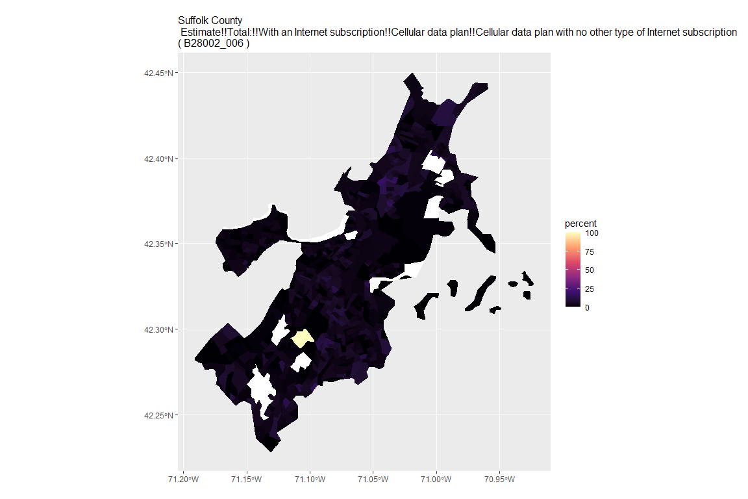

## For variable: B28002_007 : Estimate!!Total:!!With an Internet subscription!!Broadband such as cable, fiber optic or DSL

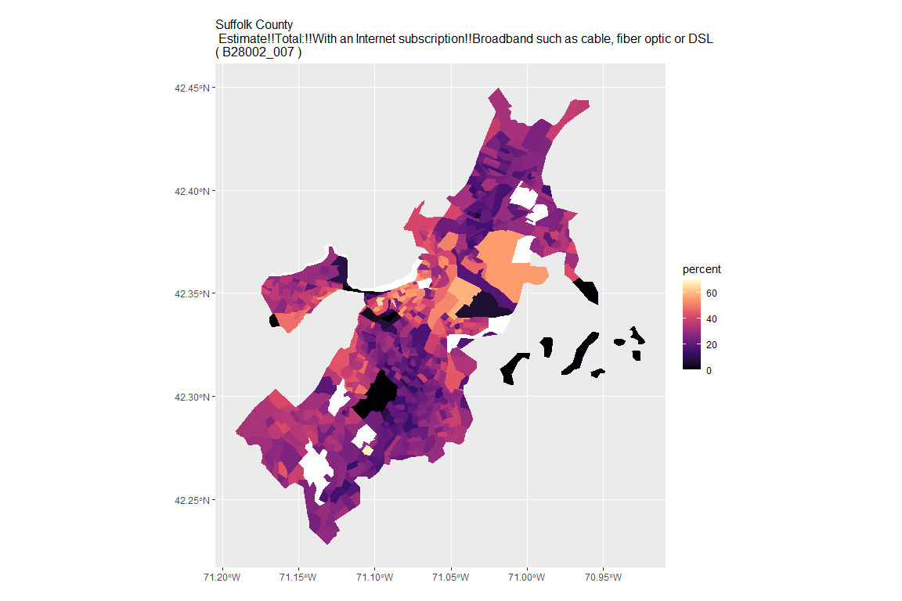

## For variable: B28002_008 : Estimate!!Total:!!With an Internet subscription!!Broadband such as cable, fiber optic or DSL!!Broadband such as cable, fiber optic or DSL with no other type of Internet subscription

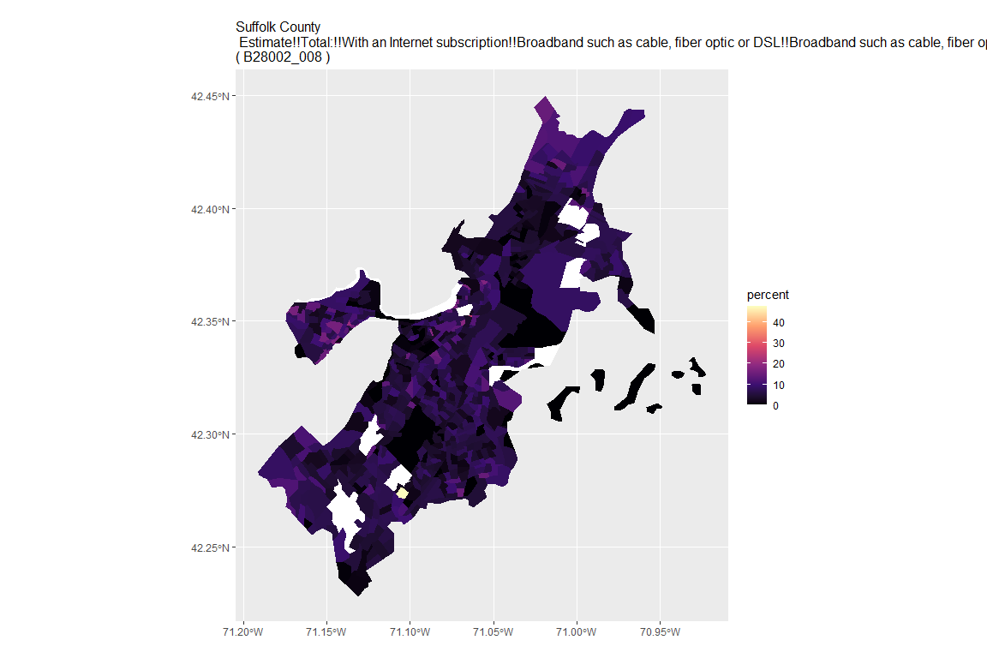

## For variable: B28002_009 : Estimate!!Total:!!With an Internet subscription!!Satellite Internet service

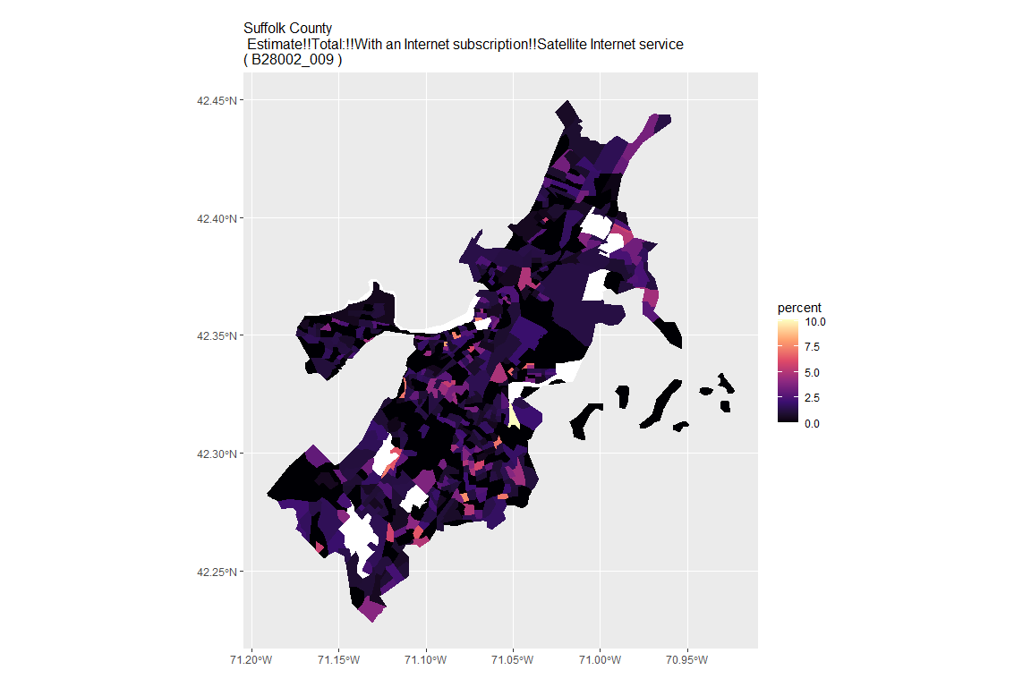

## For variable: B28002_010 : Estimate!!Total:!!With an Internet subscription!!Satellite Internet service!!Satellite Internet service with no other type of Internet subscription

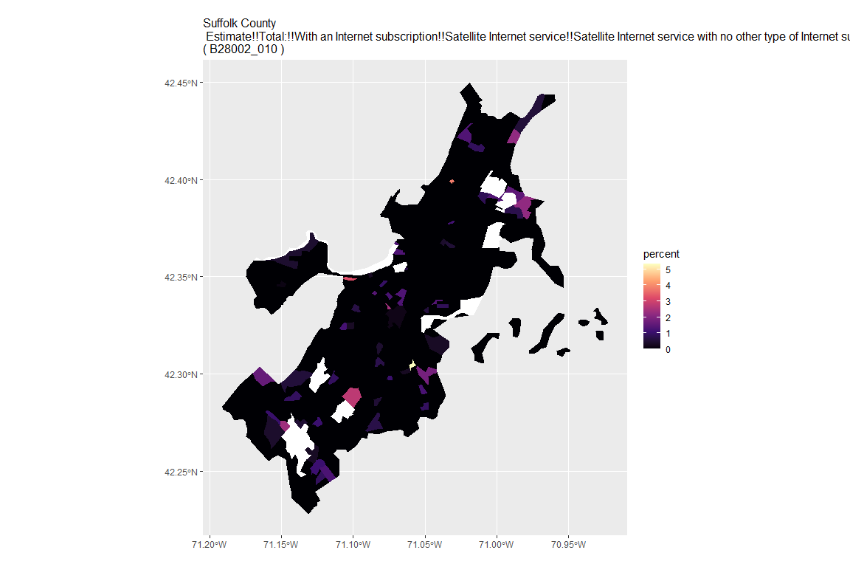

## For variable: B28002_011 : Estimate!!Total:!!With an Internet subscription!!Other service with no other type of Internet subscription

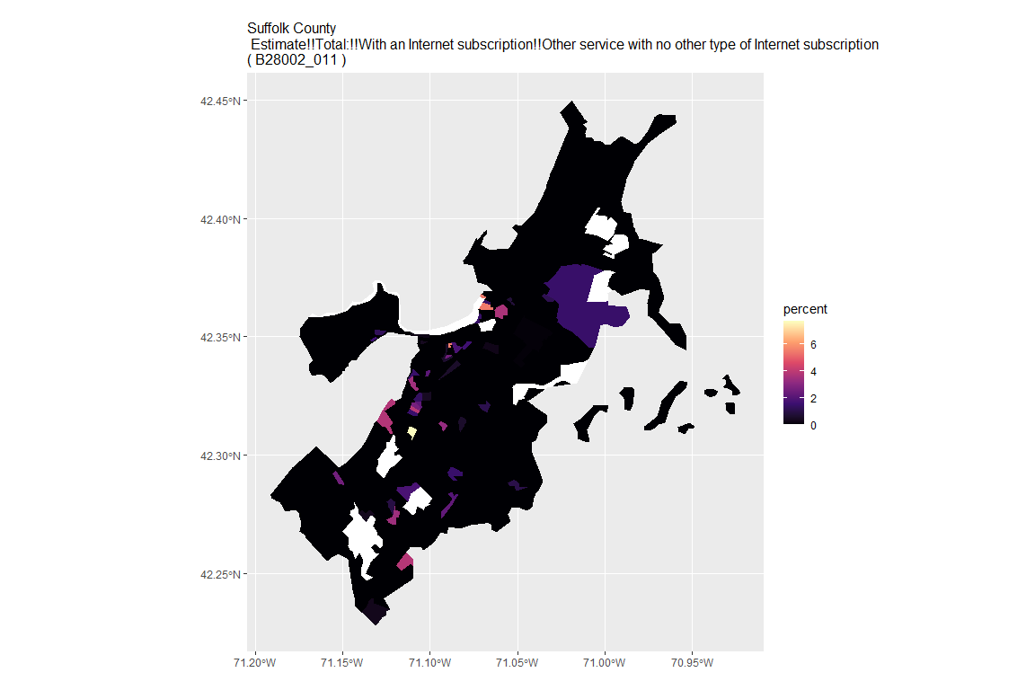

## For variable: B28002_012 : Estimate!!Total:!!Internet access without a subscription

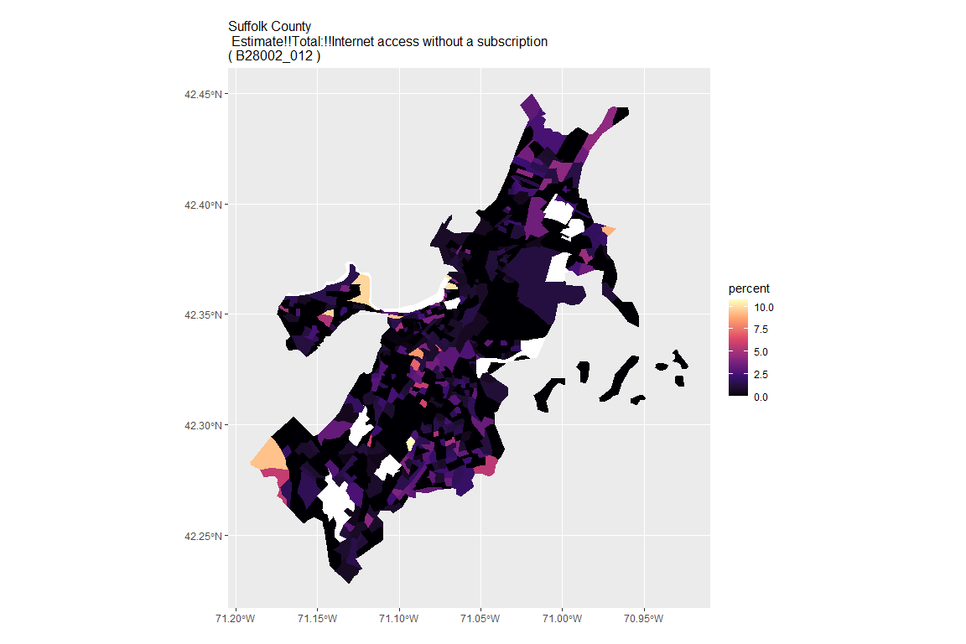

## For variable: B28002_013 : Estimate!!Total:!!No Internet access

## For county: Worcester County

## Getting data from the 2015-2019 5-year ACS  
## Downloading feature geometry from the Census website. To cache shapefiles for use in future sessions, set `options(tigris_use_cache = TRUE)`.

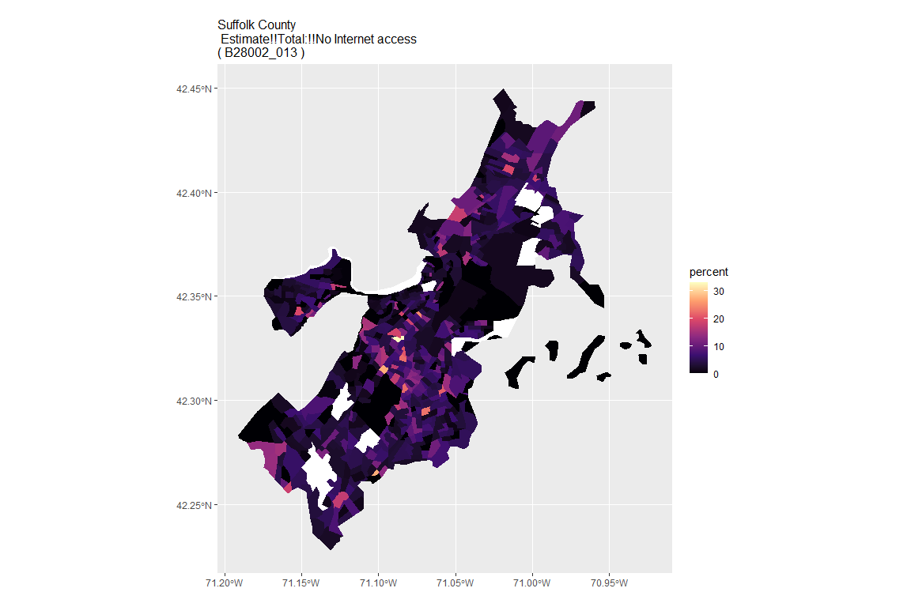

## For variable: B28002_001 : Estimate!!Total:

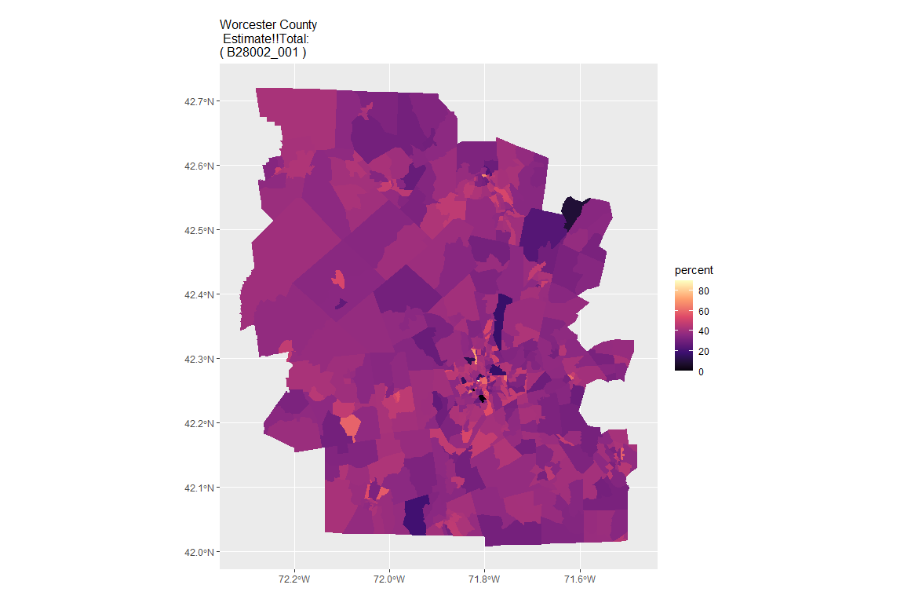

## For variable: B28002_002 : Estimate!!Total:!!With an Internet subscription

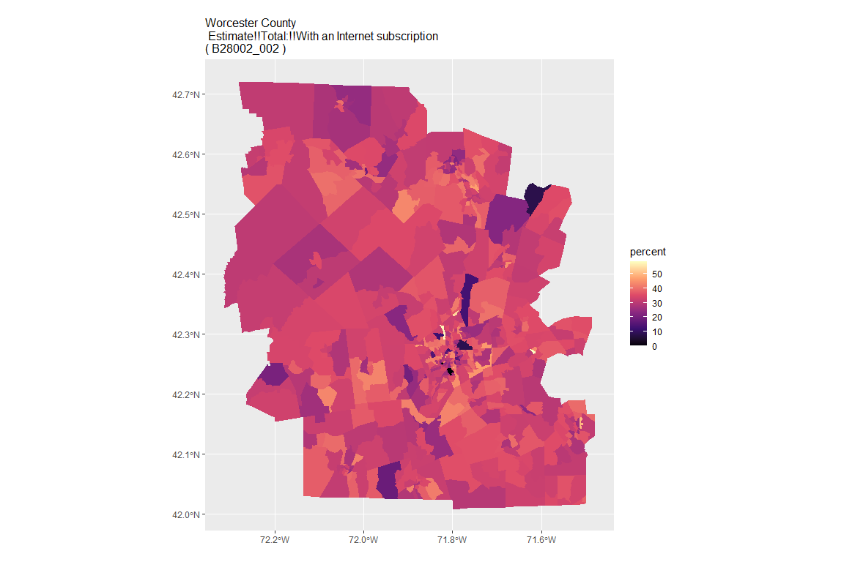

## For variable: B28002_003 : Estimate!!Total:!!With an Internet subscription!!Dial-up with no other type of Internet subscription

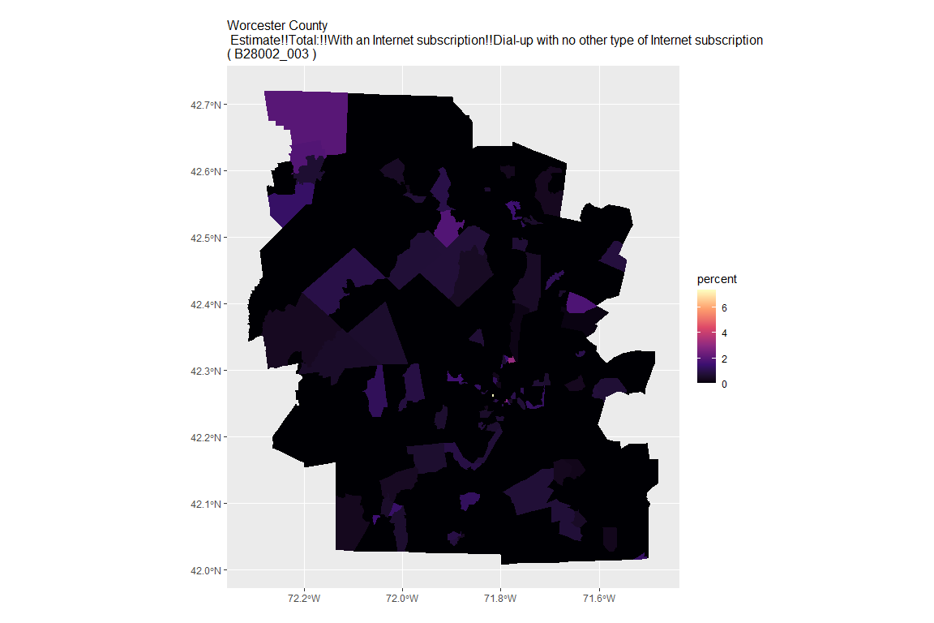

## For variable: B28002_004 : Estimate!!Total:!!With an Internet subscription!!Broadband of any type

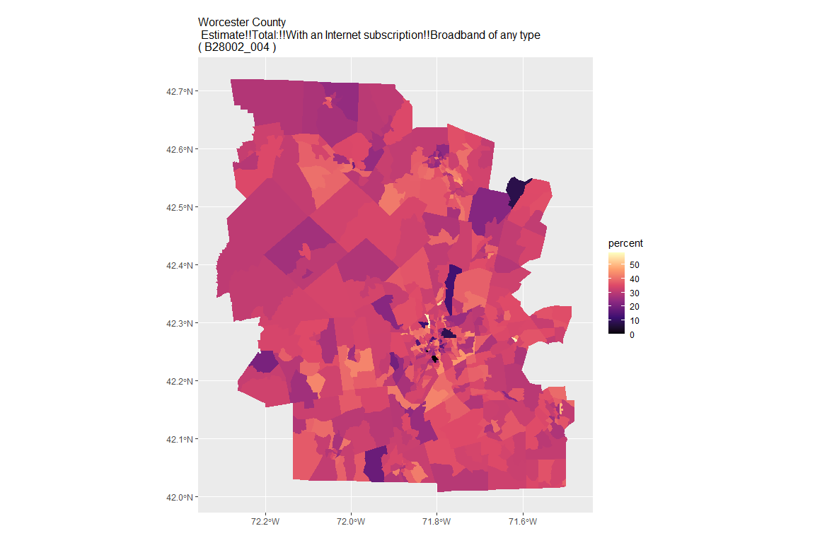

## For variable: B28002_005 : Estimate!!Total:!!With an Internet subscription!!Cellular data plan

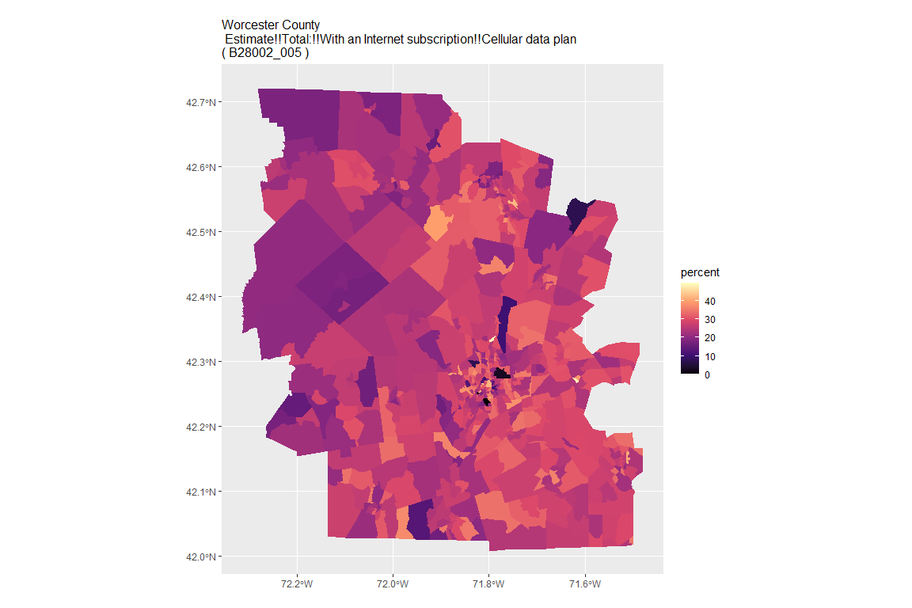

## For variable: B28002_006 : Estimate!!Total:!!With an Internet subscription!!Cellular data plan!!Cellular data plan with no other type of Internet subscription

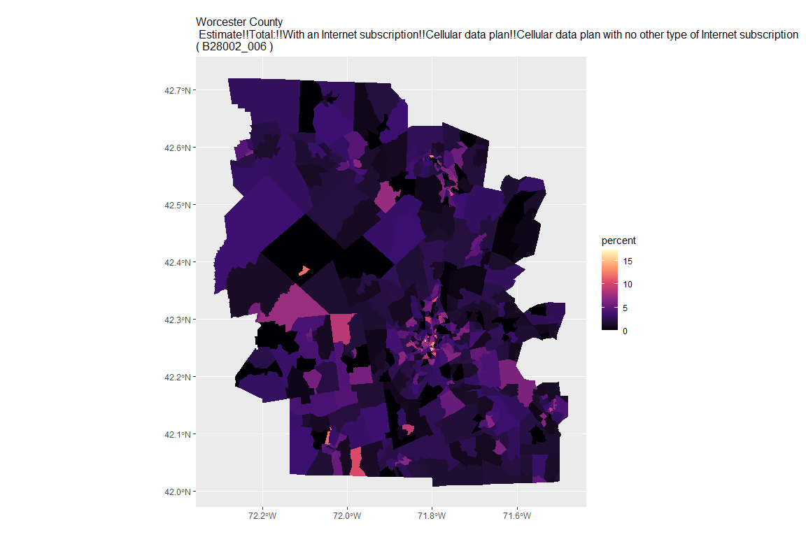

## For variable: B28002_007 : Estimate!!Total:!!With an Internet subscription!!Broadband such as cable, fiber optic or DSL

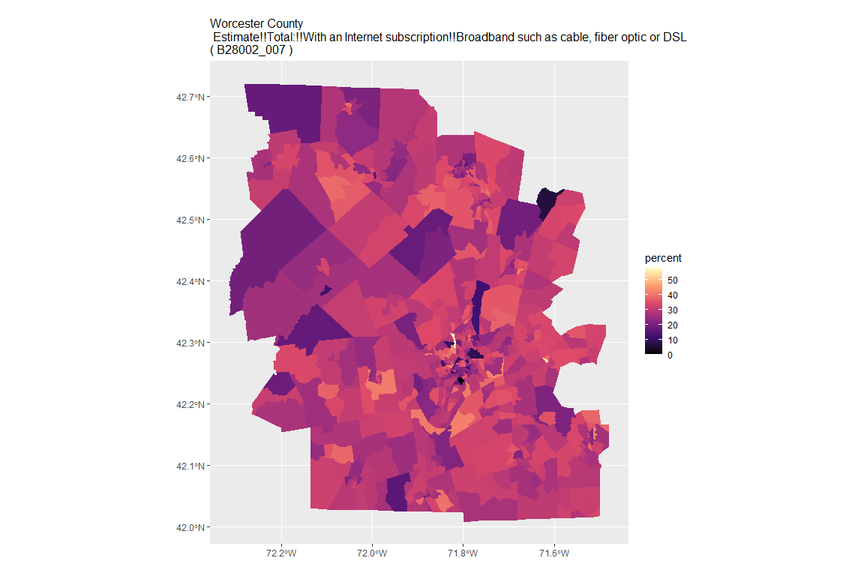

## For variable: B28002_008 : Estimate!!Total:!!With an Internet subscription!!Broadband such as cable, fiber optic or DSL!!Broadband such as cable, fiber optic or DSL with no other type of Internet subscription

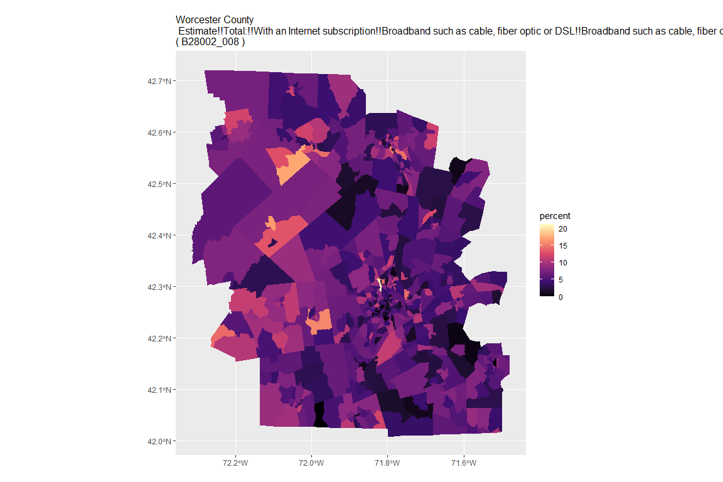

## For variable: B28002_009 : Estimate!!Total:!!With an Internet subscription!!Satellite Internet service

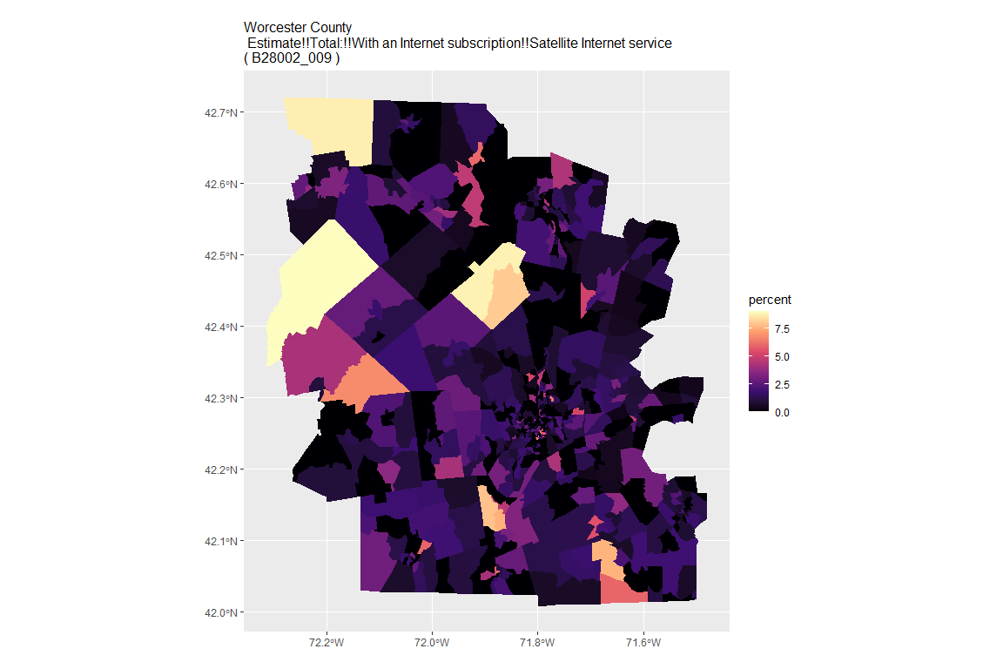

## For variable: B28002_010 : Estimate!!Total:!!With an Internet subscription!!Satellite Internet service!!Satellite Internet service with no other type of Internet subscription

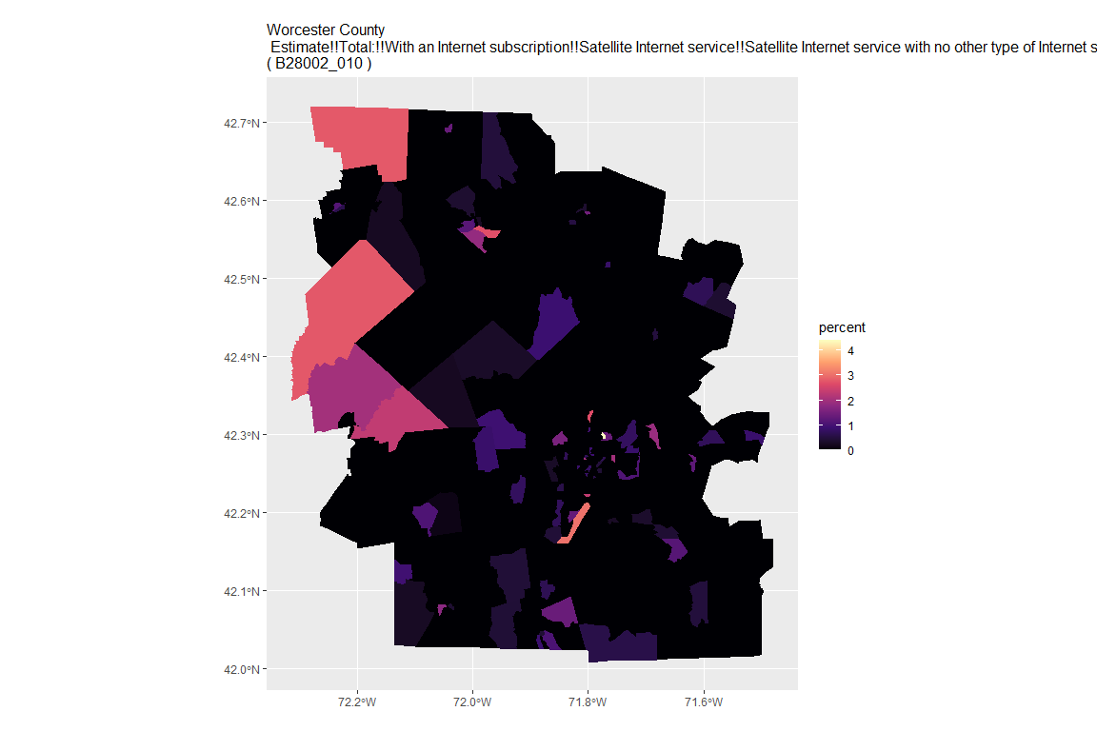

## For variable: B28002_011 : Estimate!!Total:!!With an Internet subscription!!Other service with no other type of Internet subscription

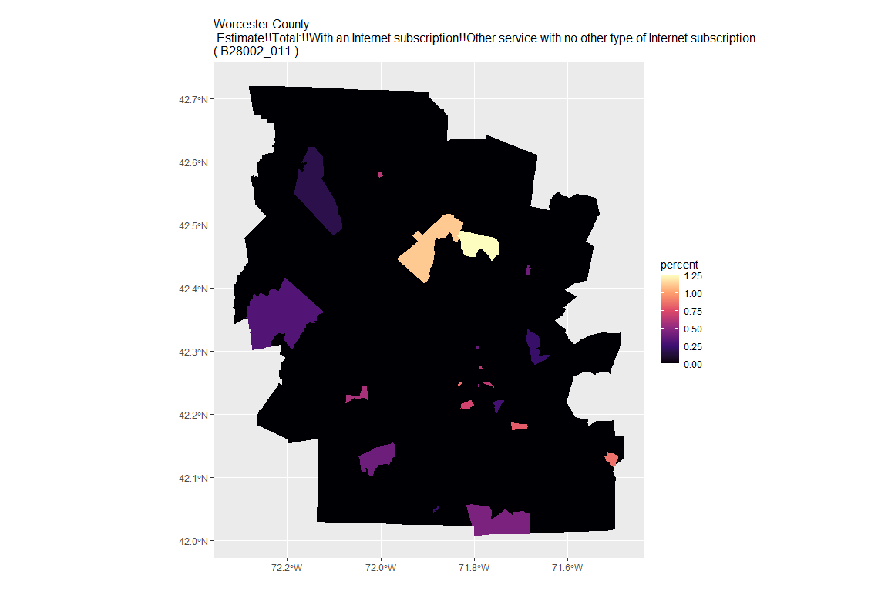

## For variable: B28002_012 : Estimate!!Total:!!Internet access without a subscription

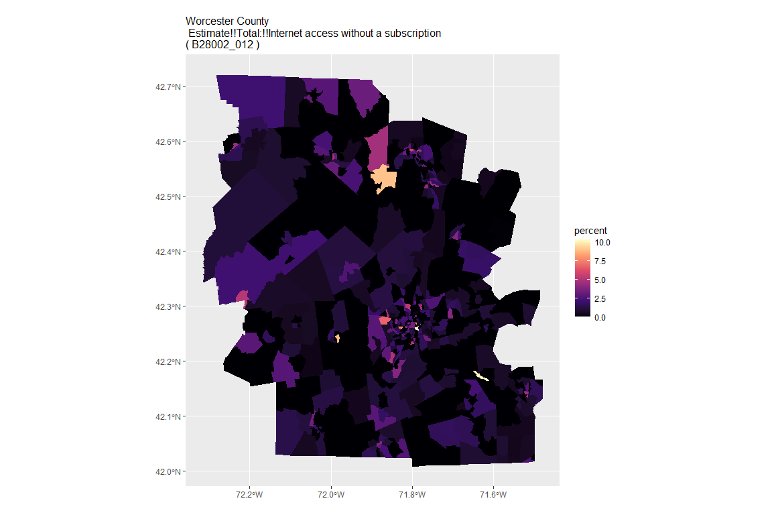

## For variable: B28002_013 : Estimate!!Total:!!No Internet access

